1. Statistical Analysis Tool

Function Prototype: void computeStats(const double \*array, int size, double \*average, double \*variance) Data Types: const double\*, int, double\*

Concepts: Pointers, arrays, functions, passing constant data, pass by reference.

Details: Compute the average and variance of an array of experimental results, ensuring the function uses pointers for accessing the data and modifying the results.

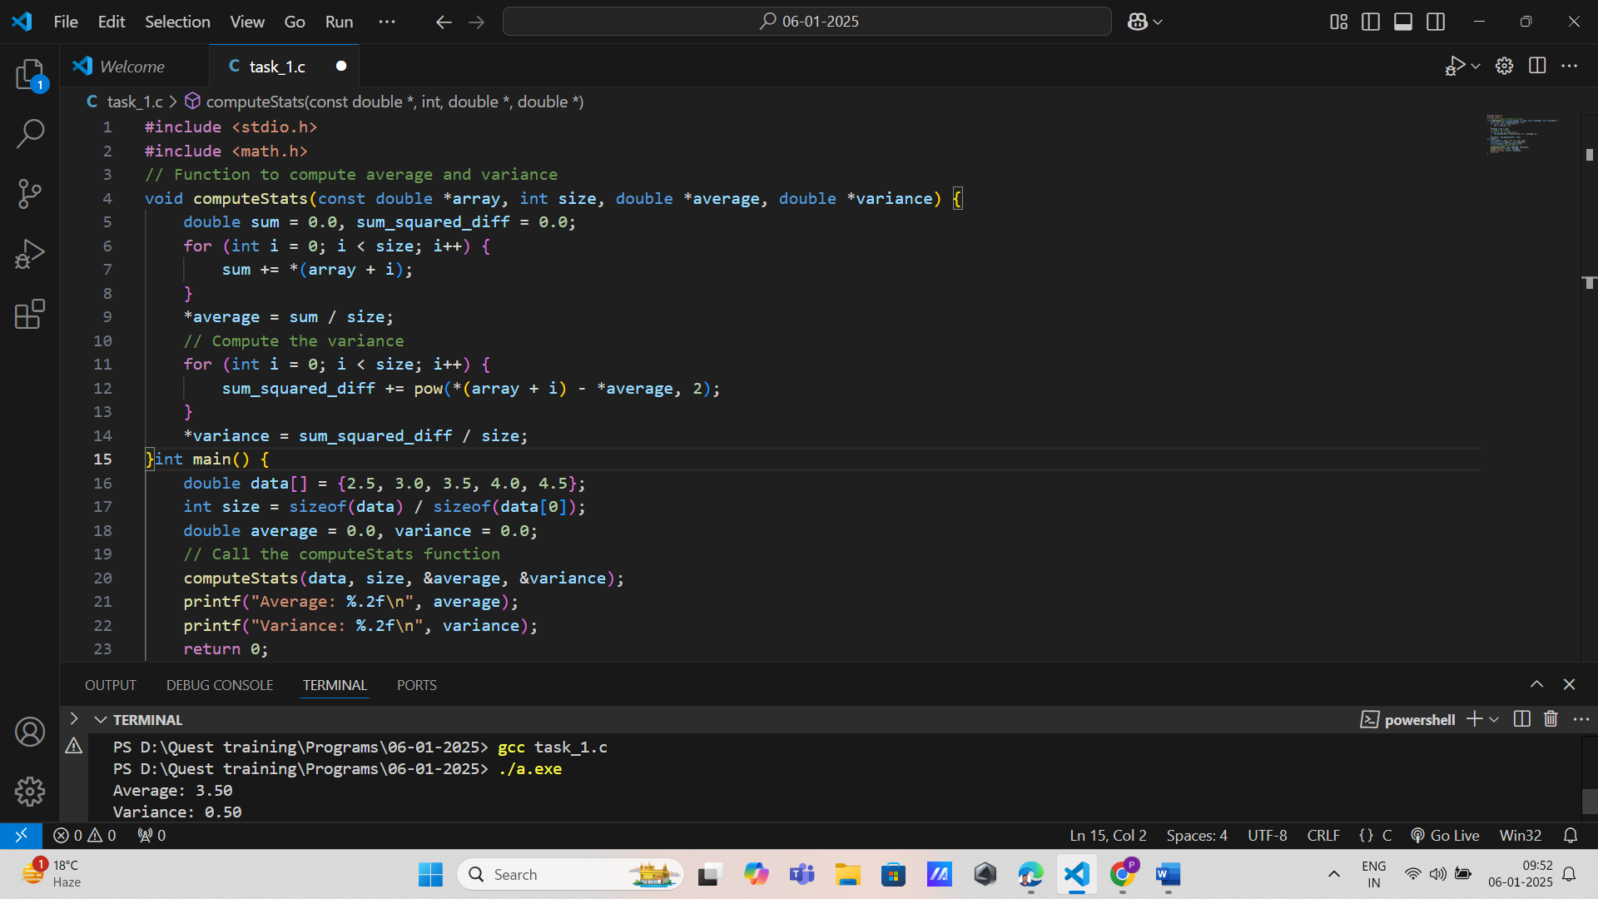

2. Data Normalization Function Prototype: double\* normalizeData(const double \*array, int size)

Data Types: const double\*, int, double\* Concepts: Arrays, functions returning pointers, loops.

Details: Normalize data points in an array, returning a pointer to the new normalized array.

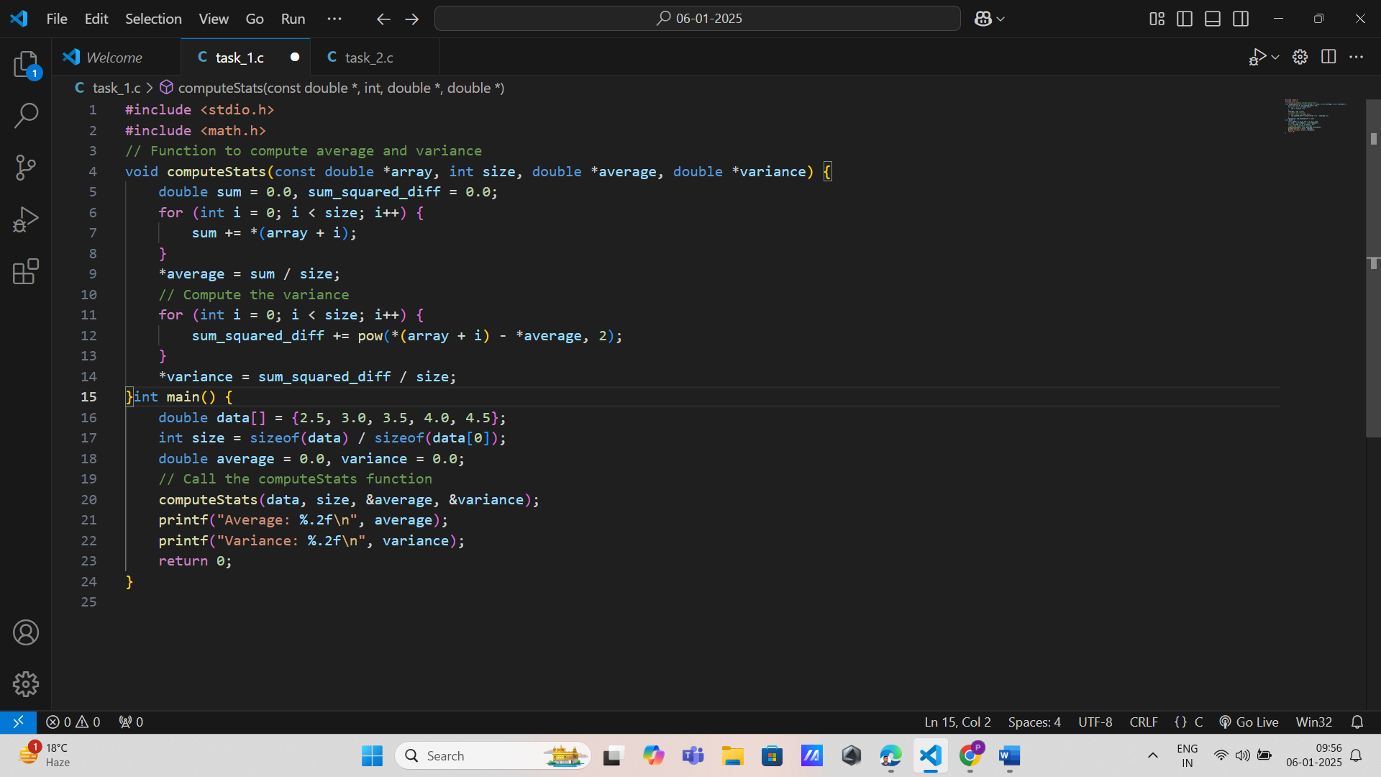

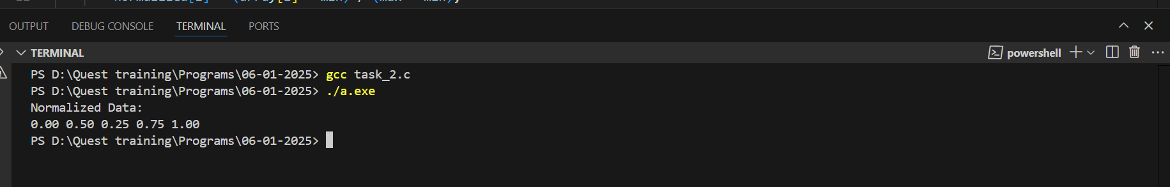

3. Experimental Report Generator

Function Prototype: void generateReport(const double \*results, const char \*descriptions[], int size)

Data Types: const double\*, const char\*[], int Concepts: Strings, arrays, functions, passing constant data.

Details: Generate a report summarizing experimental results and their descriptions, using constant data to ensure the input is not modified.

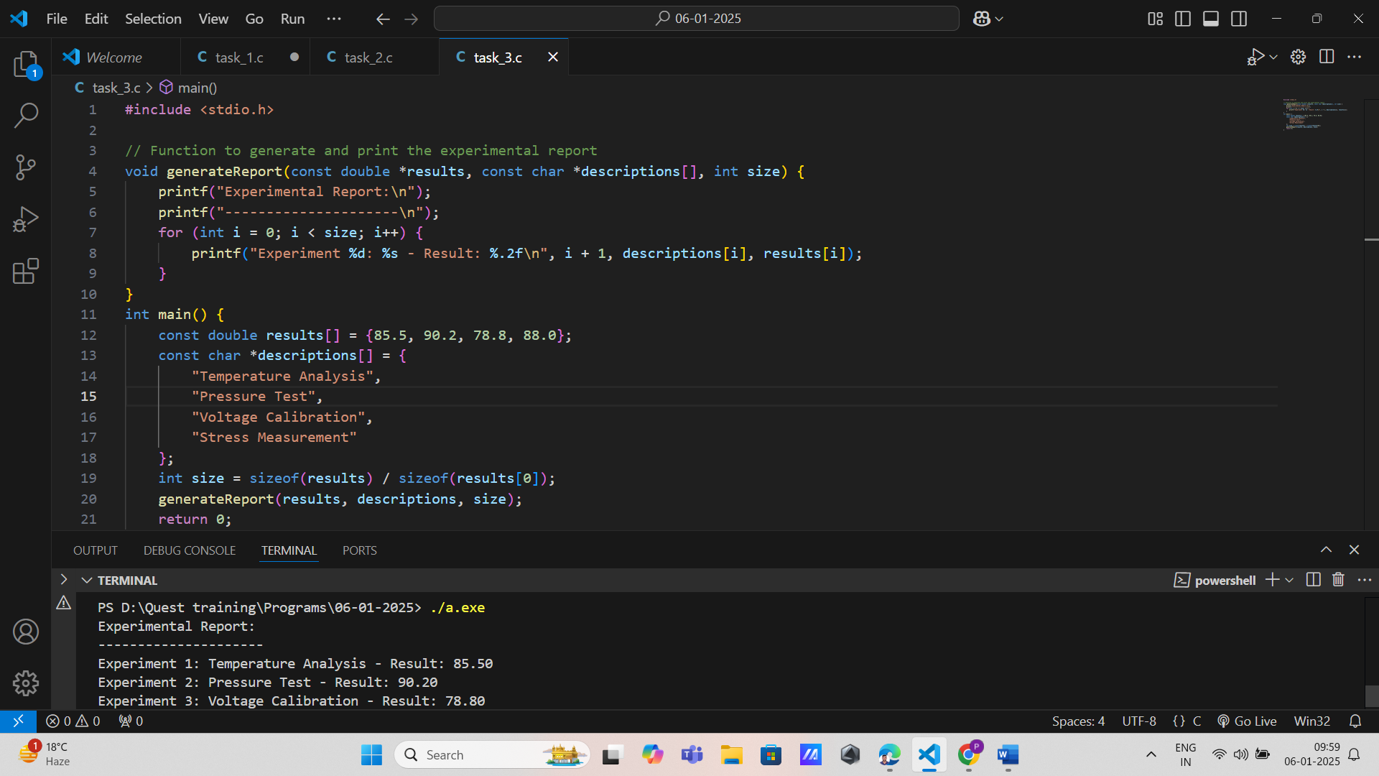

4. Data Anomaly Detector

Function Prototype: void detectAnomalies(const double \*data, int size, double threshold, int \*anomalyCount)

Data Types: const double\*, int, double, int\*

Concepts: Decision-making, arrays, pointers, functions.

Details: Detect anomalies in a dataset based on a threshold, updating the anomaly count by reference.

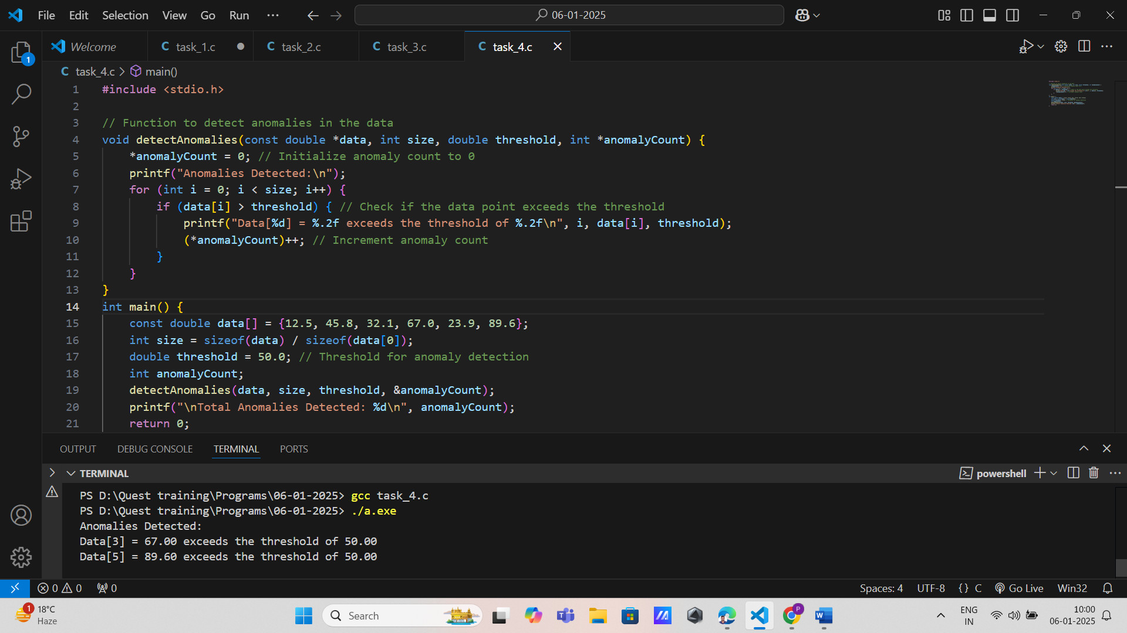

5. Data Classifier

Function Prototype: void classifyData(const double \*data, int size, char \*labels[], double threshold)

Data Types: const double\*, int, char\*[], double

Concepts: Decision-making, arrays, functions, pointers.

Details: Classify data points into categories based on a threshold, updating an array of labels.

Artificial Intelligence

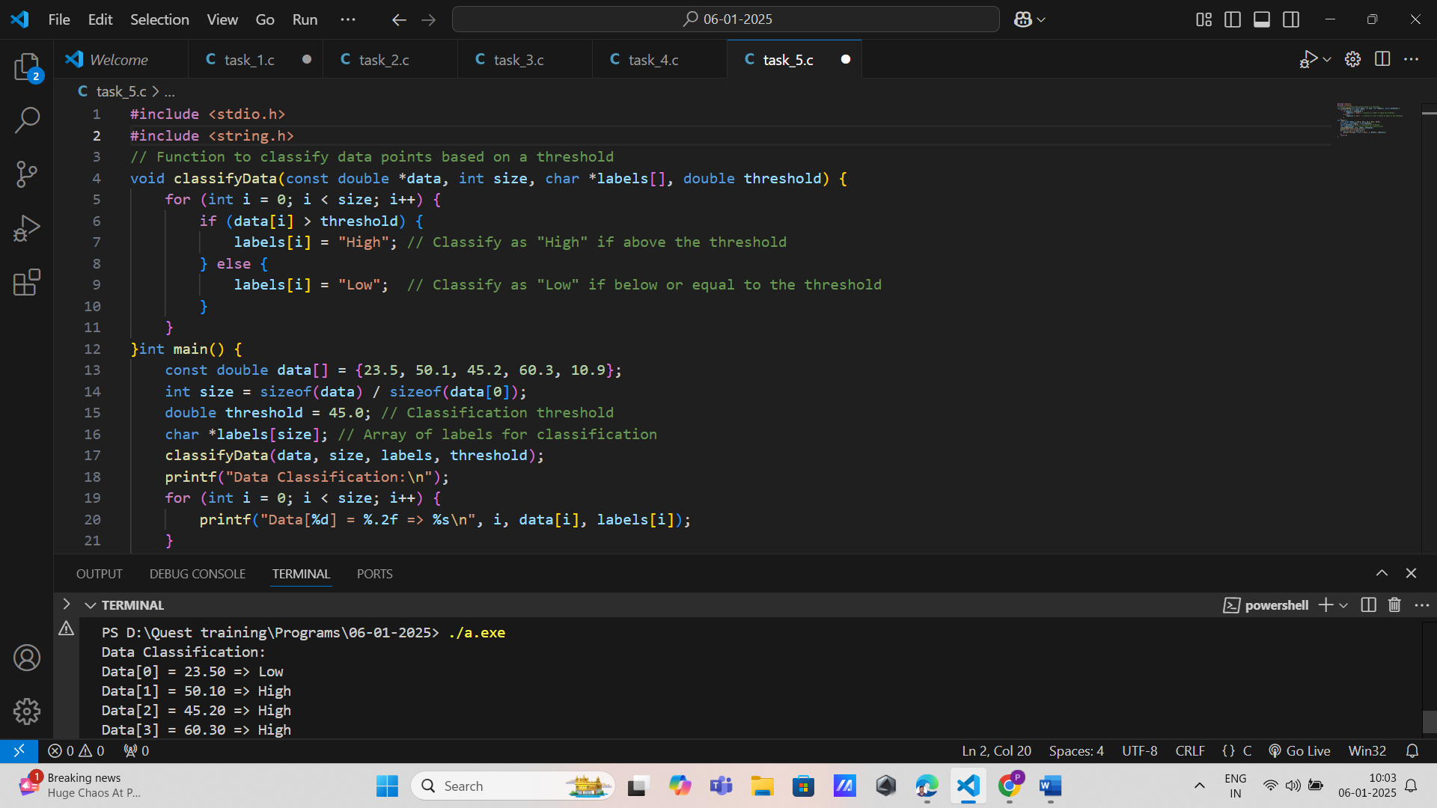

6. Neural Network Weight Adjuster

Function Prototype: void adjustWeights(double \*weights, int size, double learningRate)

Data Types: double\*, int, double Concepts: Pointers, arrays, functions, loops.

Details: Adjust neural network weights using a given learning rate, with weights passed by reference.

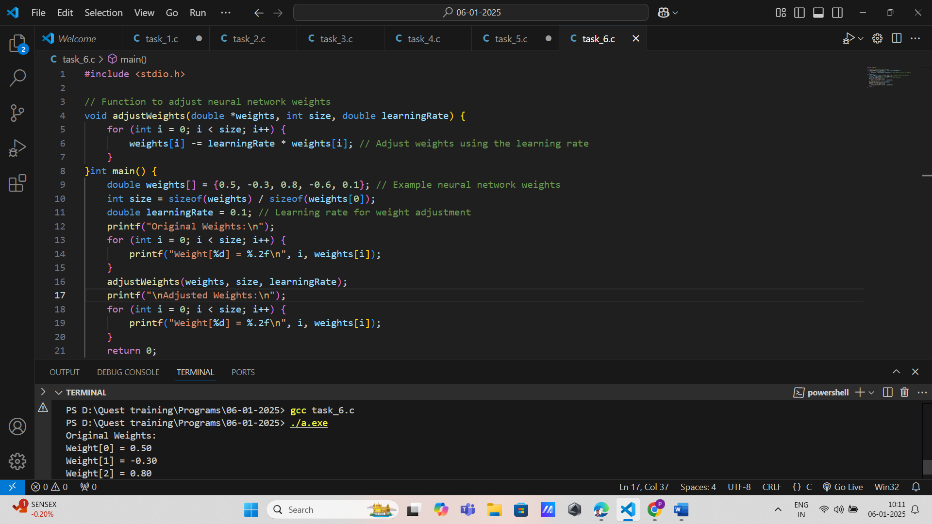

7. AI Model Evaluator

Function Prototype: void evaluateModels(const double \*accuracies, int size, double \*bestAccuracy)

Data Types: const double\*, int, double\* Concepts: Loops, arrays, functions, pointers.

Details: Evaluate multiple AI models, determining the best accuracy and updating it by reference.

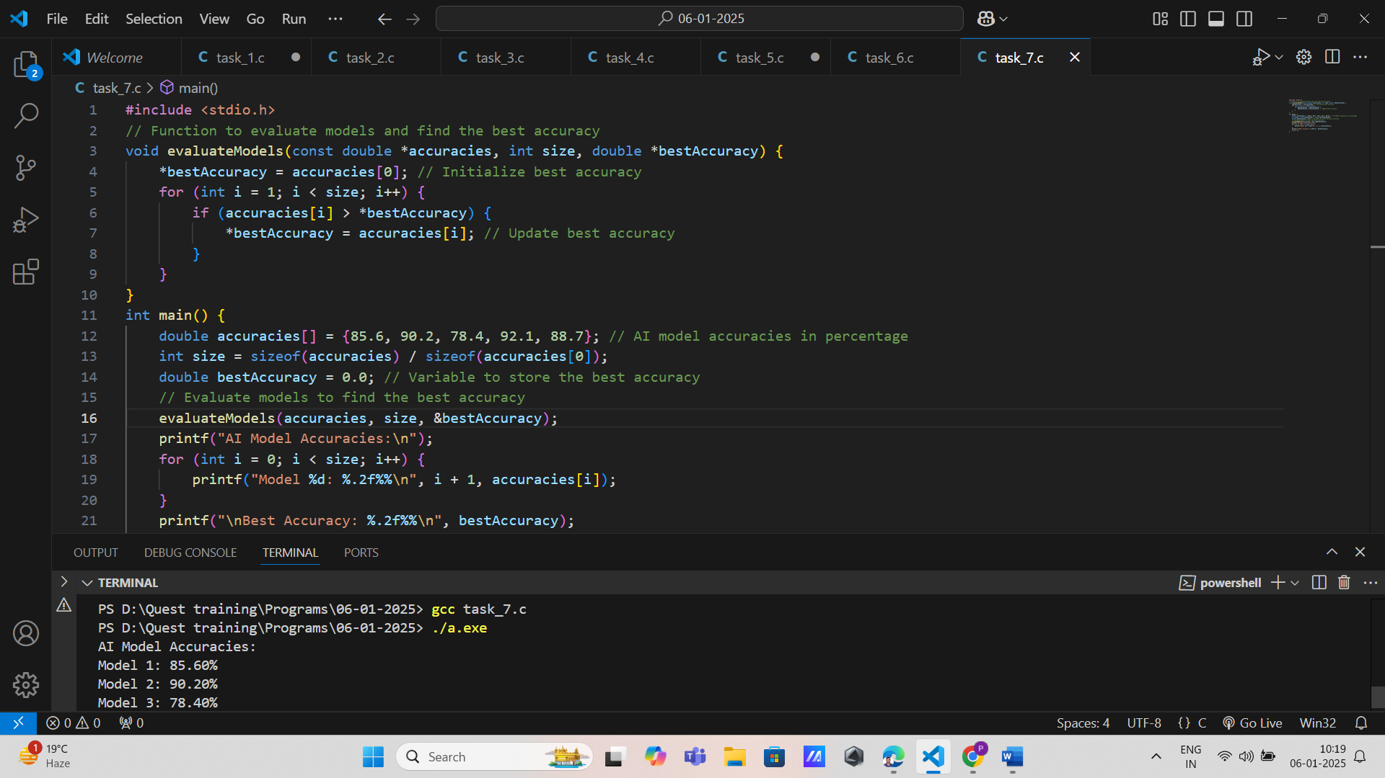

8. Decision Tree Constructor

Function Prototype: void constructDecisionTree(const double \*features, int size, int \*treeStructure)

Data Types: const double\*, int, int\* Concepts: Decision-making, arrays, functions.

Details: Construct a decision tree based on feature data, updating the tree structure by reference.

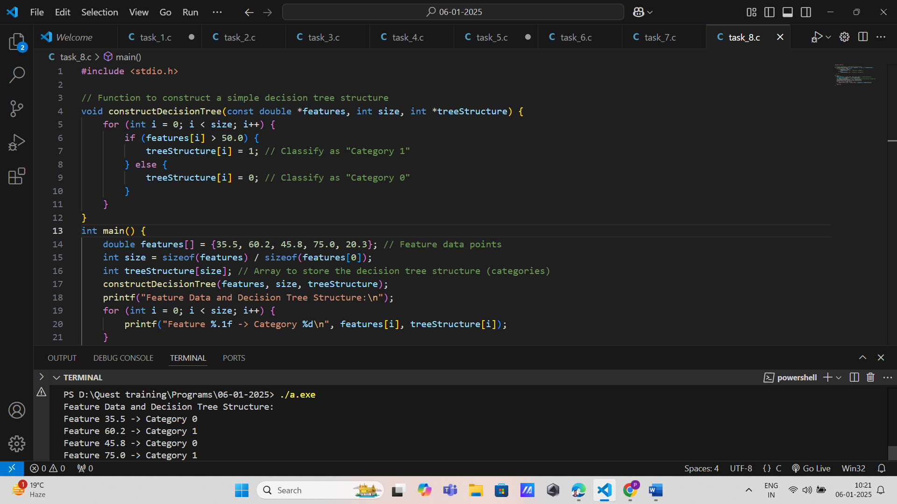

Sentiment Analysis Processor

Function Prototype: void processSentiments(const char \*sentences[], int size, int \*sentimentScores)

Data Types: const char\*[], int, int\* Concepts: Strings, arrays, functions, pointers.

Details: Analyze sentiments of sentences, updating sentiment scores by reference.

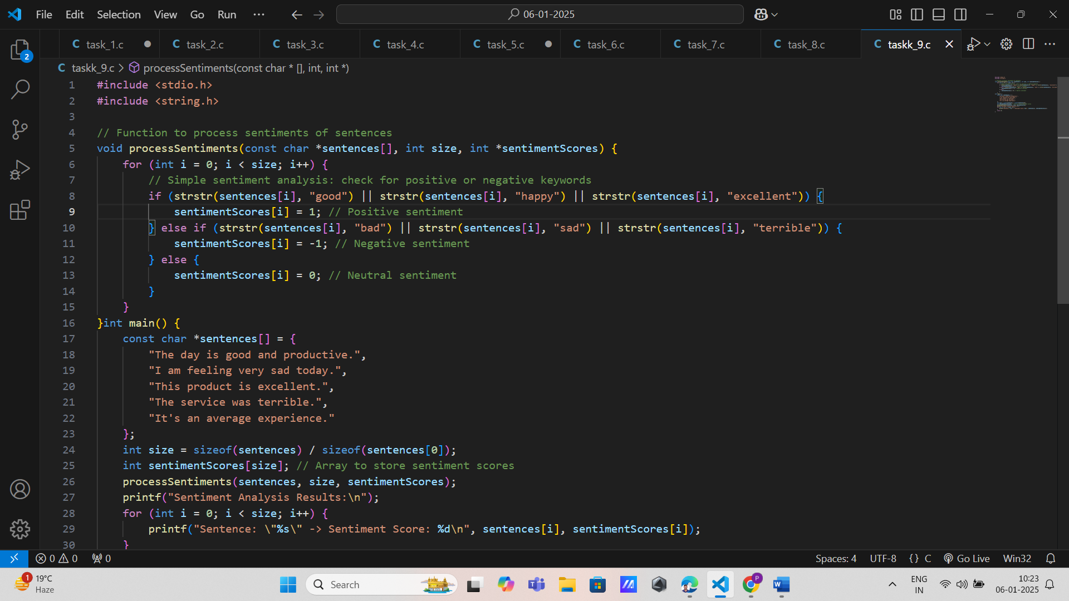

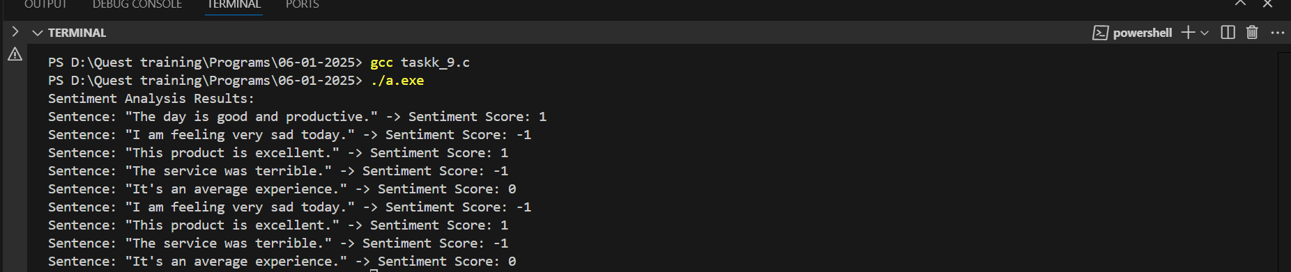

10. Training Data Generator

Function Prototype: double\* generateTrainingData(const double \*baseData, int size, int multiplier)

Data Types: const double\*, int, double\* Concepts: Arrays, functions returning pointers, loops.

Details: Generate training data by applying a multiplier to base data, returning a pointer to the new data array.

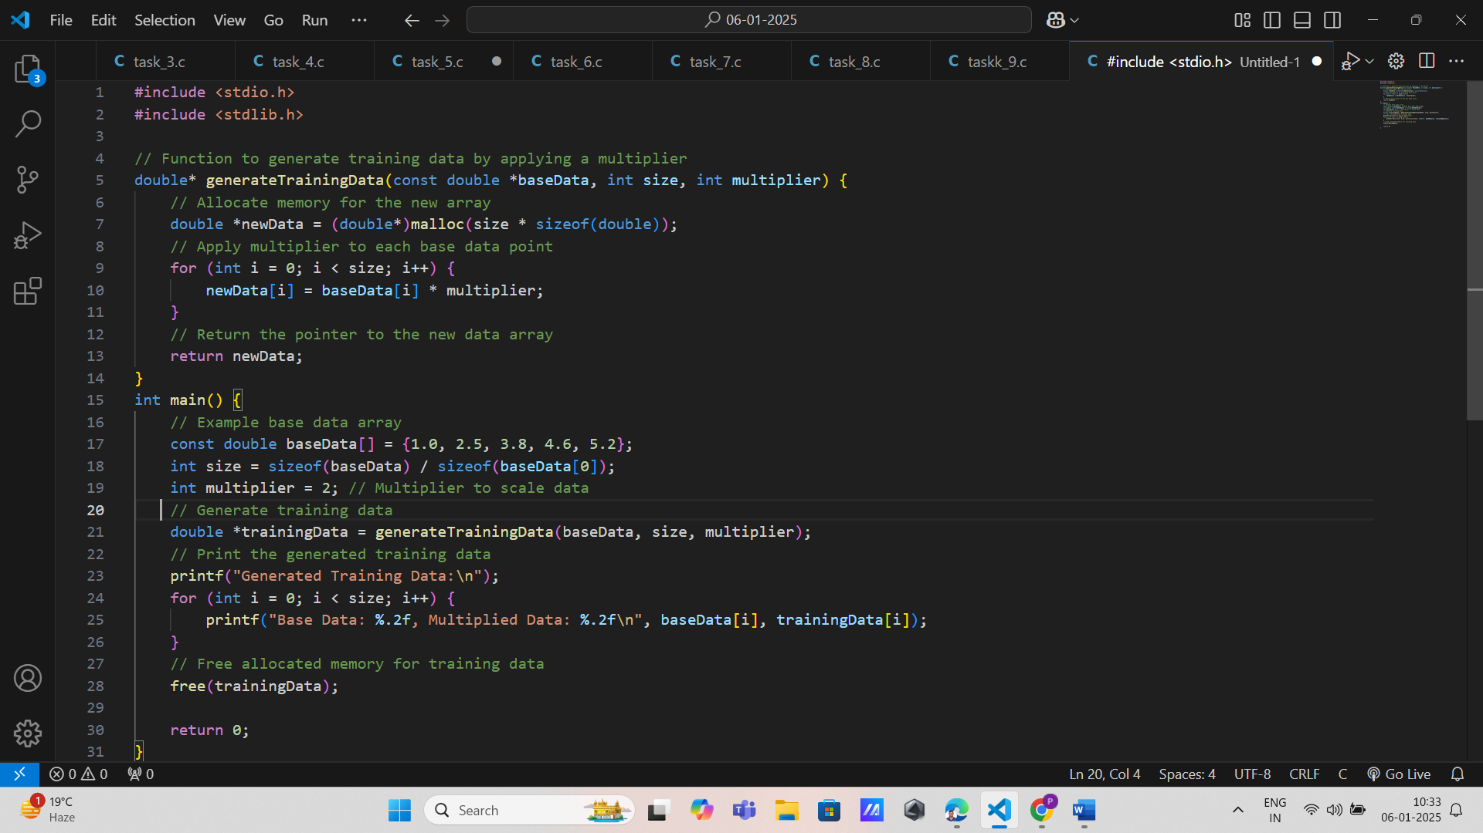

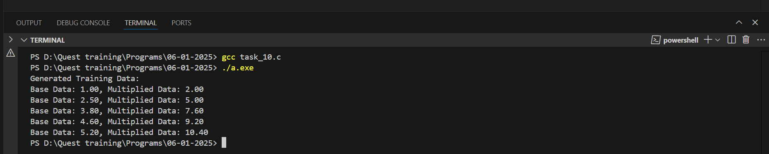

11. Edge Detection Algorithm

Function Prototype: void detectEdges(const unsigned char \*image, unsigned char \*edges, int width, int height)

Data Types: const unsigned char\*, unsigned char\*, int

Concepts: Loops, arrays, decision-making, functions.

Details: Detect edges in an image, updating the edges array by reference.

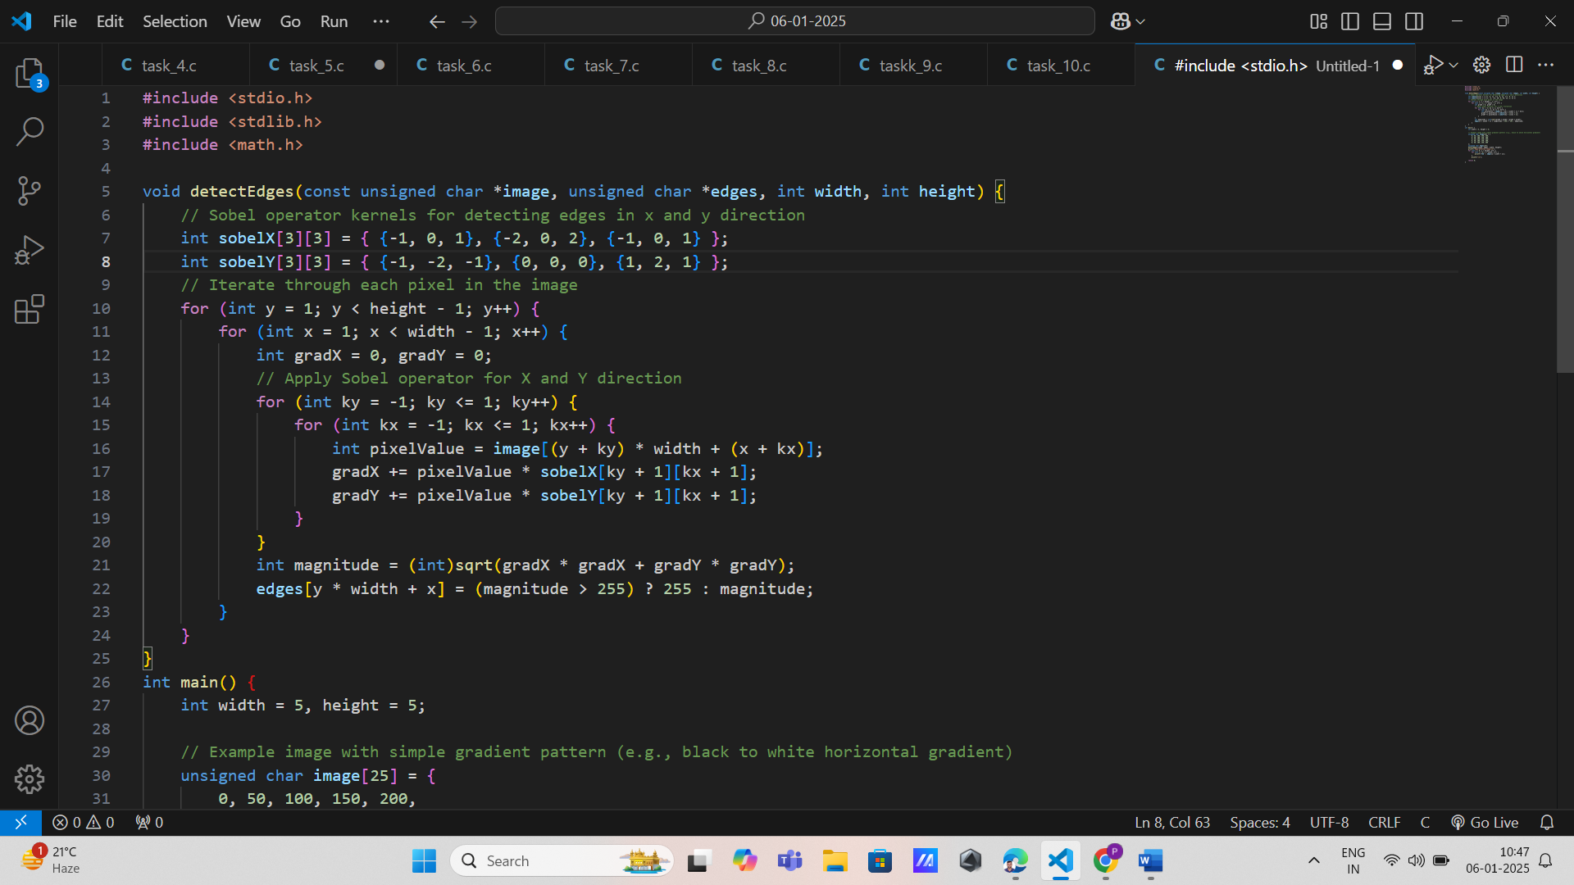

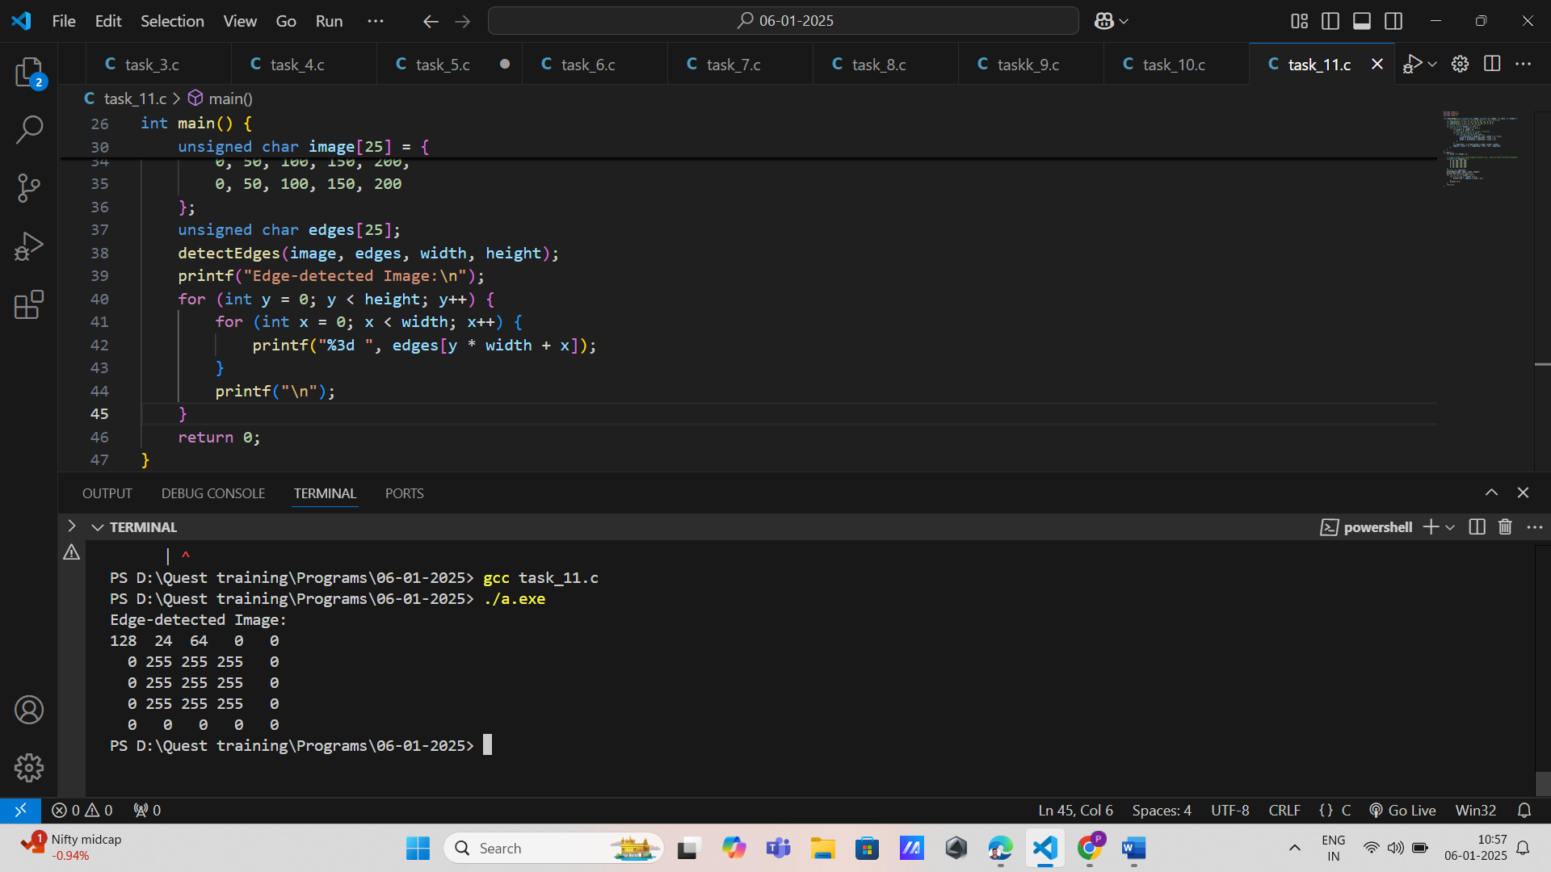

12. Object Recognition System

Function Prototype: void recognizeObjects(const double \*features, int size, char \*objectLabels[])

Data Types: const double\*, int, char\*[]

Concepts: Decision-making, arrays, functions, pointers.

Details: Recognize objects based on feature vectors, updating an array of object labels.

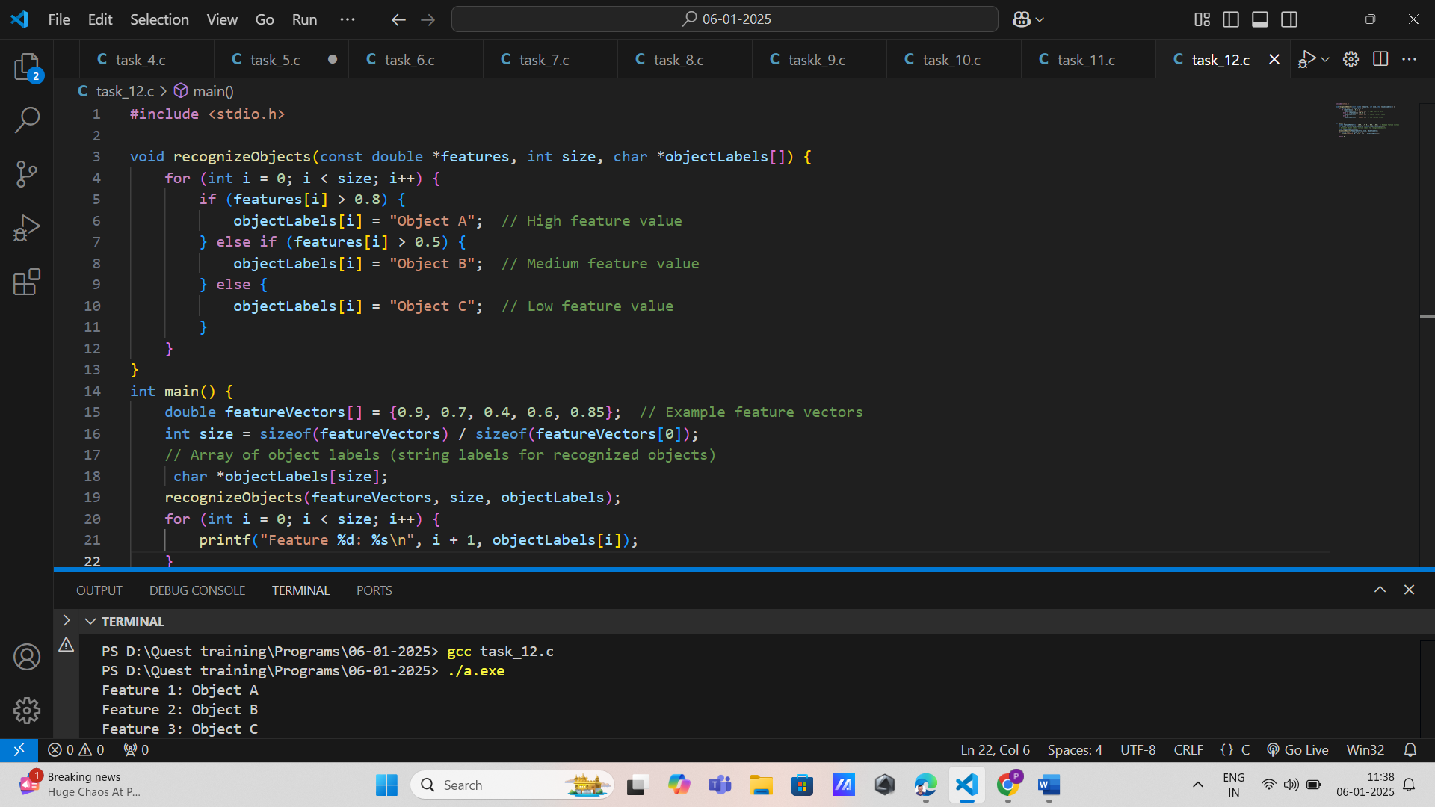

13. Image Resizing Function

Function Prototype: void resizeImage(const unsigned char \*inputImage, unsigned char \*outputImage, int originalWidth, int originalHeight, int newWidth, int newHeight)

Data Types: const unsigned char\*, unsigned char\*, int Concepts: Arrays, functions, pointers.

Details: Resize an image to new dimensions, modifying the output image by reference.

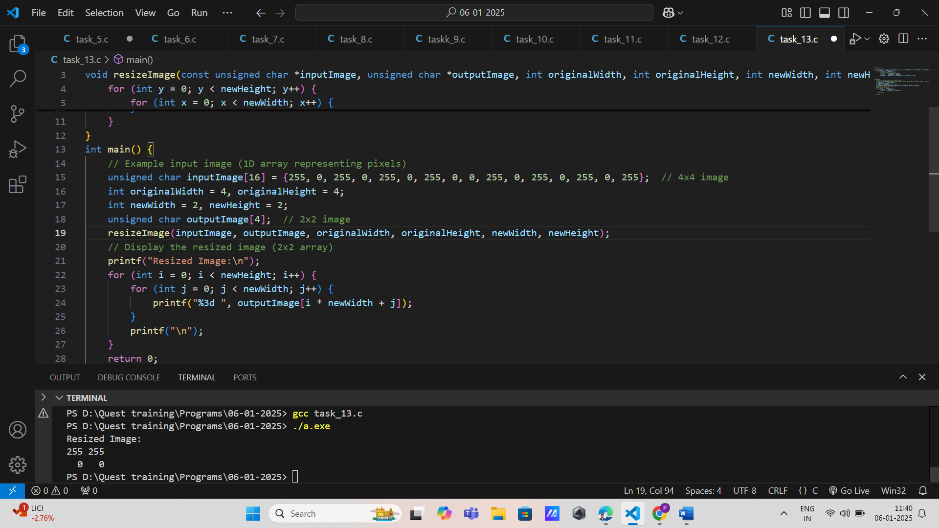

14. Color Balance Adjuster

Function Prototype: void balanceColors(const unsigned char \*image, unsigned char \*balancedImage, int width, int height)

Data Types: const unsigned char\*, unsigned char\*, int Concepts: Arrays, functions, pointers, loops.

Details: Adjust the color balance of an image, updating the balanced image by reference.

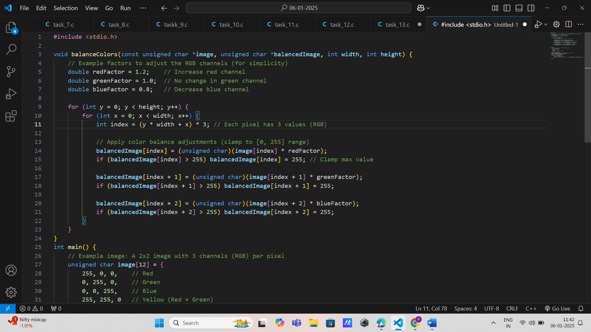

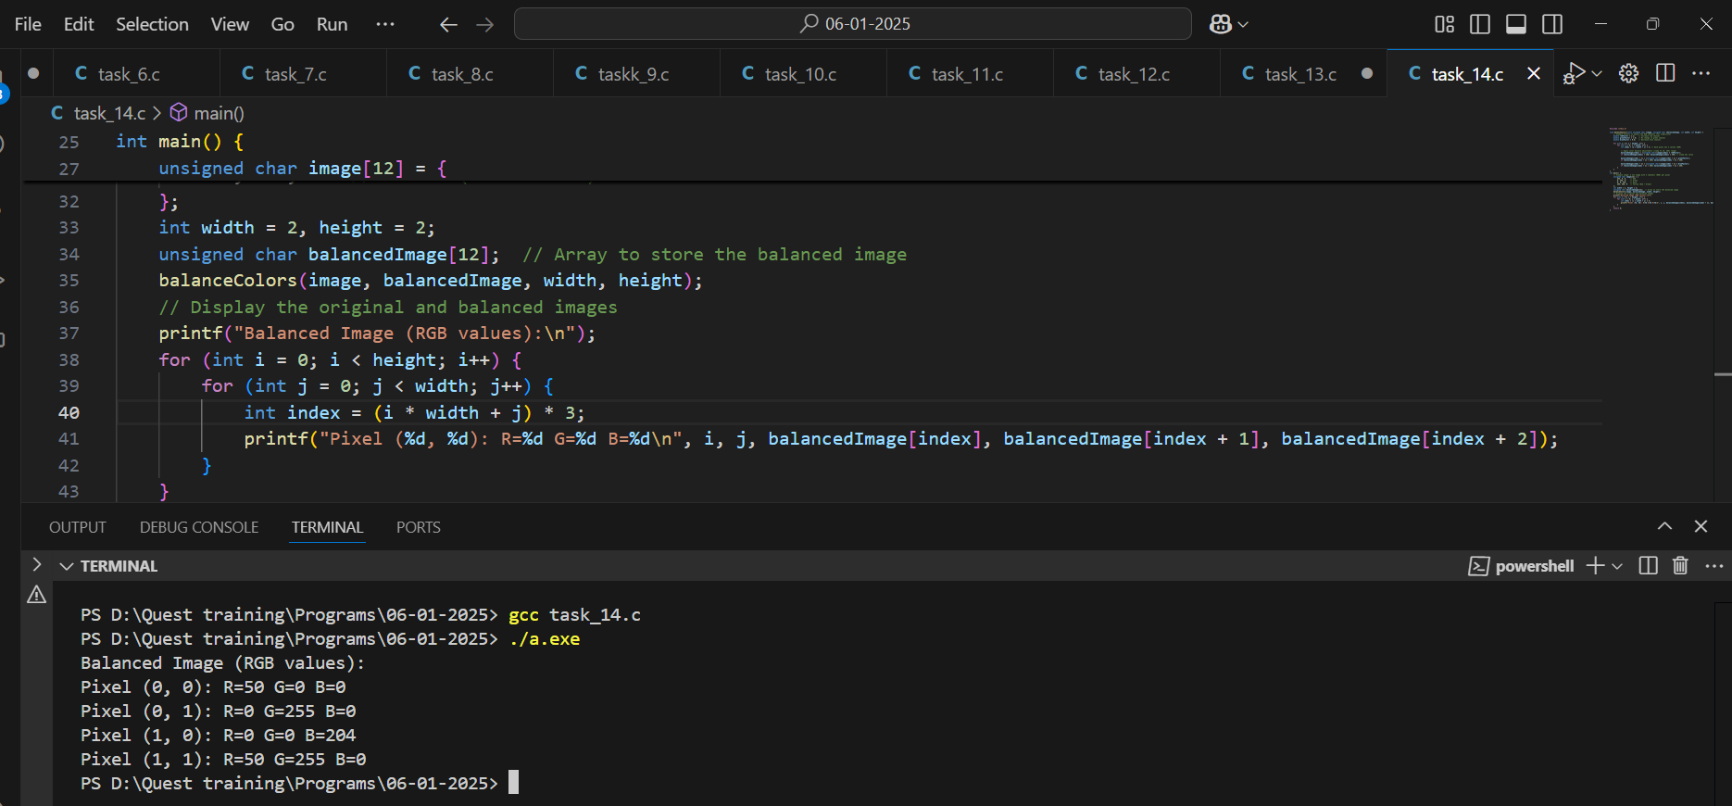

15. Pattern Recognition Algorithm

Function Prototype: void recognizePatterns(const char \*patterns[], int size, int \*matchCounts)

Data Types: const char\*[], int, int\*

Concepts: Strings, arrays, decision-making, pointers.

Details: Recognize patterns in a dataset, updating match counts by reference.

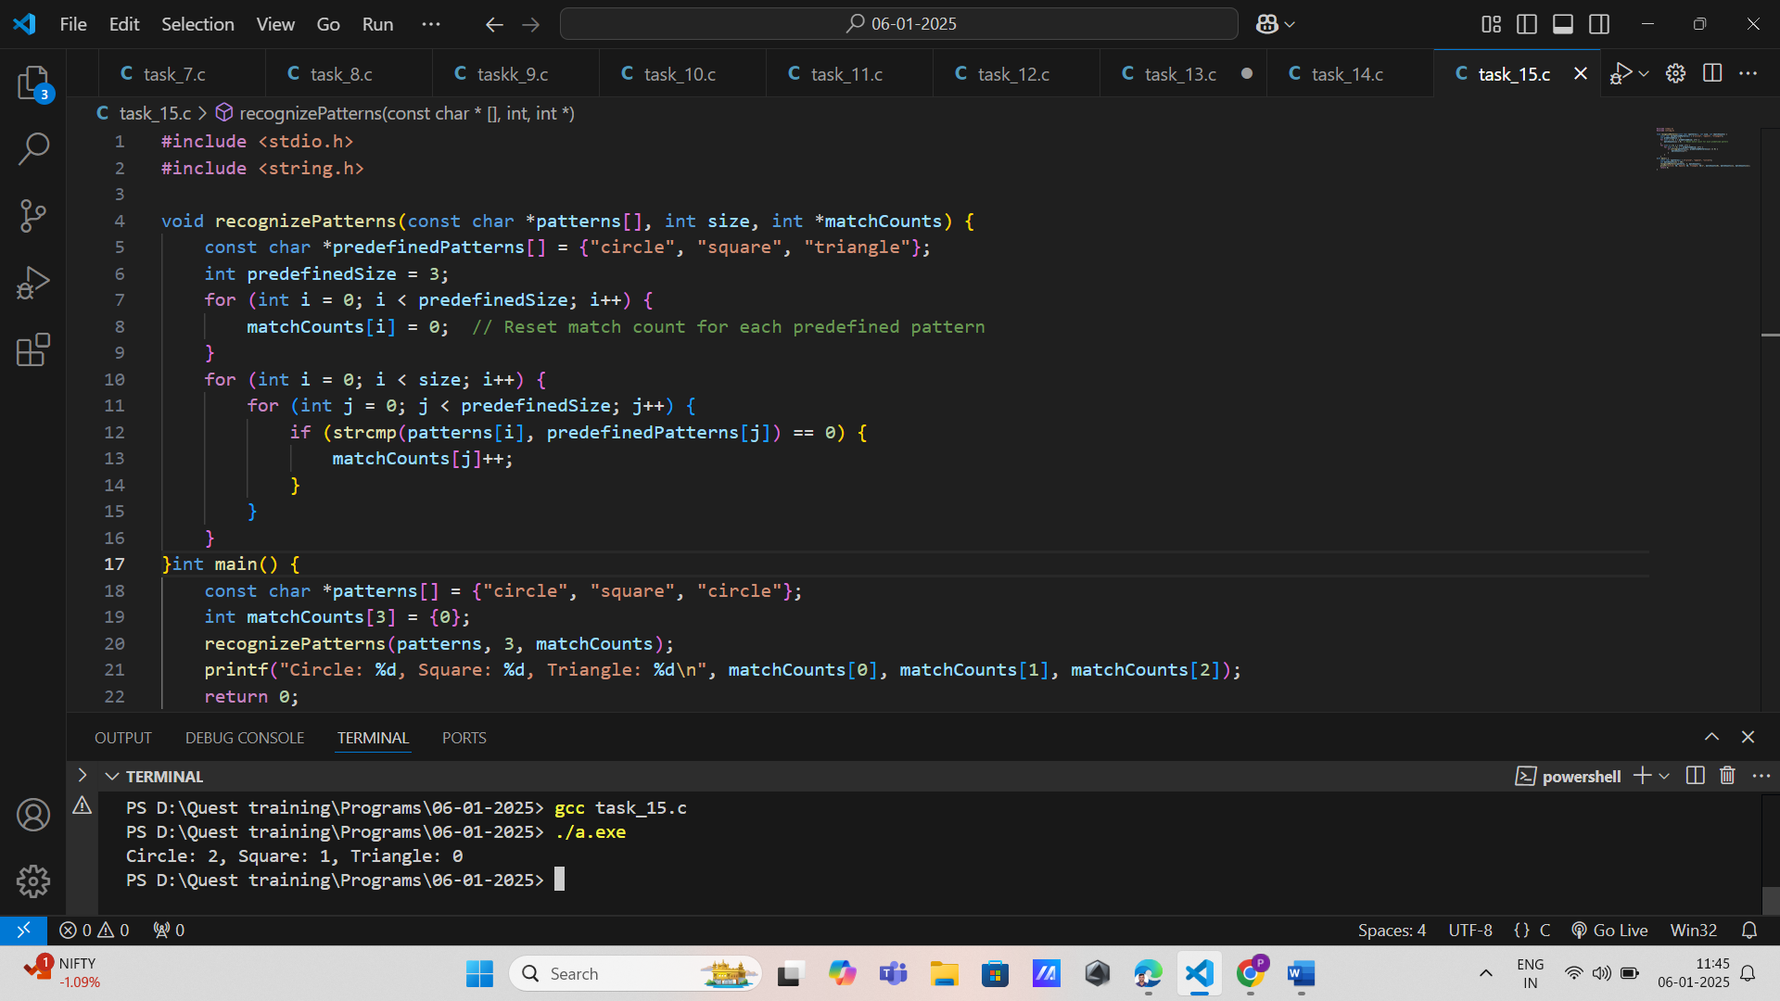

16. Climate Data Analyzer

Function Prototype: void analyzeClimateData(const double \*temperatureReadings, int size, double \*minTemp, double \*maxTemp)

Data Types: const double\*, int, double\*

Concepts: Decision-making, arrays, functions.

Details: Analyze climate data to find minimum and maximum temperatures, updating these values by reference.

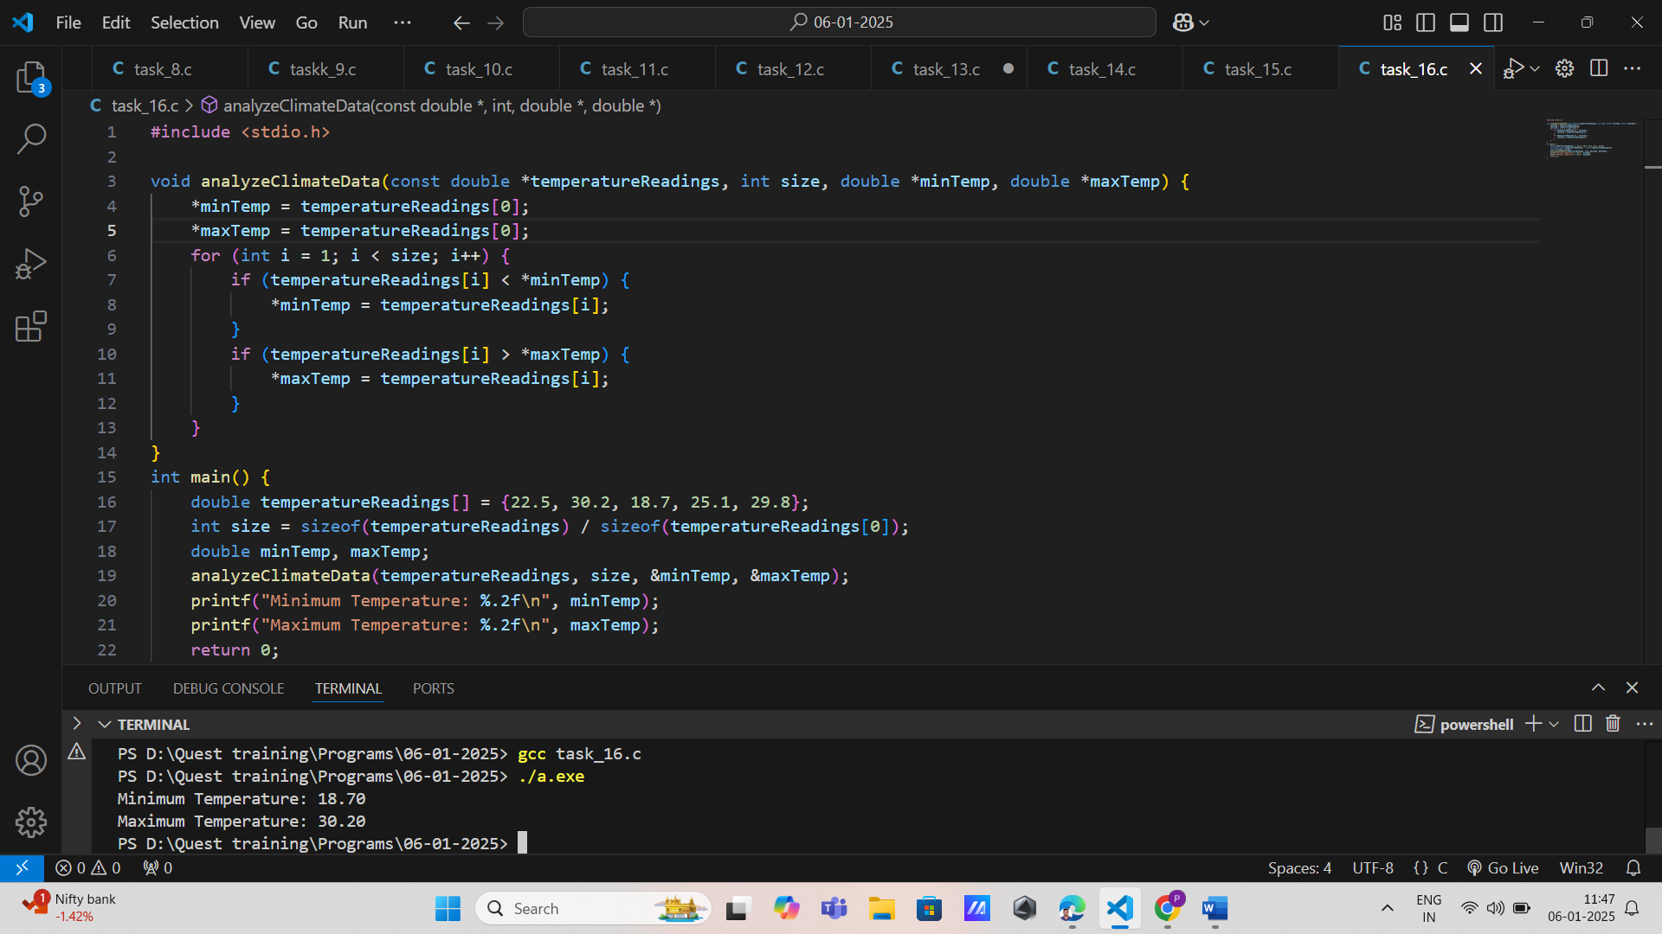

17. Quantum Data Processor

Function Prototype: void processQuantumData(const double \*measurements, int size, double \*processedData)

Data Types: const double\*, int, double\* Concepts: Arrays, functions, pointers, loops.

Details: Process quantum measurement data, updating the processed data array by reference.

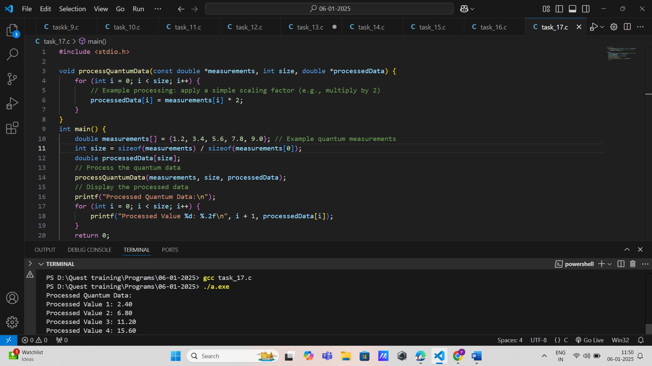

18. Scientific Data Visualization

Function Prototype: void visualizeData(const double \*data, int size, const char \*title)

Data Types: const double\*, int, const char\*

Concepts: Arrays, functions, strings.

Details: Visualize scientific data with a given title, using constant data for the title.

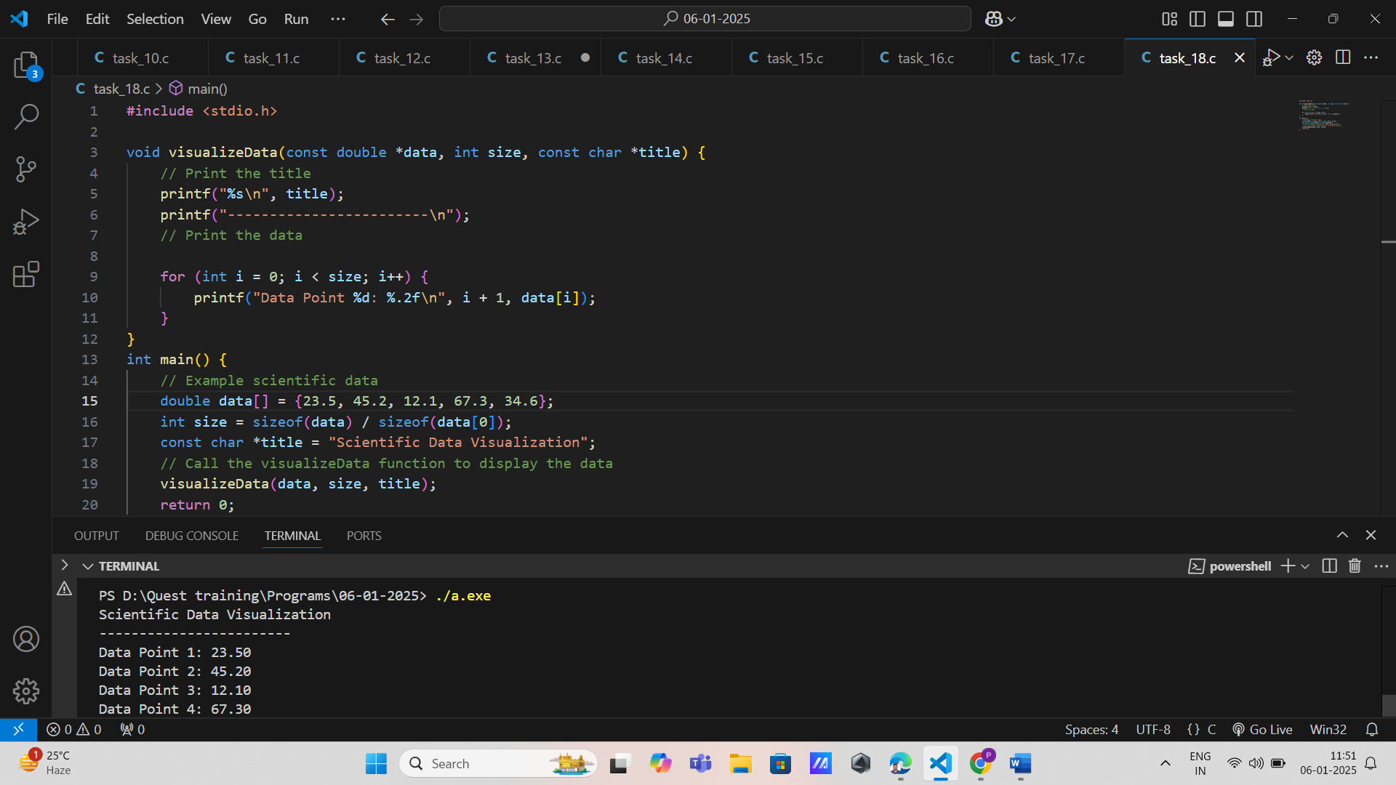

19. Genetic Data Simulator

Function Prototype: double\* simulateGeneticData(const double \*initialData, int size, double mutationRate)

Data Types: const double\*, int, double Concepts: Arrays, functions returning pointers, loops.

Details: Simulate genetic data evolution by applying a mutation rate, returning a pointer to the simulated data.

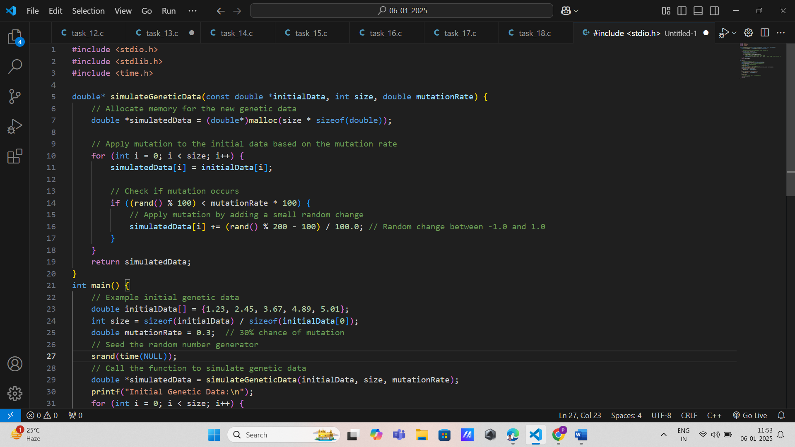

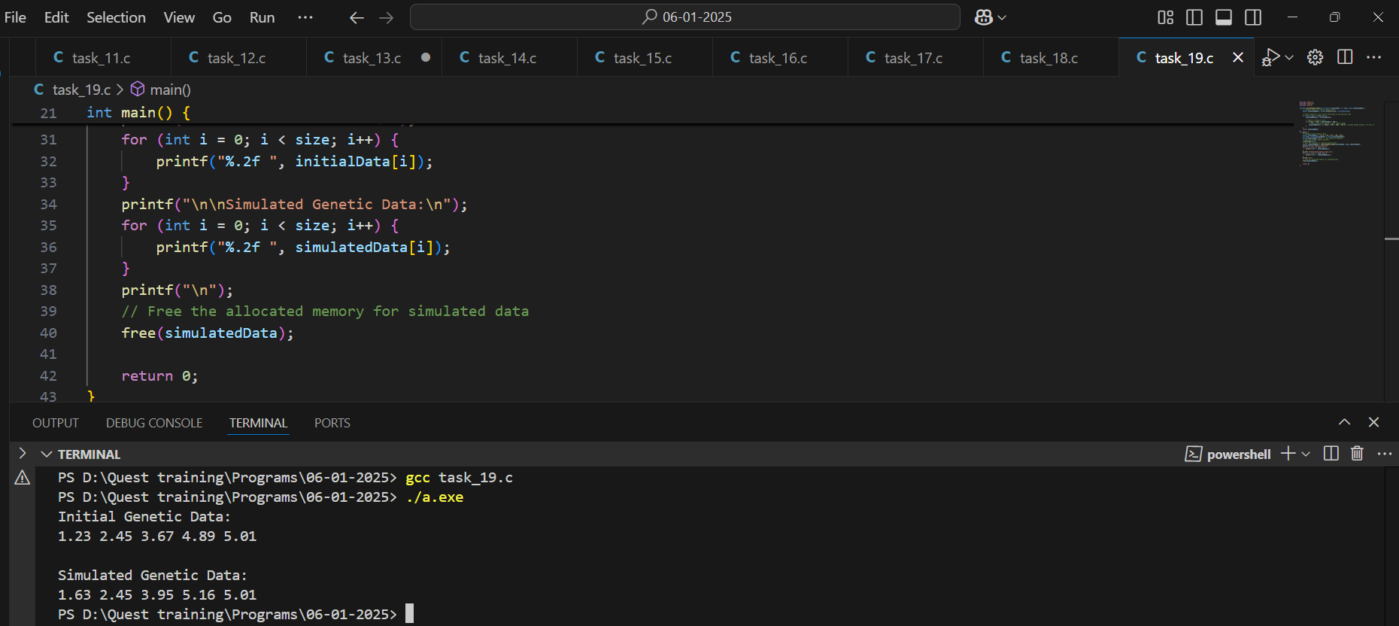

20. AI Performance Tracker

Function Prototype: void trackPerformance(const double \*performanceData, int size, double \*maxPerformance, double \*minPerformance)

Data Types: const double\*, int, double\* Concepts: Arrays, functions, pointers.

Details: Track AI performance data, updating maximum and minimum performance by reference.

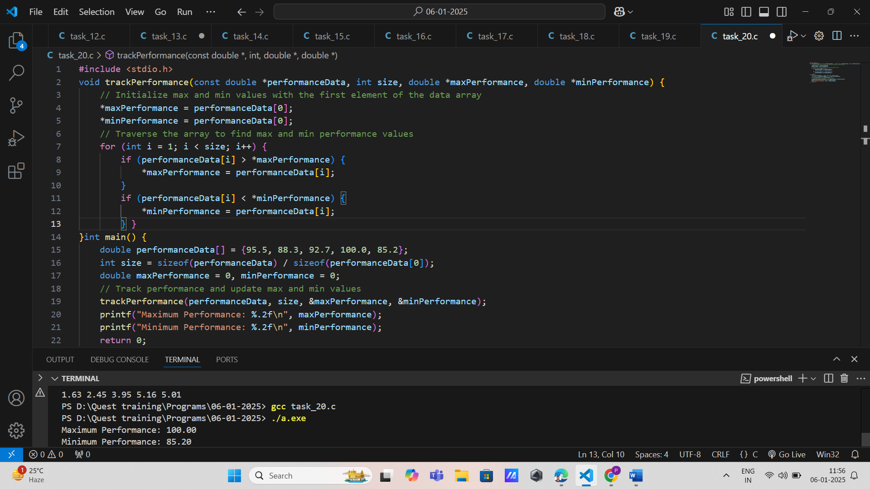

21. Sensor Data Filter

Function Prototype: void filterSensorData(const double \*sensorData, double \*filteredData, int size, double filterThreshold)

Data Types: const double\*, double\*, int, double Concepts: Arrays, functions, decision-making.

Details: Filter sensor data based on a threshold, updating the filtered data array by reference.

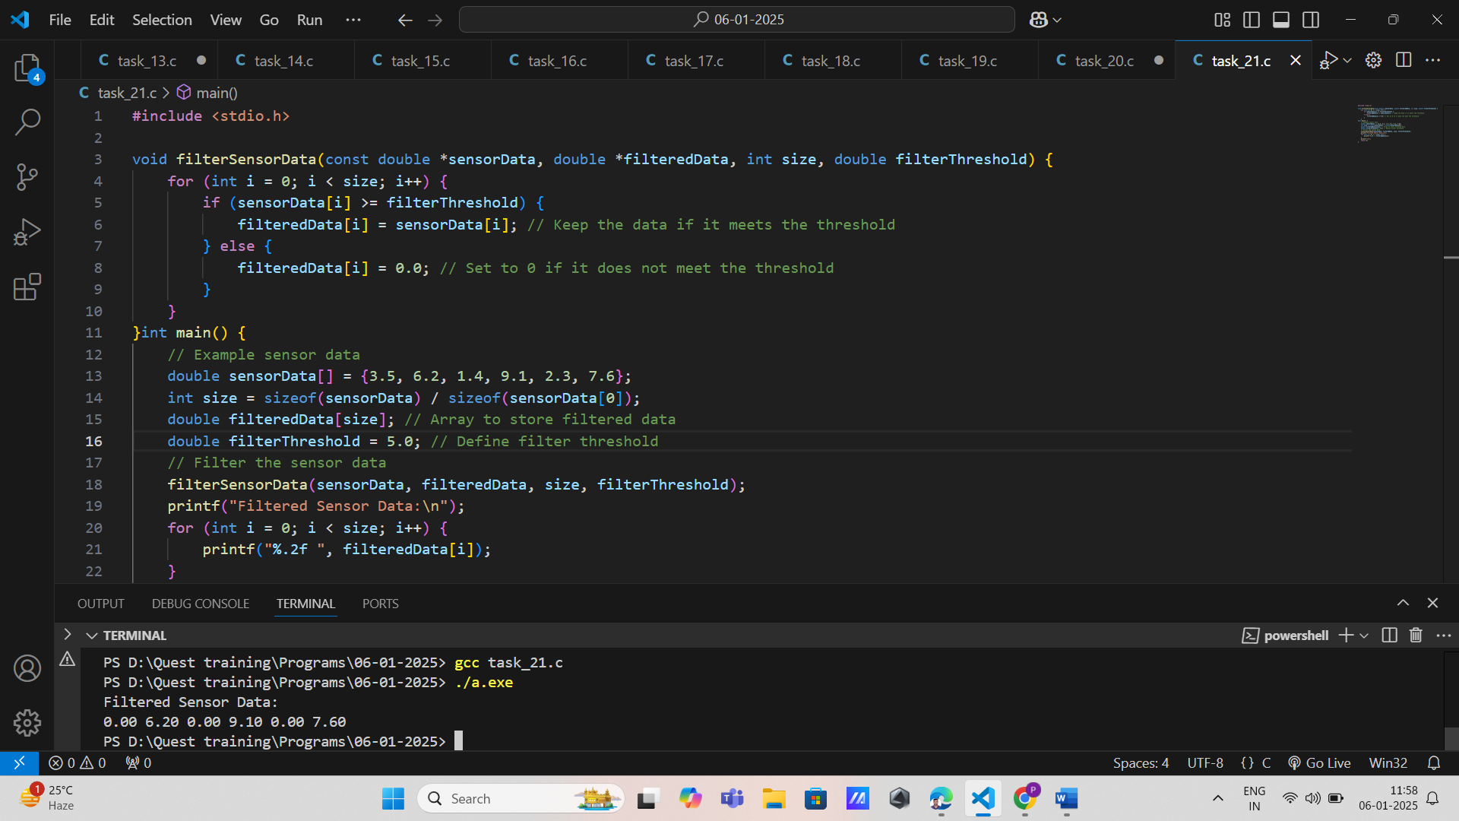

22. Logistics Data Planner

Function Prototype: void planLogistics(const double \*resourceLevels, double \*logisticsPlan, int size)

Data Types: const double\*, double\*, int Concepts: Arrays, functions, pointers, loops.

Details: Plan logistics based on resource levels, updating the logistics plan array by reference.

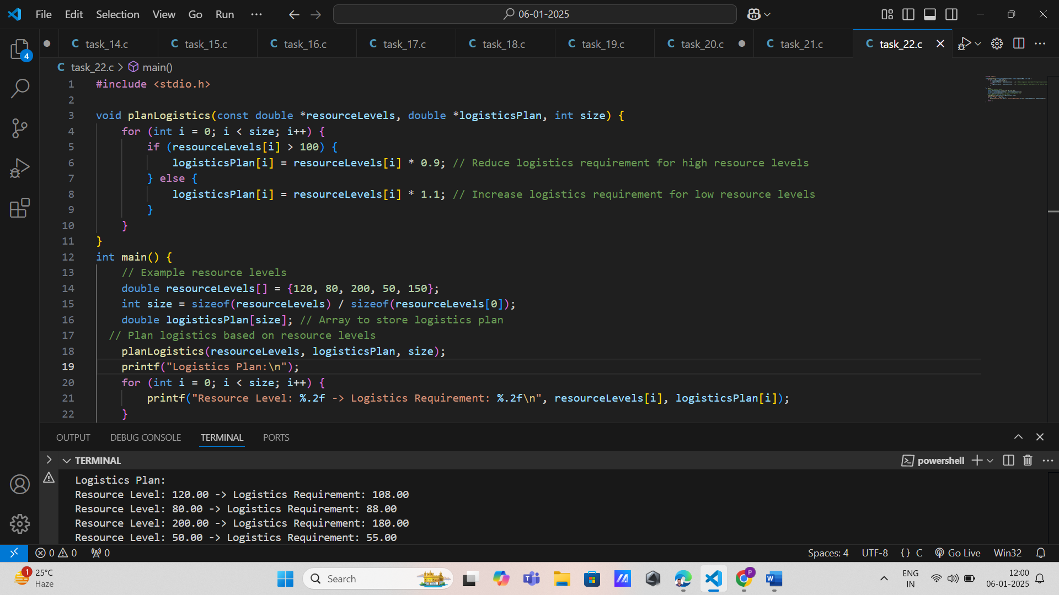

23. Satellite Image Processor

Function Prototype: void processSatelliteImage(const unsigned char \*imageData, unsigned char \*processedImage, int width, int height)

Data Types: const unsigned char\*, unsigned char\*, int Concepts: Arrays, functions, pointers, loops.

Details: Process satellite image data, updating the processed image by reference.

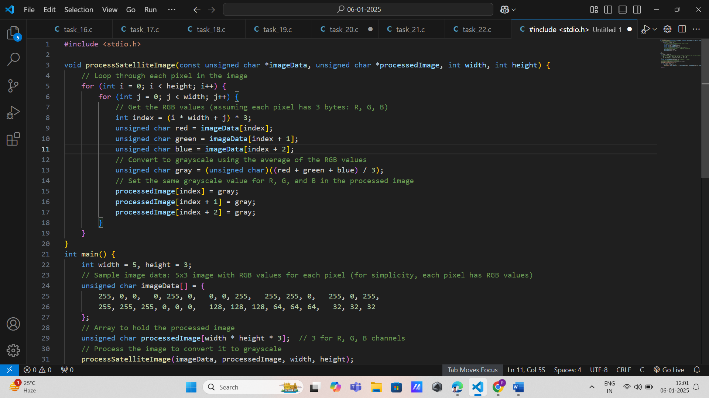

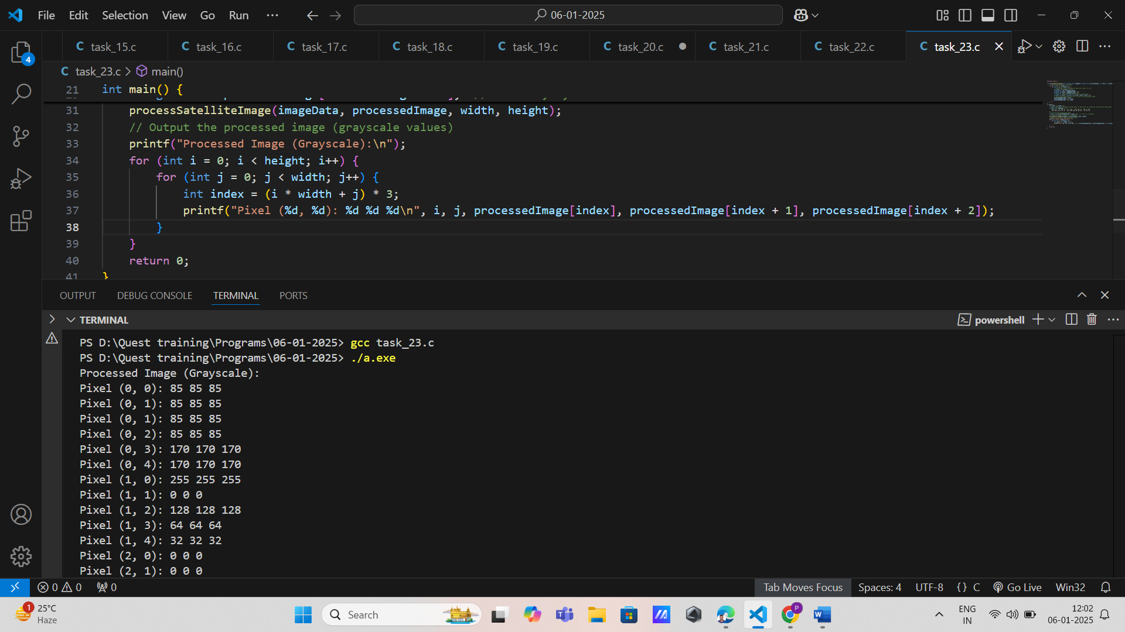

24. Flight Path Analyzer

Function Prototype: void analyzeFlightPath(const double \*pathCoordinates, double \*optimizedPath, int size)

Data Types: const double\*, double\*, int Concepts: Arrays, functions, pointers, loops.

Details: Analyze and optimize flight path coordinates, updating the optimized path by reference.

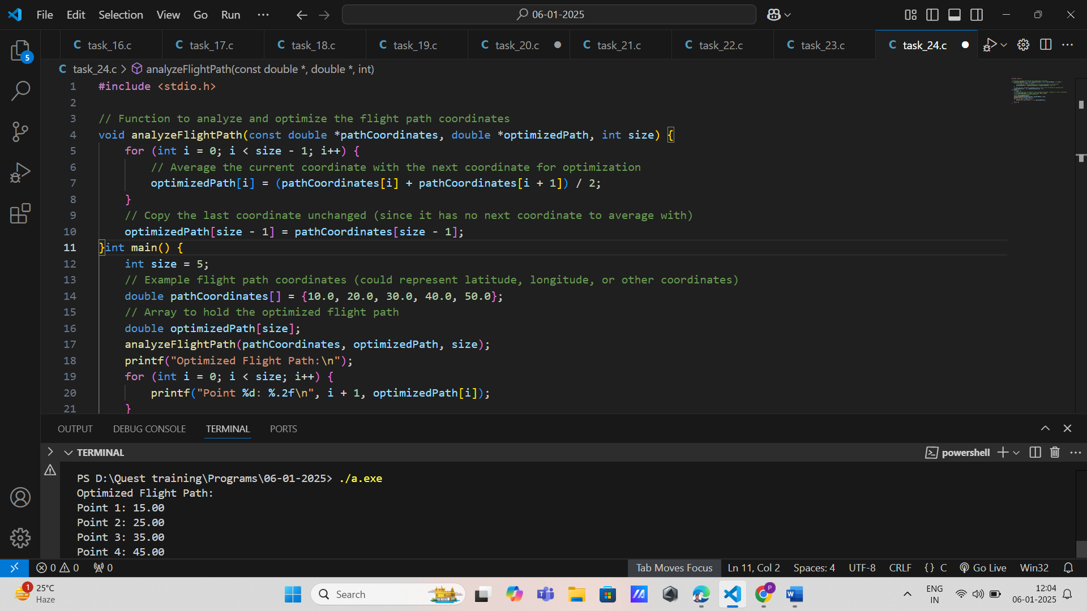25. AI Data Augmenter

Function Prototype: void augmentData(const double \*originalData, double \*augmentedData, int size, double augmentationFactor)

Data Types: const double\*, double\*, int, doubleConcepts: Arrays, functions, pointers, loops.

Details: Augment AI data by applying an augmentation factor, updating the augmented data array by reference.

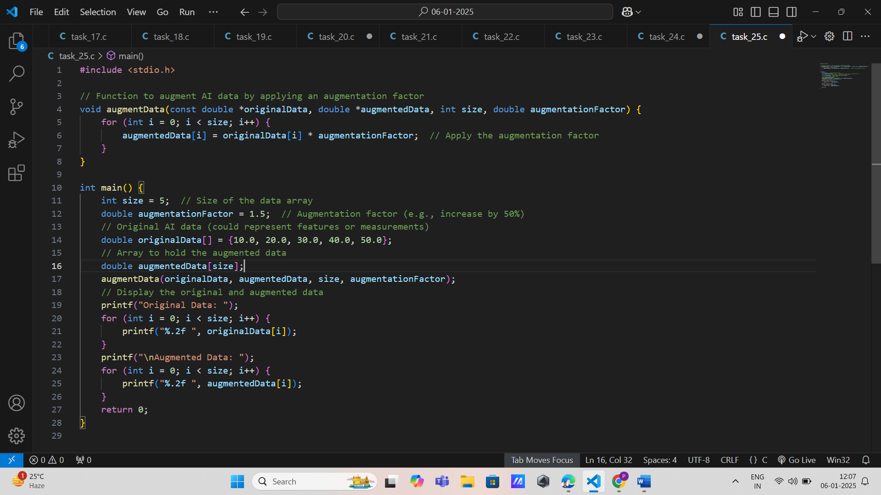

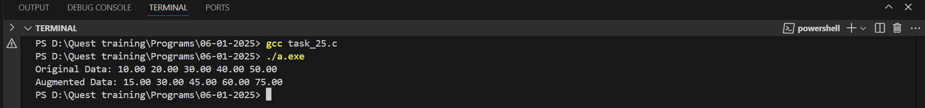

26. Medical Image Analyzer

Function Prototype: void analyzeMedicalImage(const unsigned char \*imageData, unsigned char \*analysisResults, int width, int height)

Data Types: const unsigned char\*, unsigned char\*, int Concepts: Arrays, functions, pointers, loops.

Details: Analyze medical image data, updating analysis results by reference.

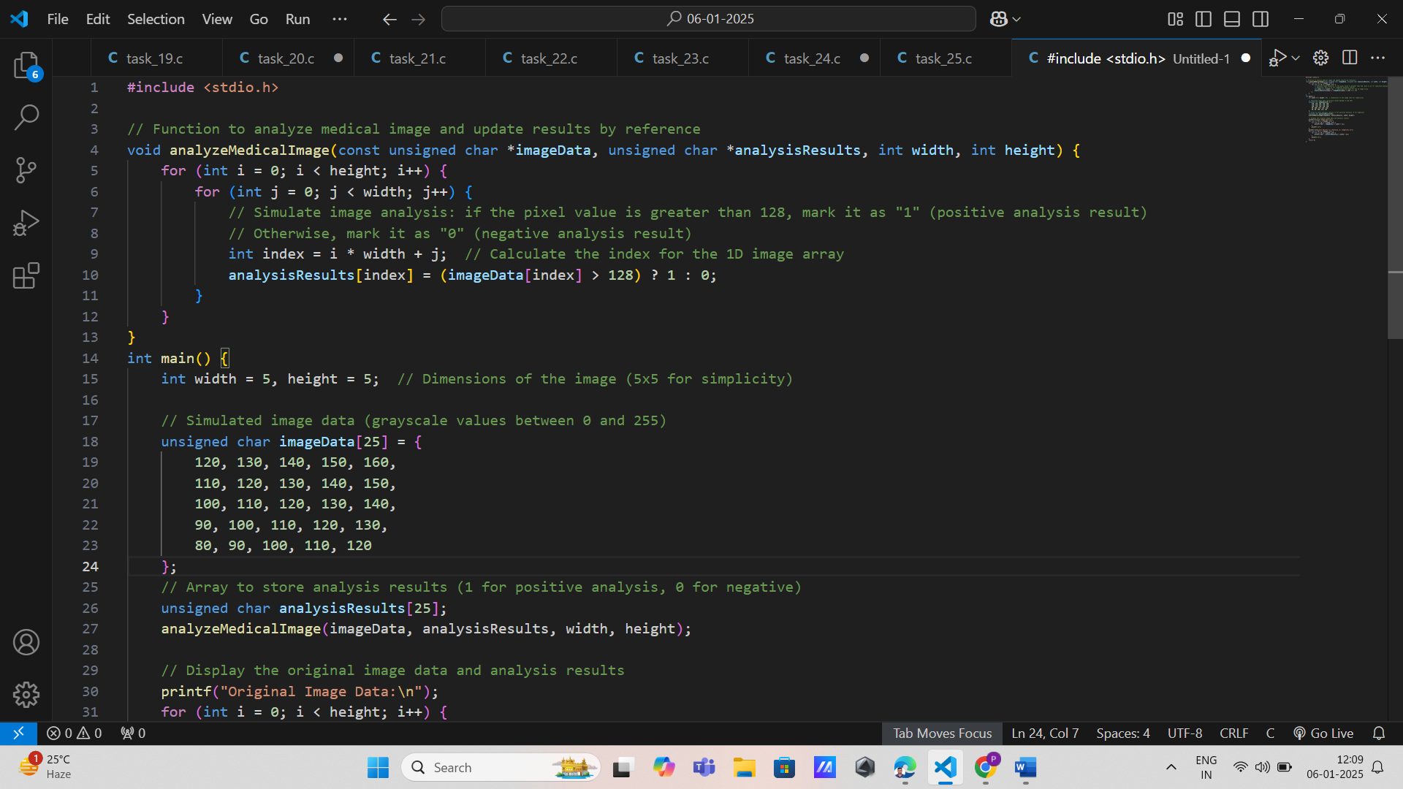

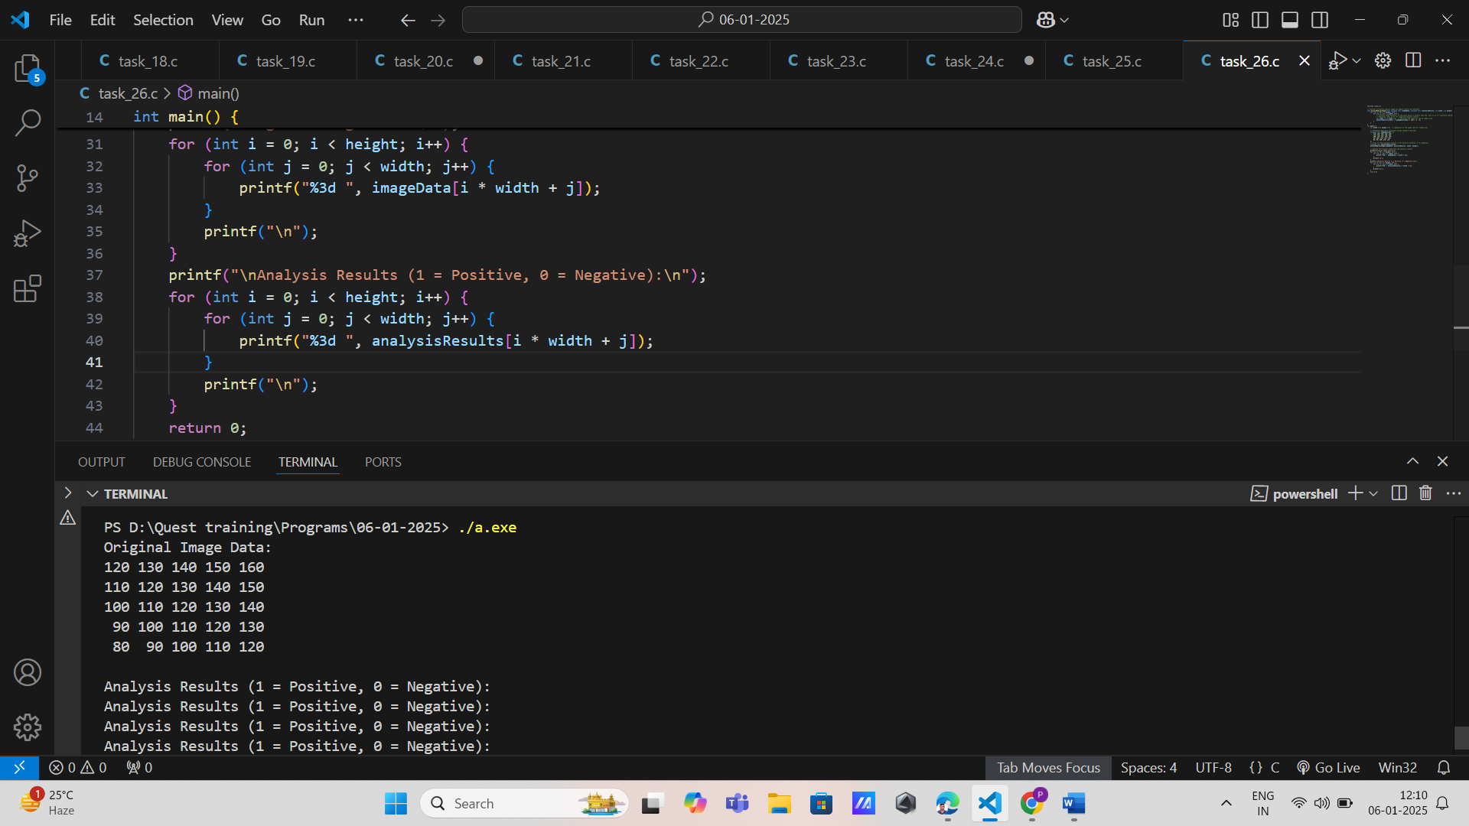

27. Object Tracking System

Function Prototype: void trackObjects(const double \*objectData, double \*trackingResults, int size)

Data Types: const double\*, double\*, int Concepts: Arrays, functions, pointers, loops.

Details: Track objects based on data, updating tracking results by reference.

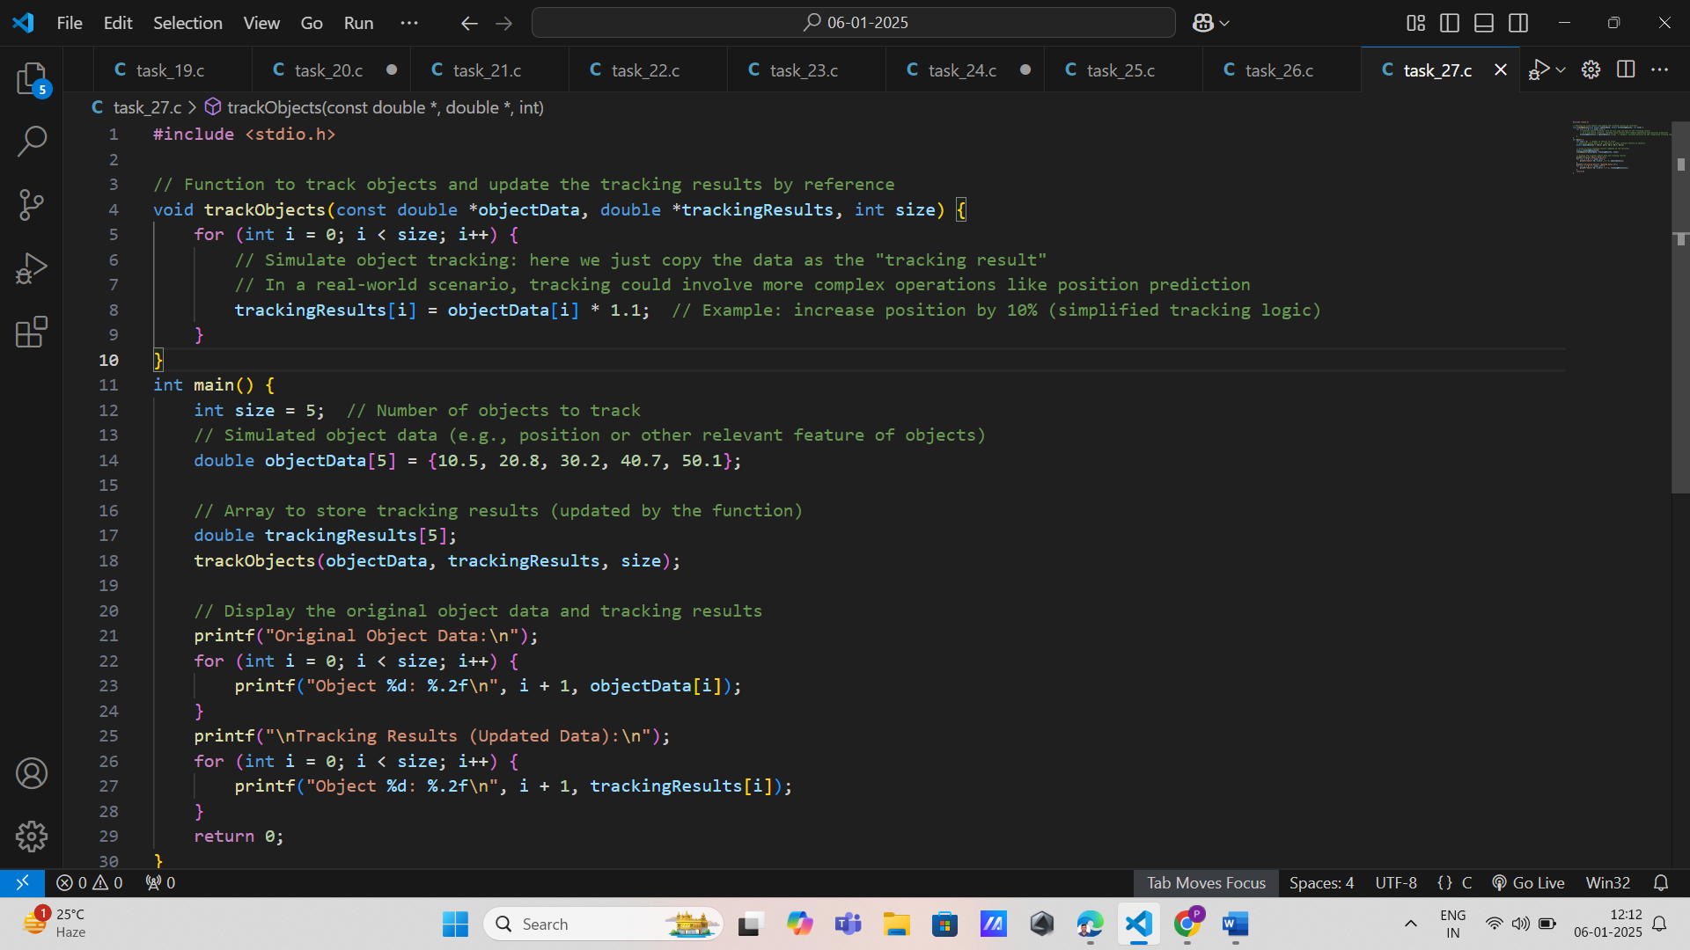

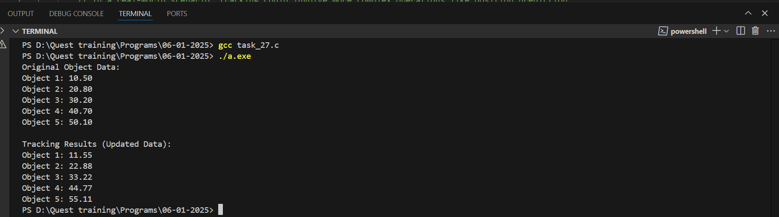

28. Defense Strategy Optimizer

Function Prototype: void optimizeDefenseStrategy(const double \*threatLevels, double \*optimizedStrategies, int size)

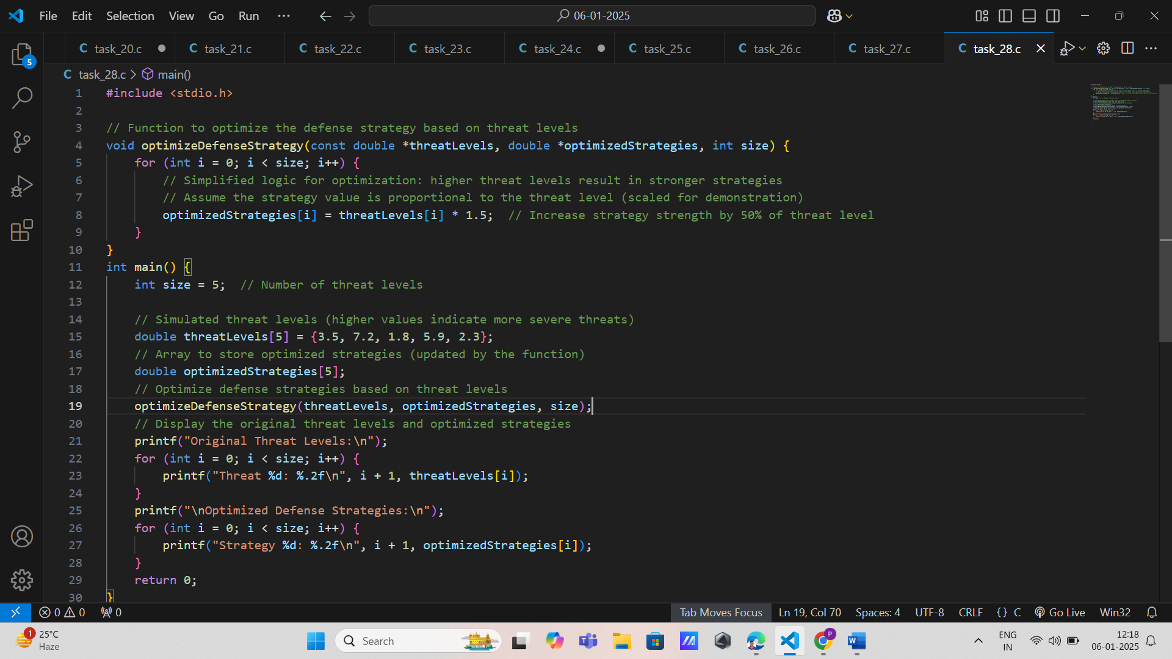

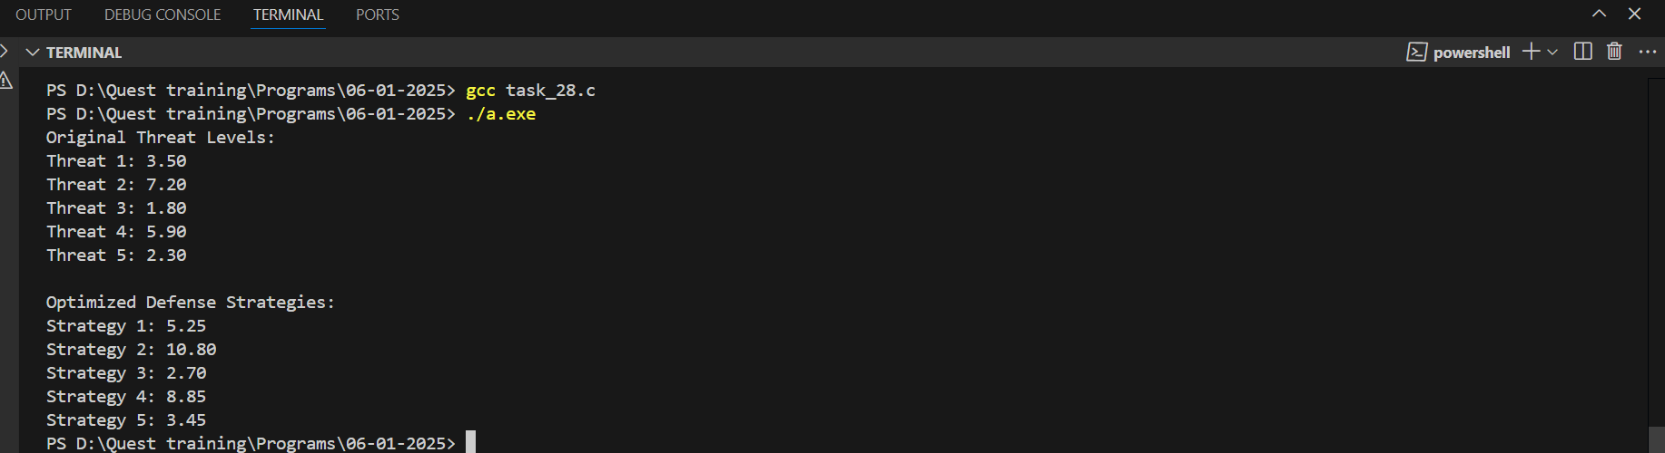

29. Computer Vision

\* Image Filter Application

\* Function Prototype: void applyFilter(const unsigned char \*image, unsigned char \*filteredImage, int width, int height)

\* Data Types: const unsigned char\*, unsigned char\*, int Concepts: Arrays, pointers, functions.

\* Details: Apply a filter to an image, modifying the filtered image by reference.

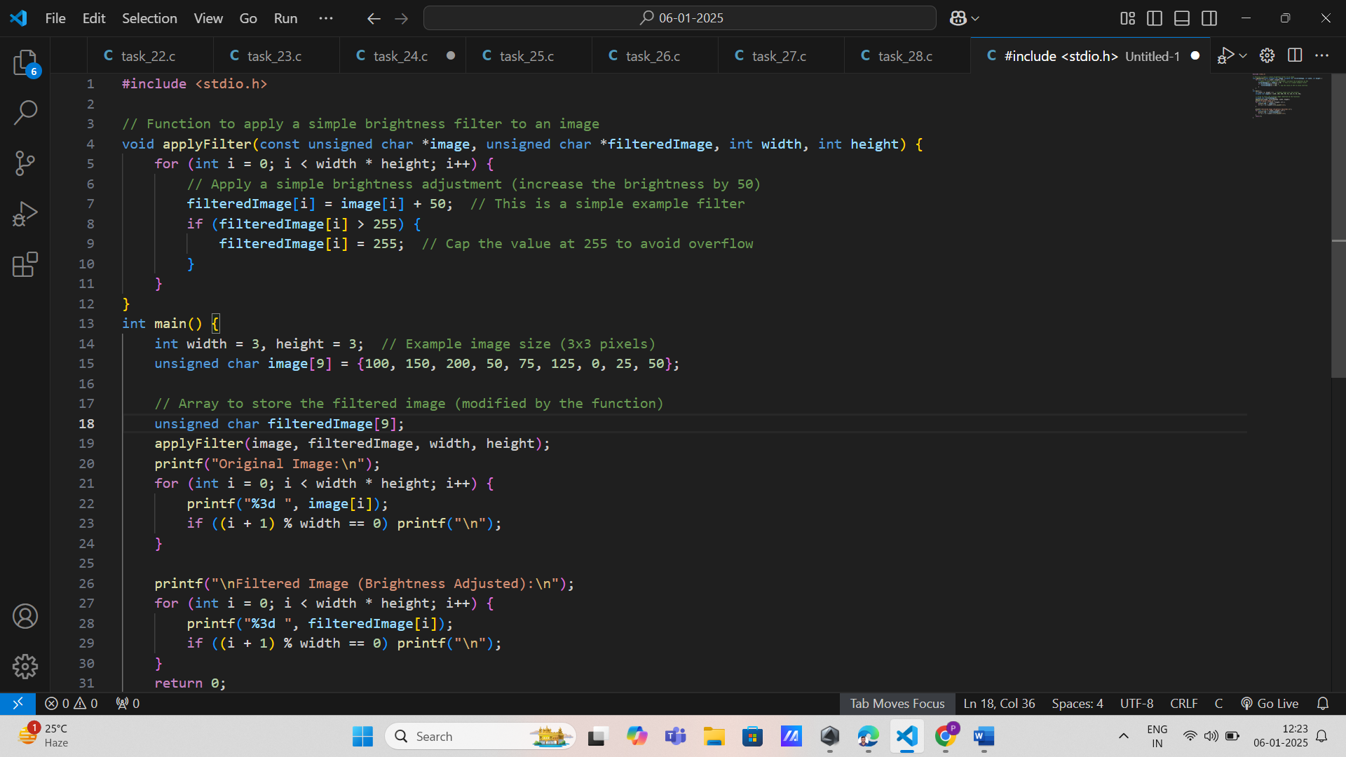

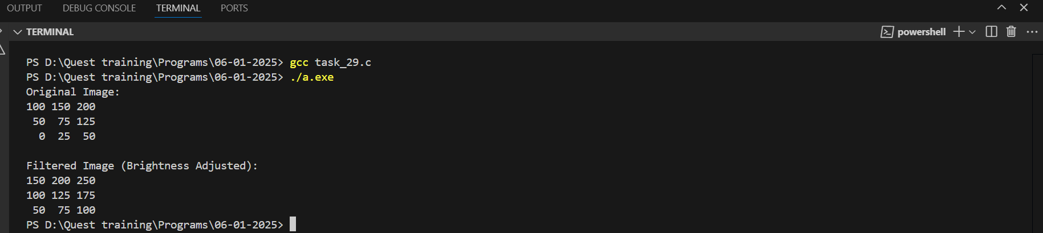

1. string Length Calculation

Requirement: Write a program that takes a string input and calculates its length using strlen(). The program should handle empty strings and output appropriate messages. Input: A string from the user. Output: Length of the string.

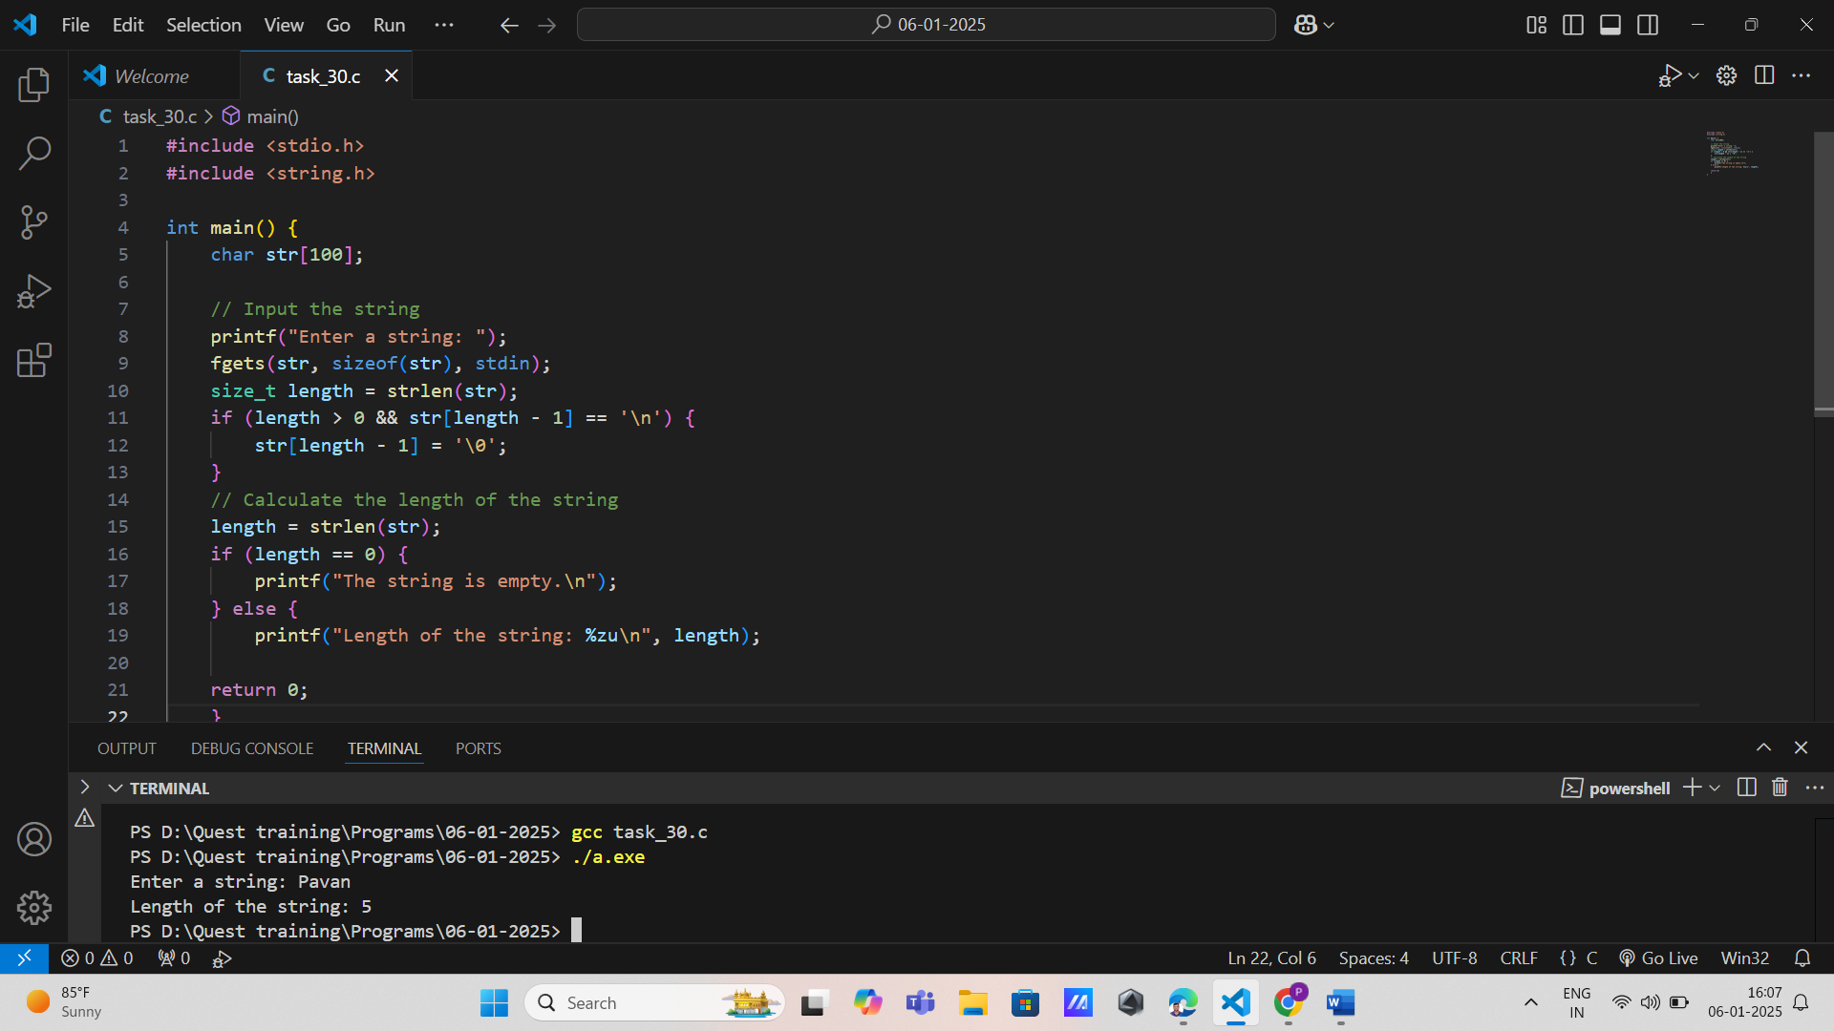

2. String Copy: Requirement: Implement a program that copies one string to another using strcpy(). The program should validate if the source string fits into the destination buffer.

Input: Two strings from the user (source and destination).

Output: The copied string.

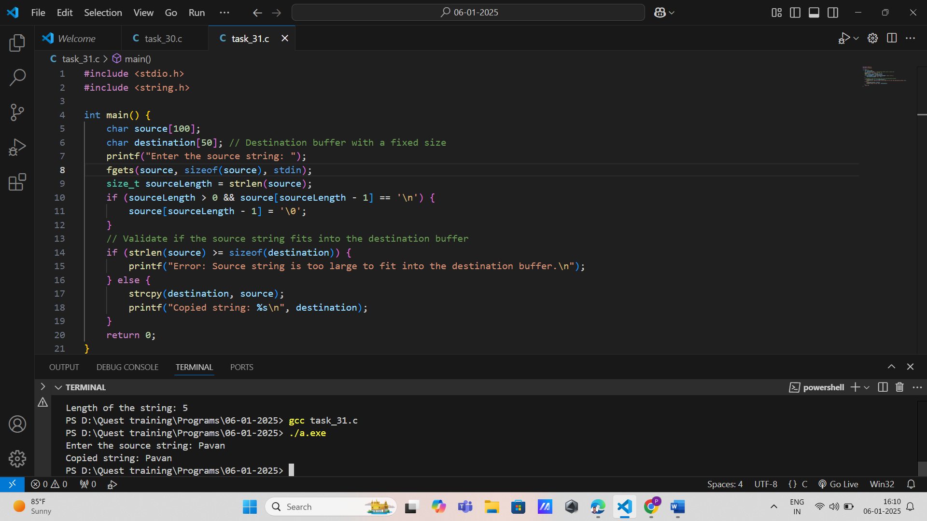

3. String Concatenation: Requirement: Create a program that concatenates two strings using strcat(). Ensure the destination string has enough space to hold the result.

Input: Two strings from the user.

Output: The concatenated string.

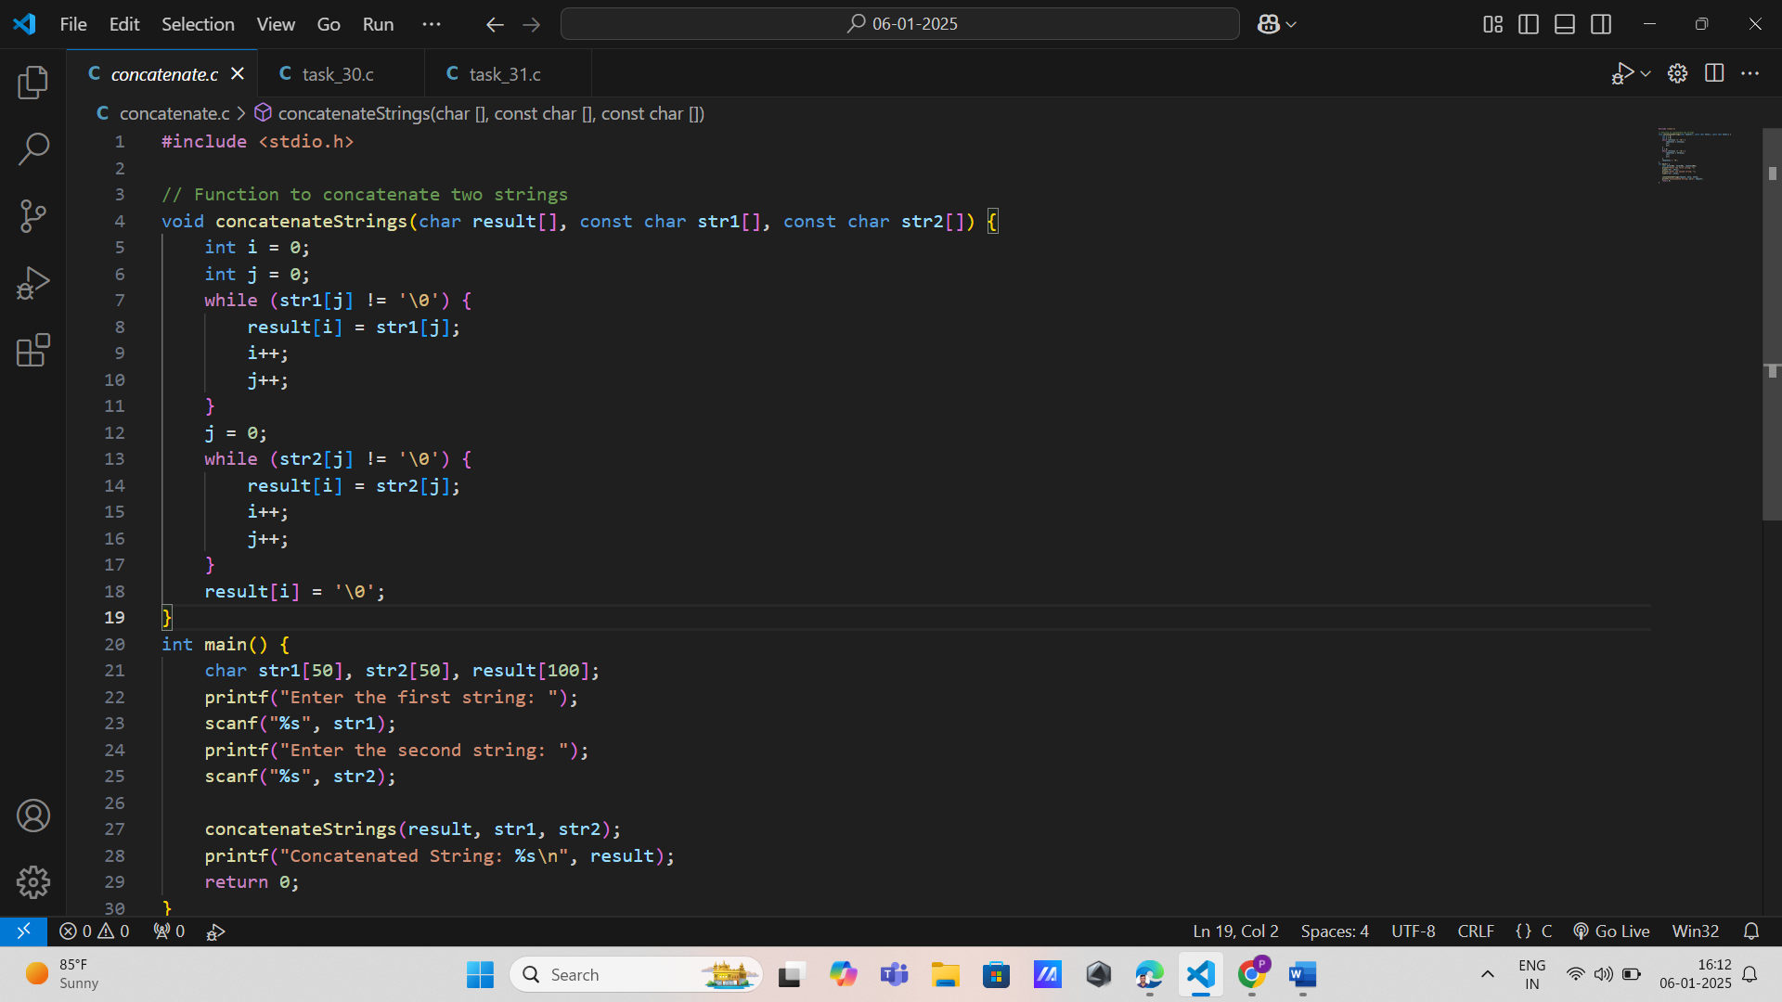

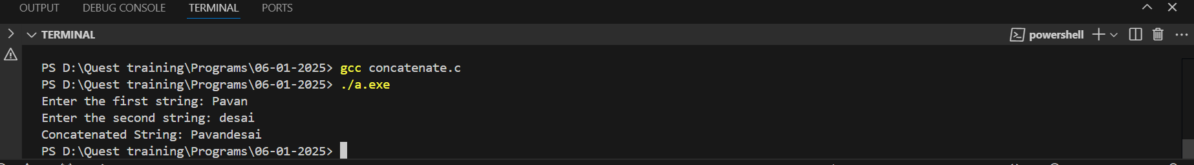

4. String Comparison: Requirement: Develop a program that compares two strings using strcmp(). It should indicate if they are equal or which one is greater.

Input: Two strings from the user.

Output: Comparison result.

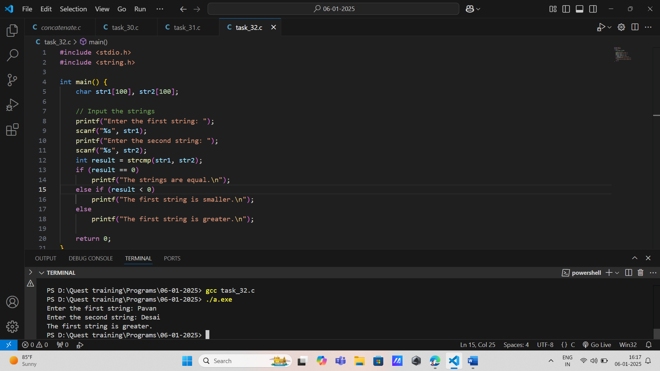

5. Convert to Uppercase: Requirement: Write a program that converts all characters in a string to uppercase using strupr().

Input: A string from the user.

Output: The uppercase version of the string.

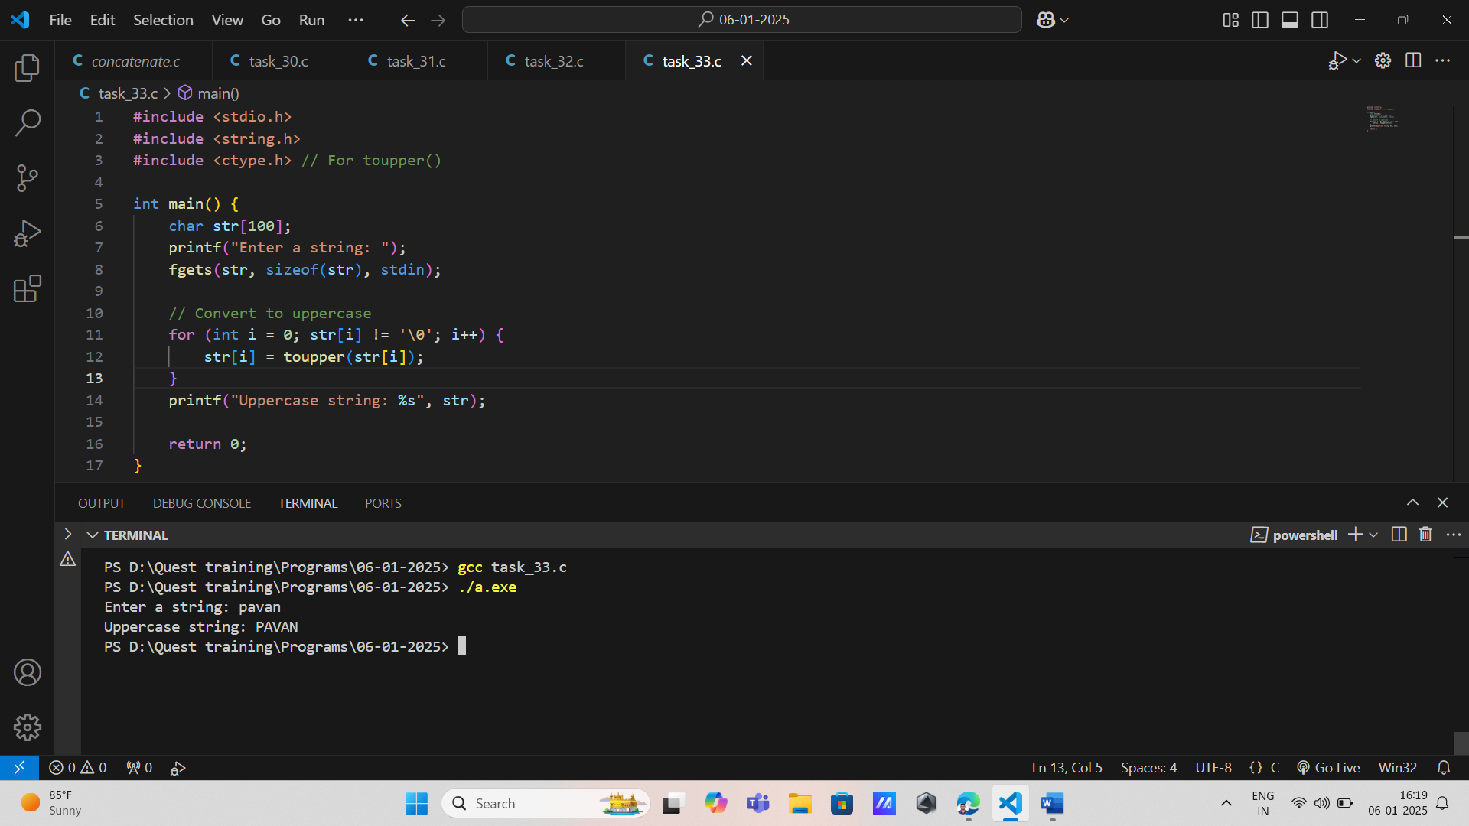

6. Convert to Lowercase: Requirement: Implement a program that converts all characters in a string to lowercase using strlwr().

Input: A string from the user.

Output: The lowercase version of the string.

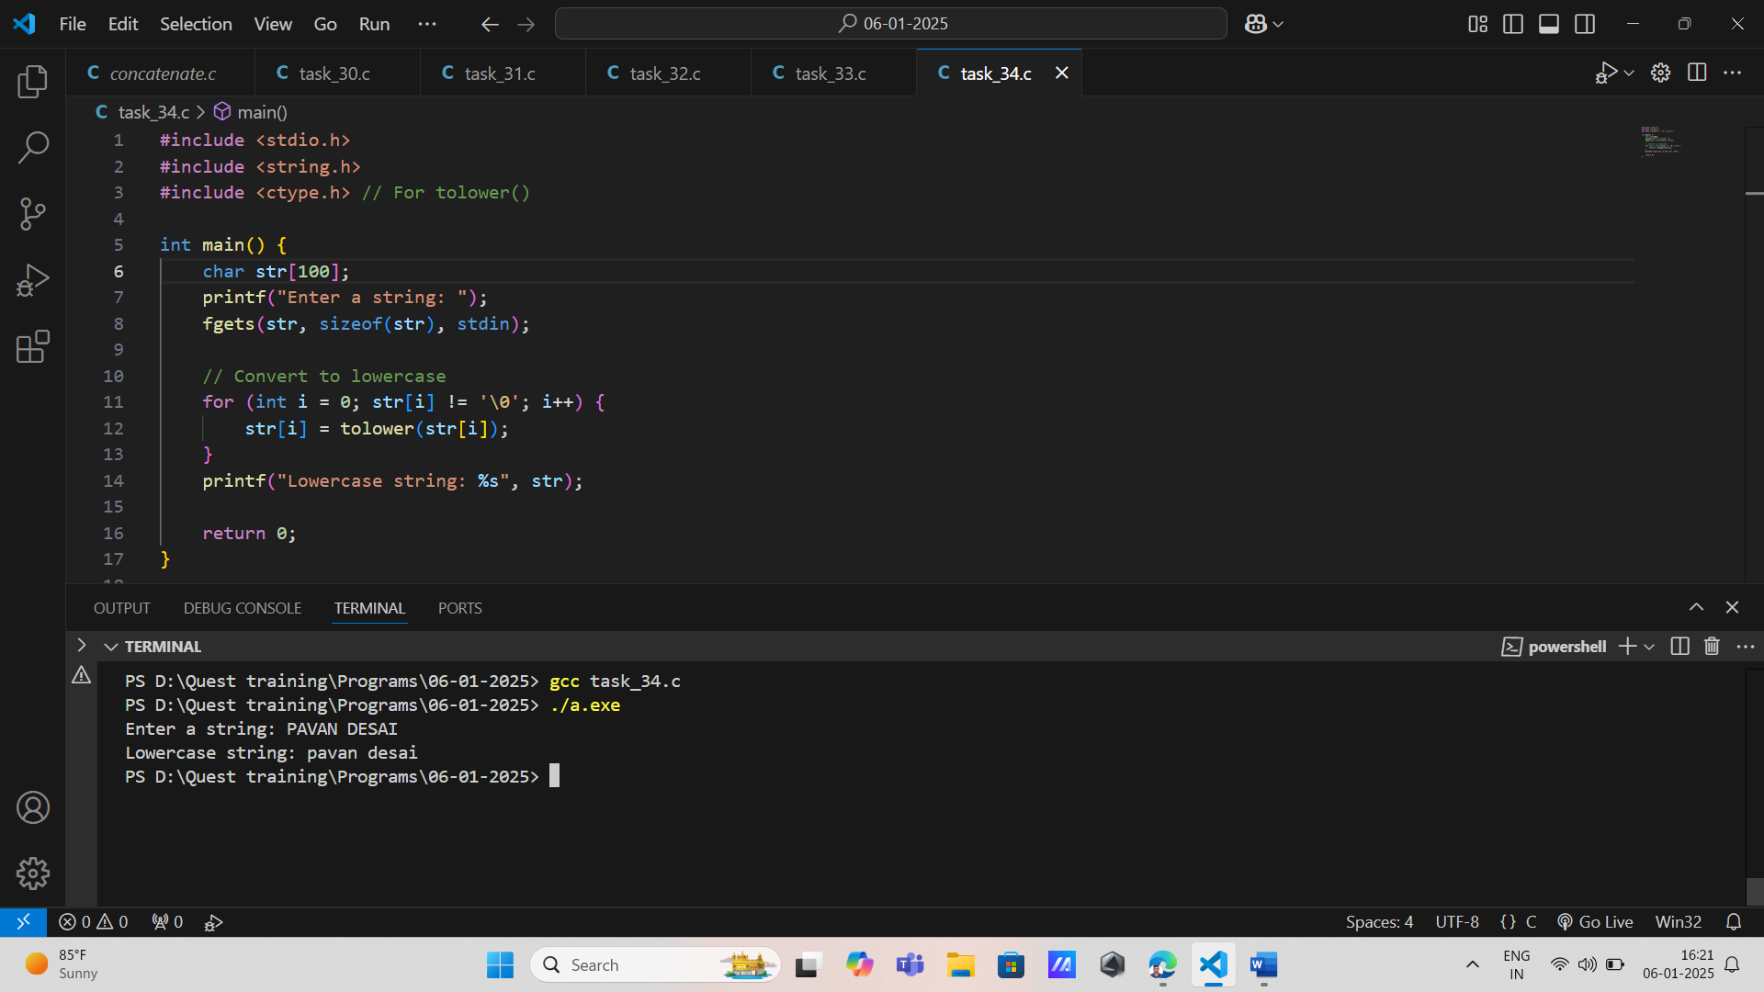

7. Substring Search: Requirement: Create a program that searches for a substring within a given string using strstr() and returns its starting index or an appropriate message if not found.

Input: A main string and a substring from the user.

Output: Starting index or not found message

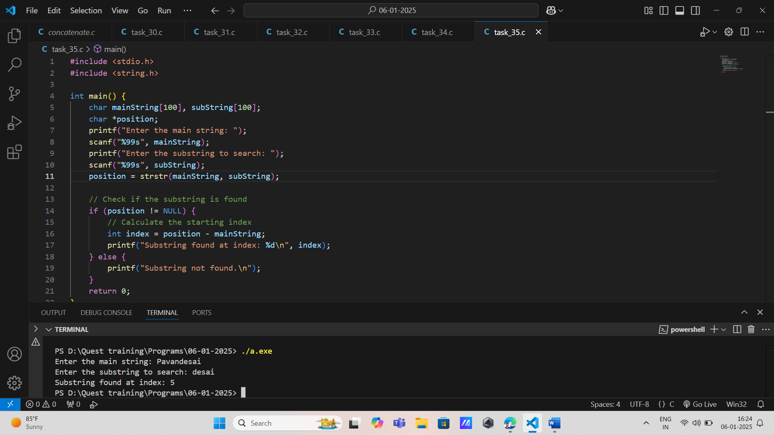

8. Character Search: Requirement: Write a program that finds the first occurrence of a character in a string using strchr() and returns its index or indicates if not found.

Input: A string and a character from the user.

Output: Index of first occurrence or not found message.

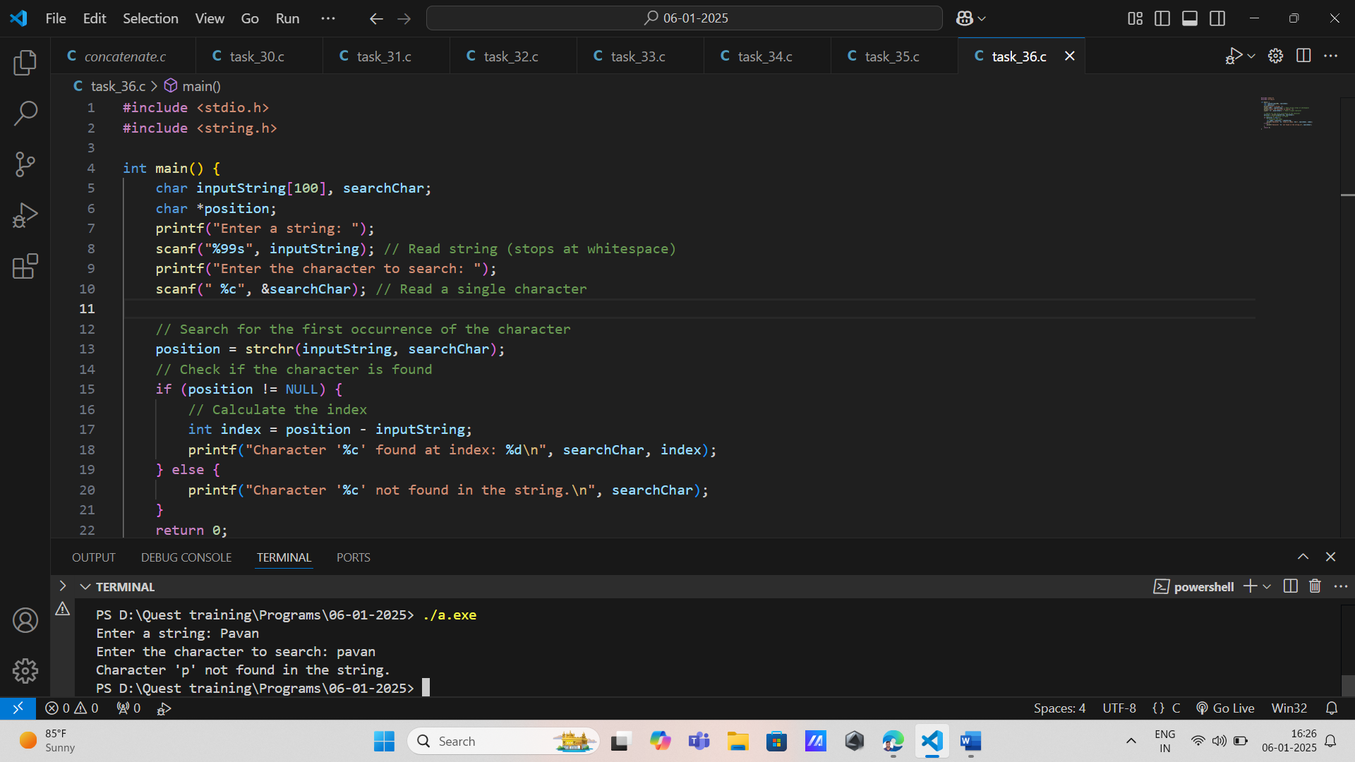

9. String Reversal: Requirement: Implement a function that reverses a given string in place without using additional memory, leveraging strlen() for length determination.

Input: A string from the user.

Output: The reversed string.

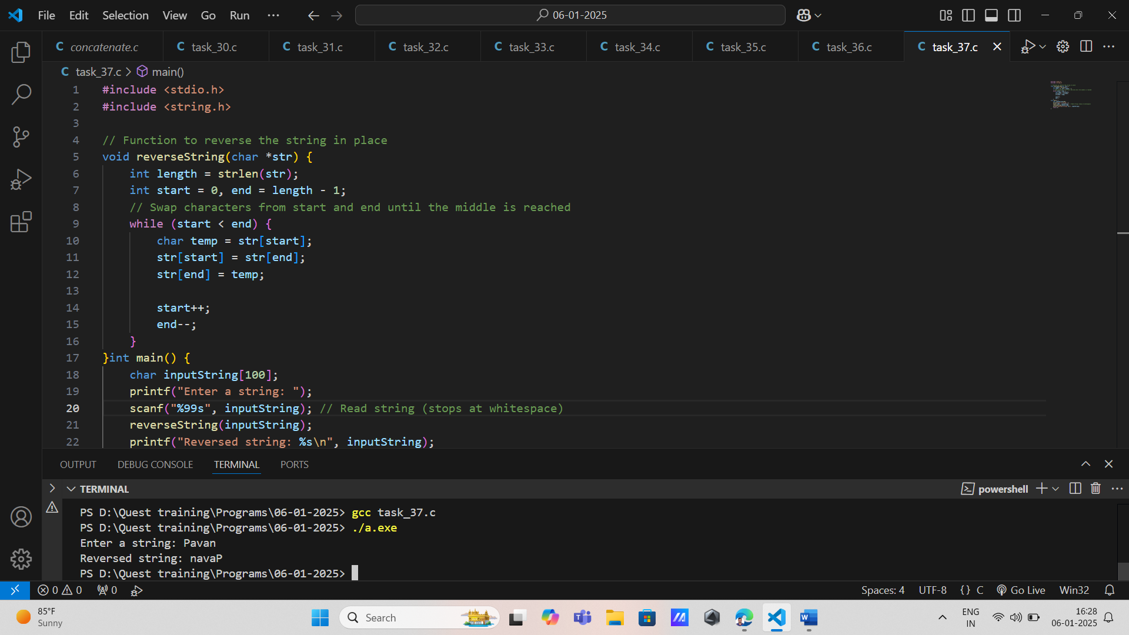

10. String Tokenization: Requirement: Create a program that tokenizes an input string into words using strtok() and counts how many tokens were found.

Input: A sentence from the user.

Output: Number of words (tokens).

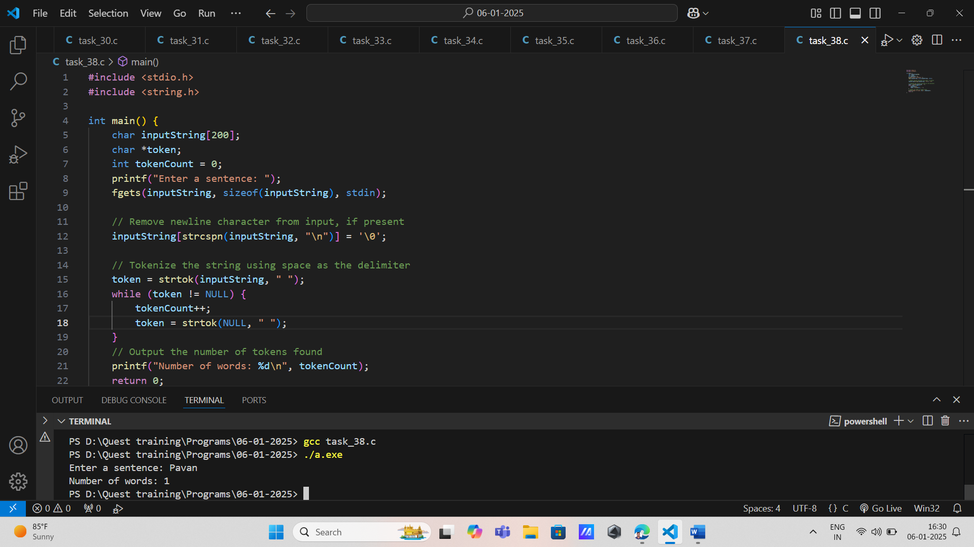

11. String Duplication: Requirement: Write a function that duplicates an input string (allocating new memory) using strdup() and displays both original and duplicated strings.

Input: A string from the user.

Output: Original and duplicated strings.

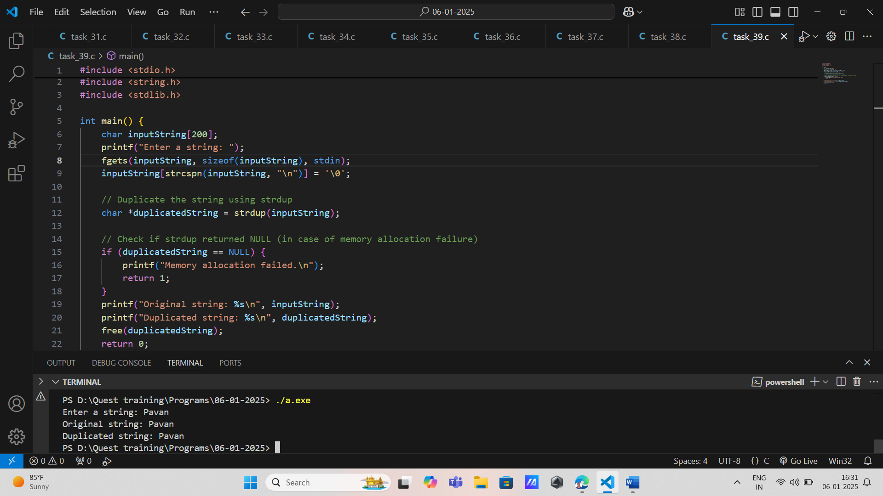

12. Case-Insensitive Comparison: Requirement: Develop a program to compare two strings without case sensitivity using strcasecmp() and report equality or differences.

Input: Two strings from the user.

Output: Comparison result.

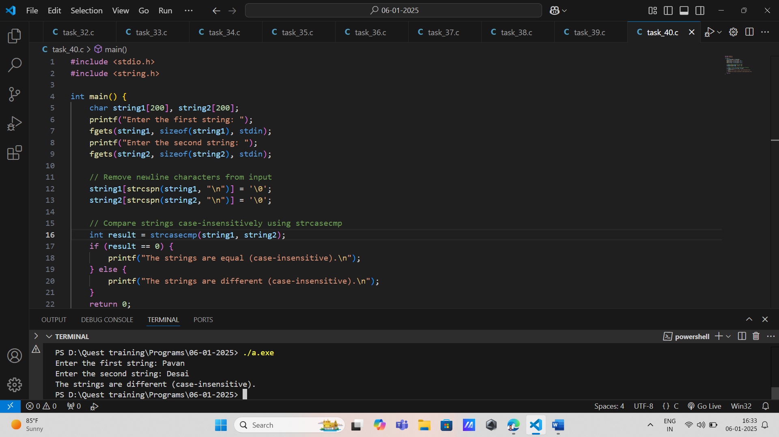

13. String Trimming: Requirement: Implement functionality to trim leading and trailing whitespace from a given string, utilizing pointer arithmetic with strlen().

Input: A string with extra spaces from the user.

Output: Trimmed version of the string.

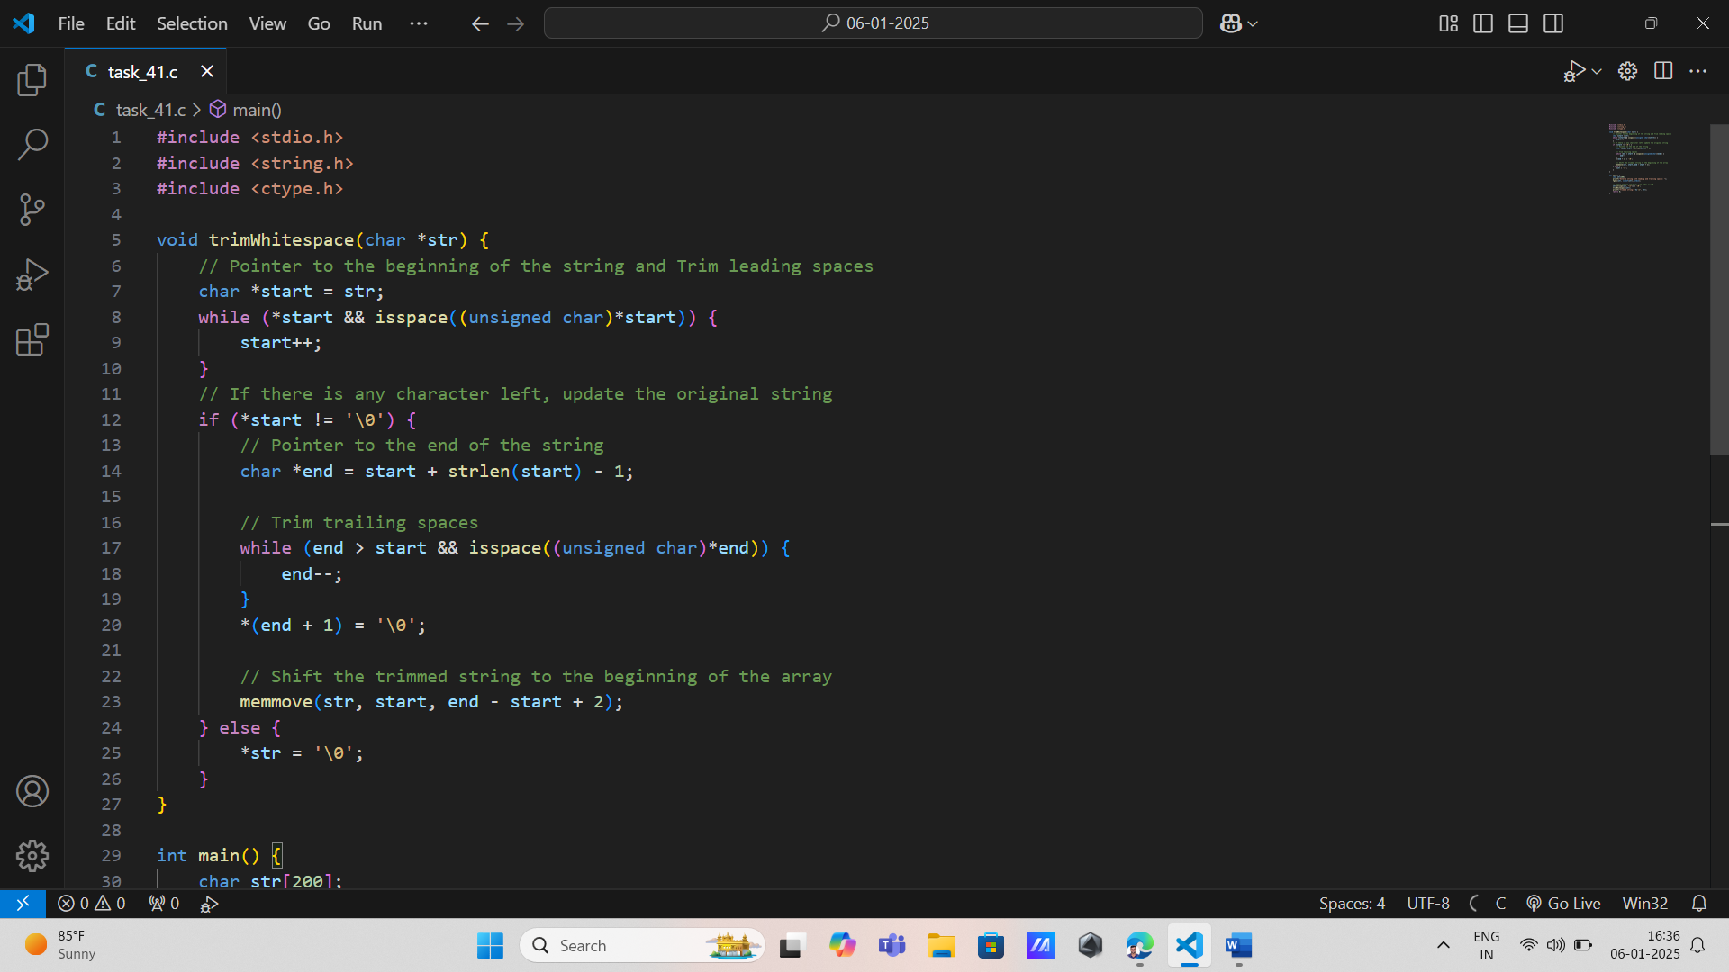

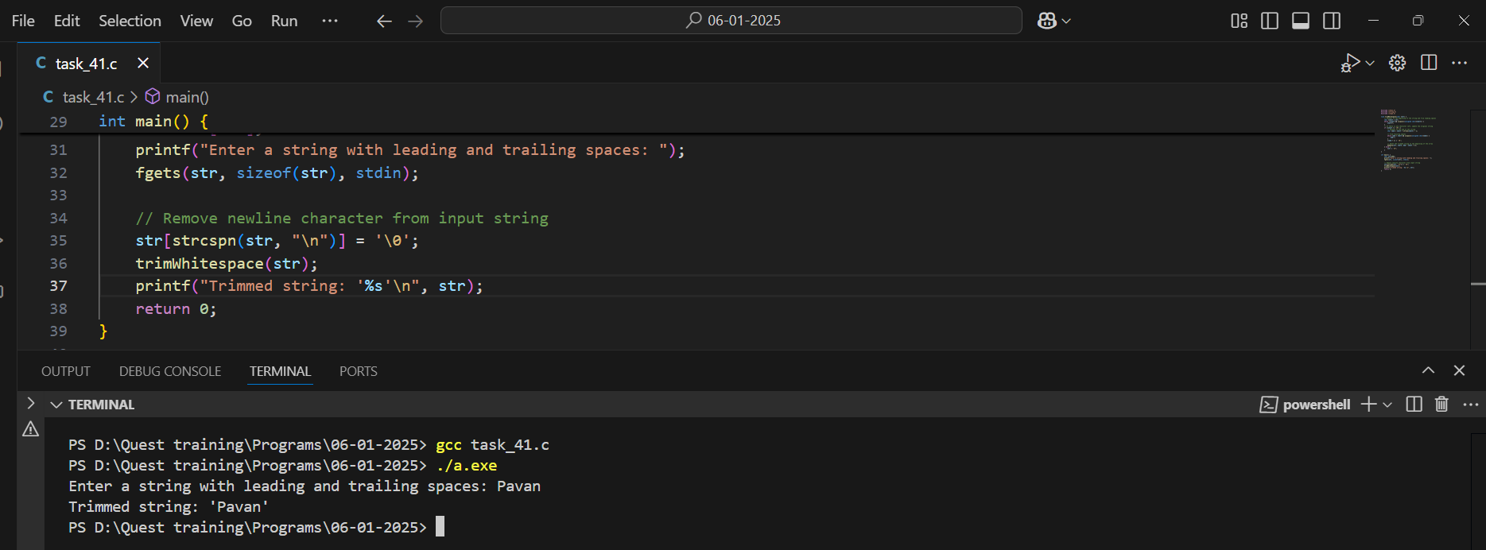

14. Find Last Occurrence of Character: Requirement: Write a program that finds the last occurrence of a character in a string using manual iteration instead of library functions, returning its index.

Input: A string and a character from the user.

Output: Index of last occurrence or not found message.

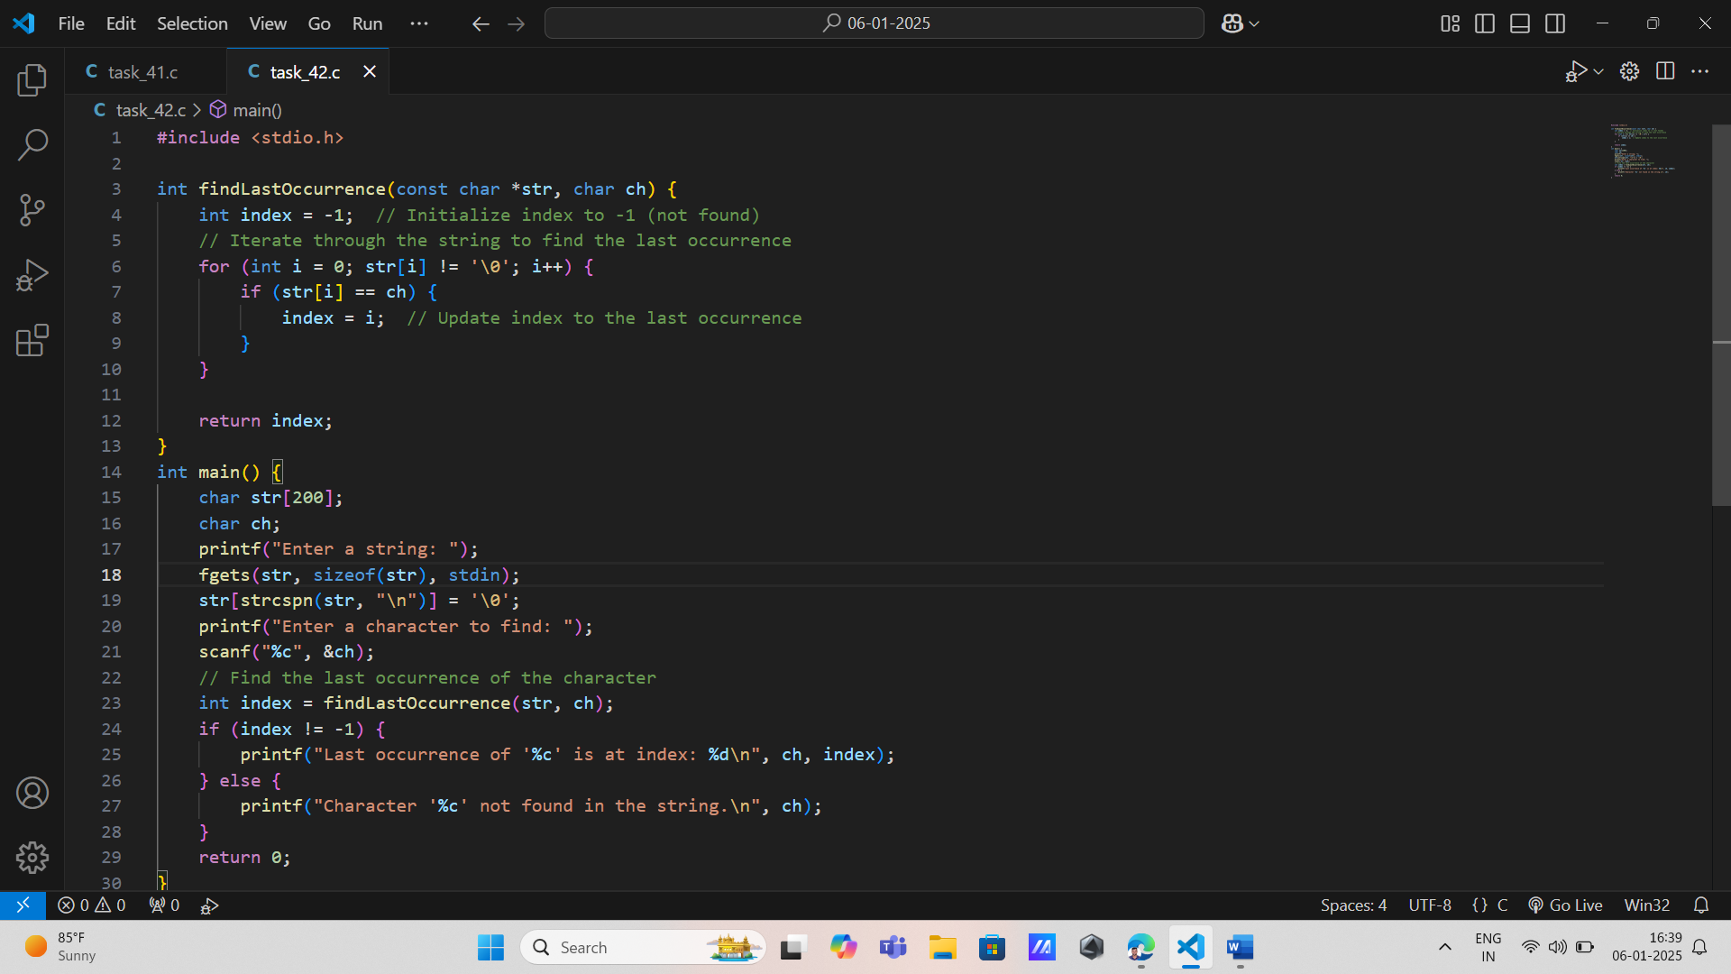

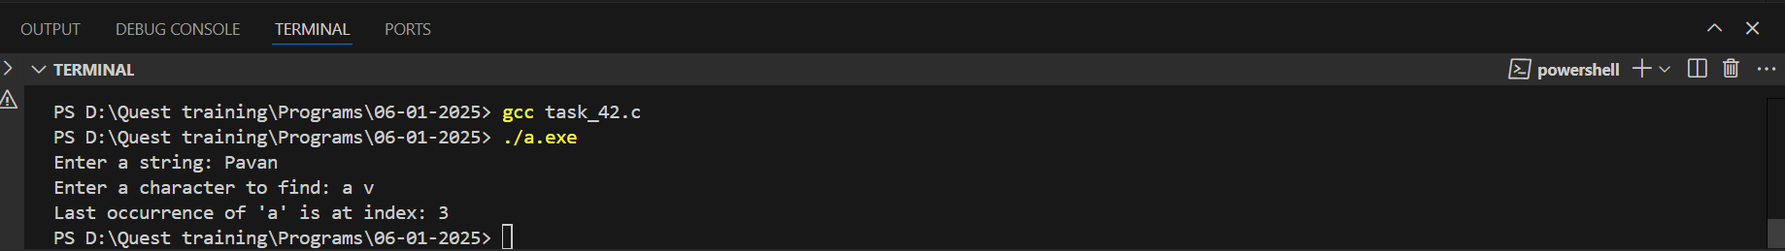

15. Count Vowels in String: Requirement: Create a program that counts how many vowels are present in an input string by iterating through each character.

Input: A string from the user.

Output: Count of vowels.

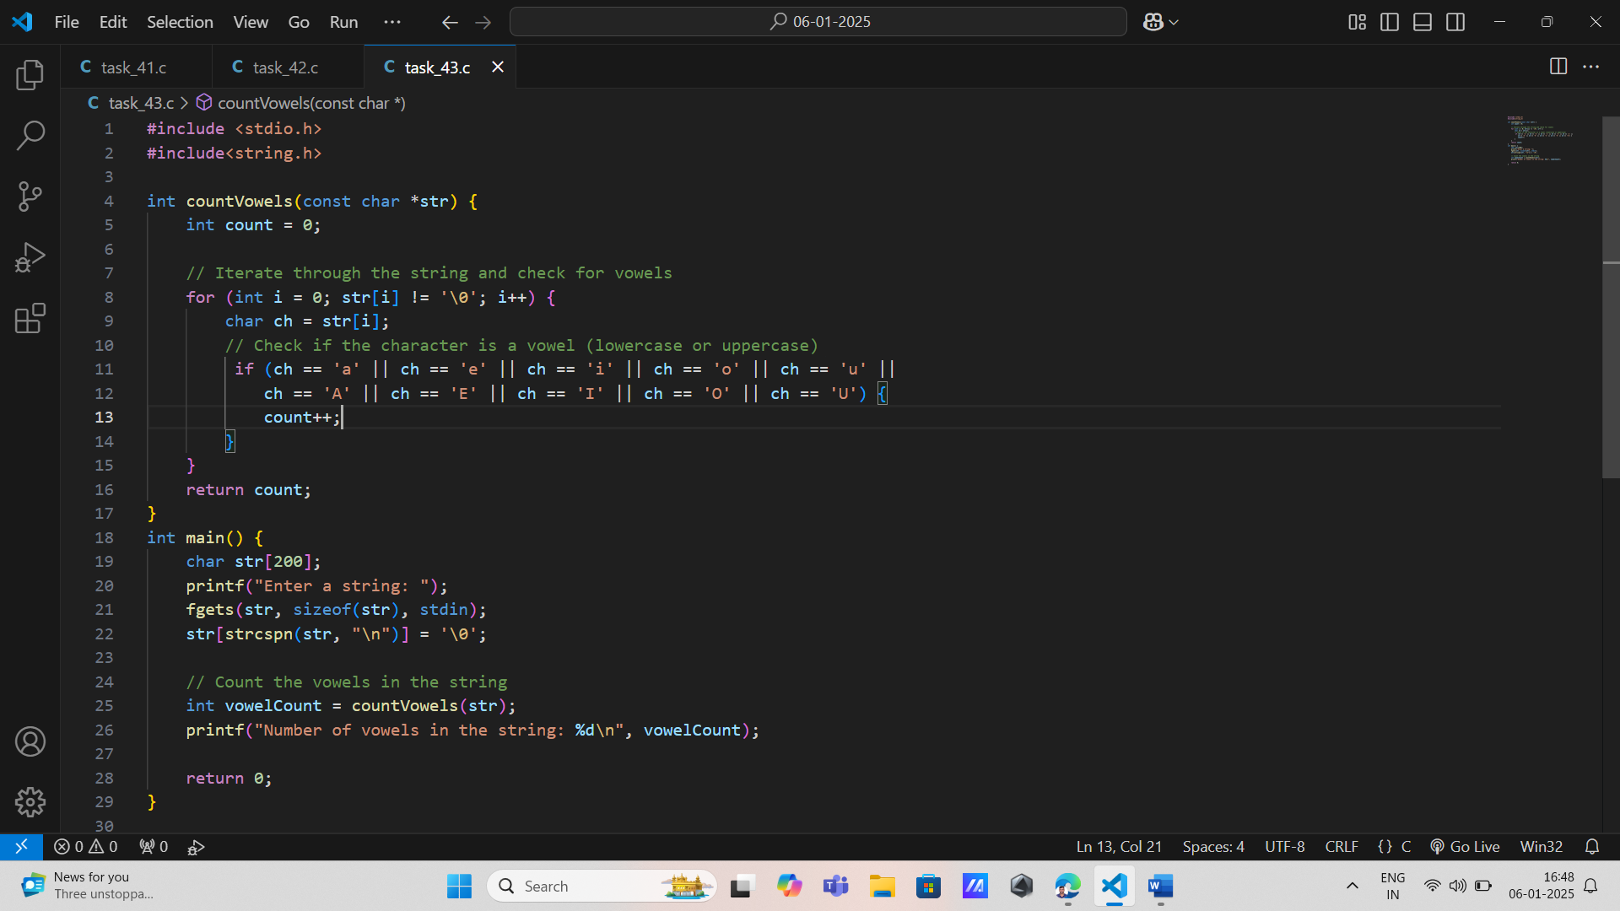

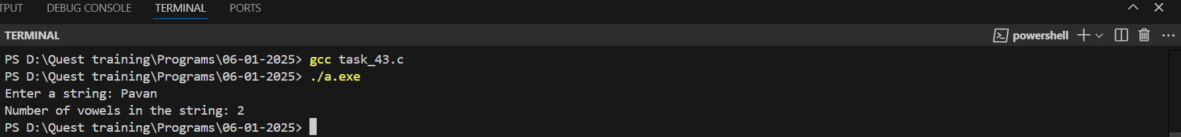

16. Count Specific Characters: Requirement: Implement functionality to count how many times a specific character appears in an input string, allowing for case sensitivity options.

Input: A string and a character from the user.

Output: Count of occurrences.

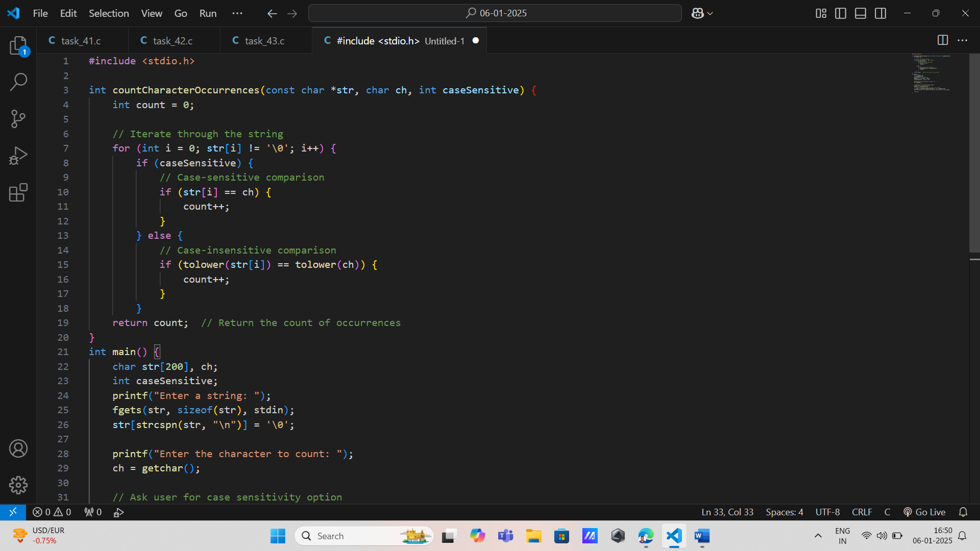

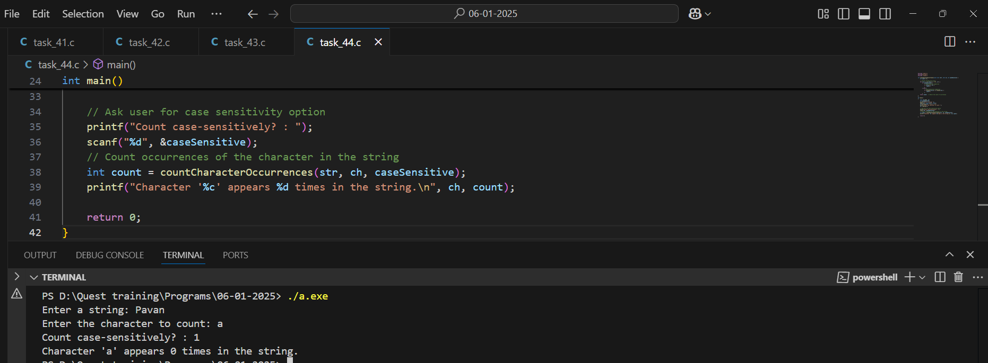

16. Remove All Occurrences of Character: Requirement: Write a function that removes all occurrences of a specified character from an input string, modifying it in place.

Input: A string and a character to remove from it.

Output: Modified string without specified characters.

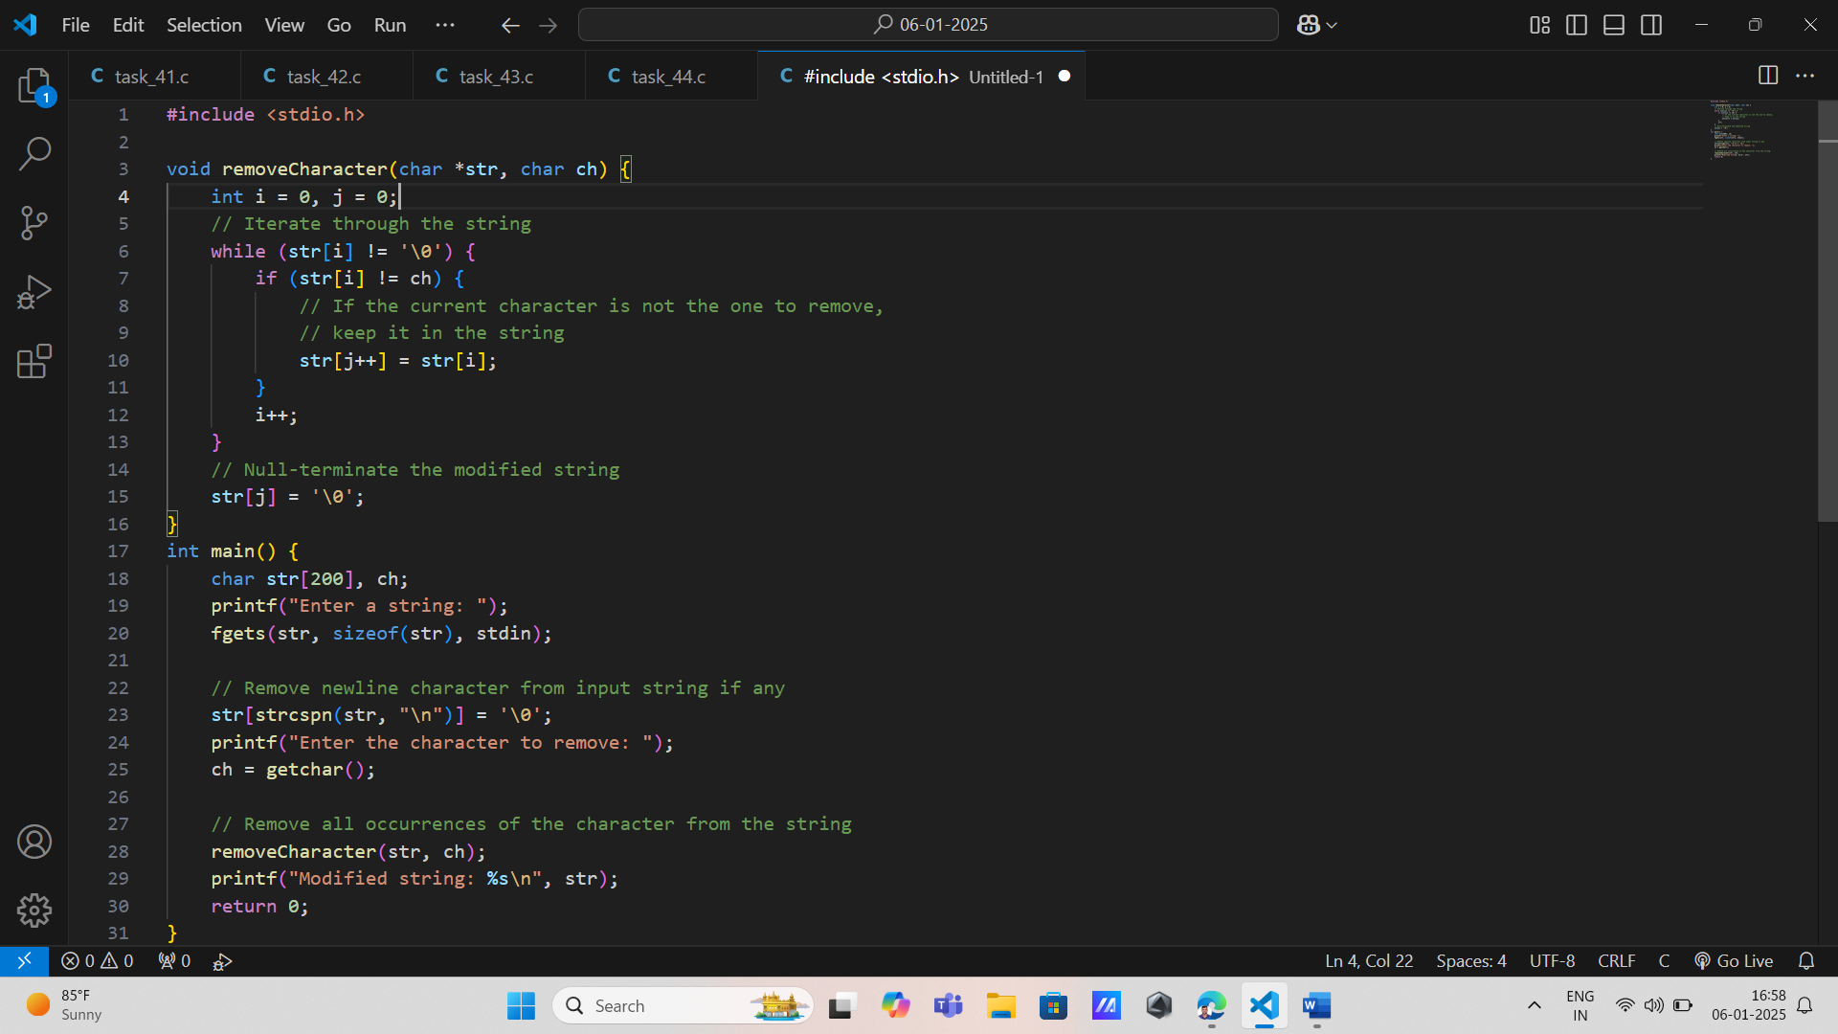

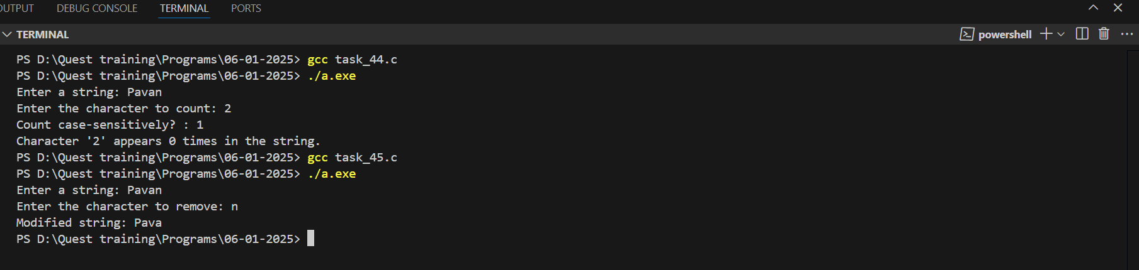

17. Check for Palindrome: Requirement: Develop an algorithm to check if an input string is a palindrome by comparing characters from both ends towards the center, ignoring case and spaces.

Input: A potential palindrome from the user.

Output: Whether it is or isn't a palindrome.

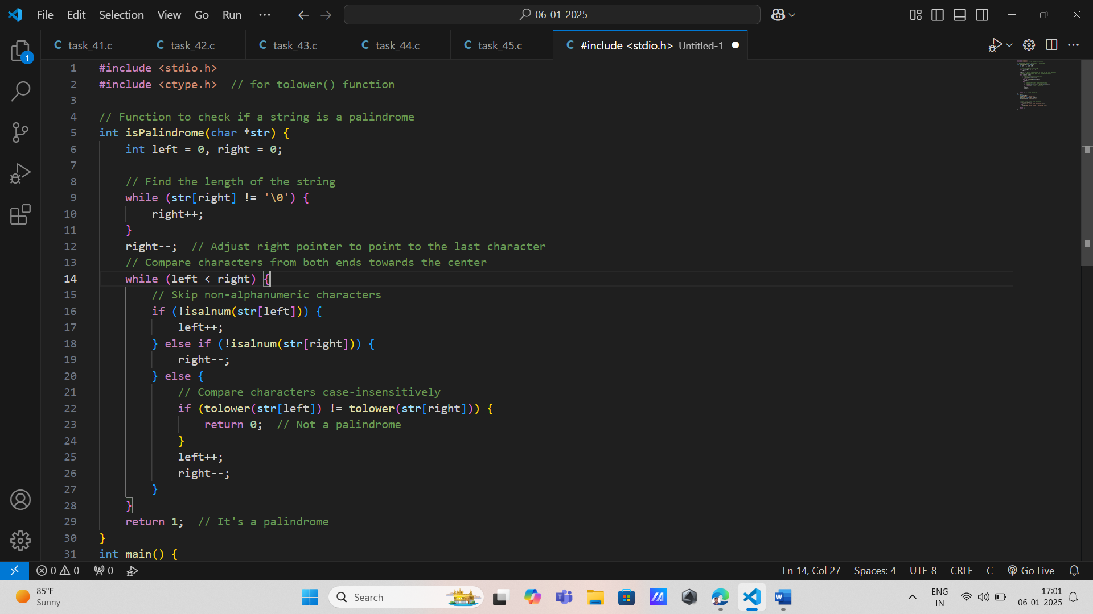

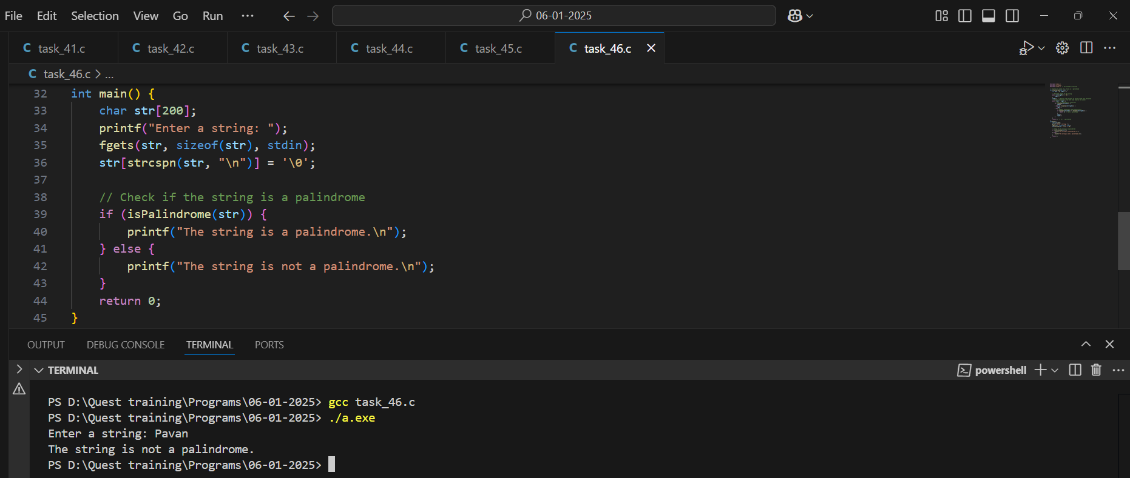

18. Extract Substring: Requirement

Create functionality to extract a substring based on specified start index and length parameters, ensuring valid indices are provided by users.

Input: A main string, start index, and length from the user.

Output: Extracted substring or error message for invalid indices.

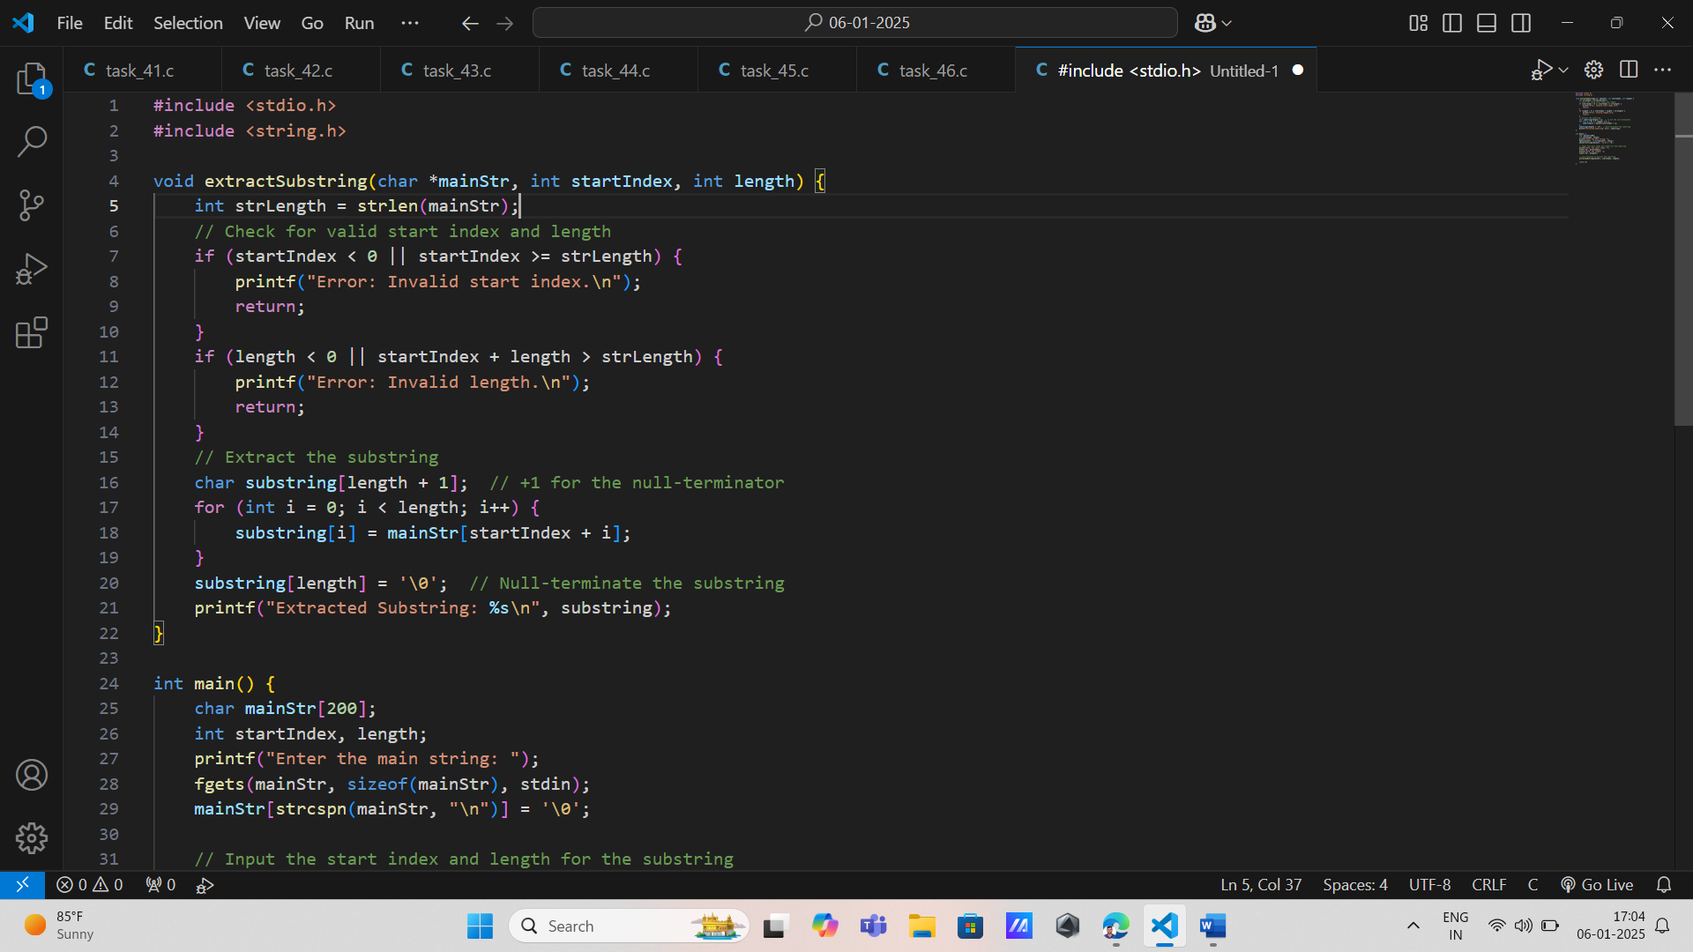

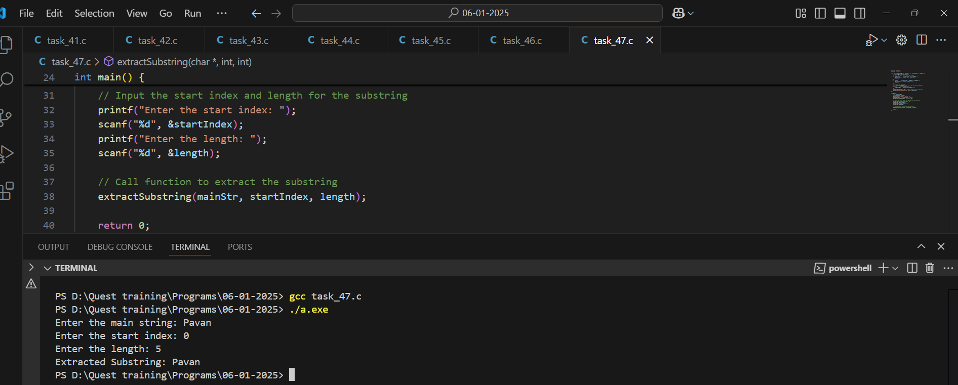

19. Sort Characters in String: Requirement: Implement functionality to sort characters in an input string alphabetically, demonstrating usage of nested loops for comparison without library sorting functions.

Input: A string from the user.

Output: Sorted version of the characters in the string.

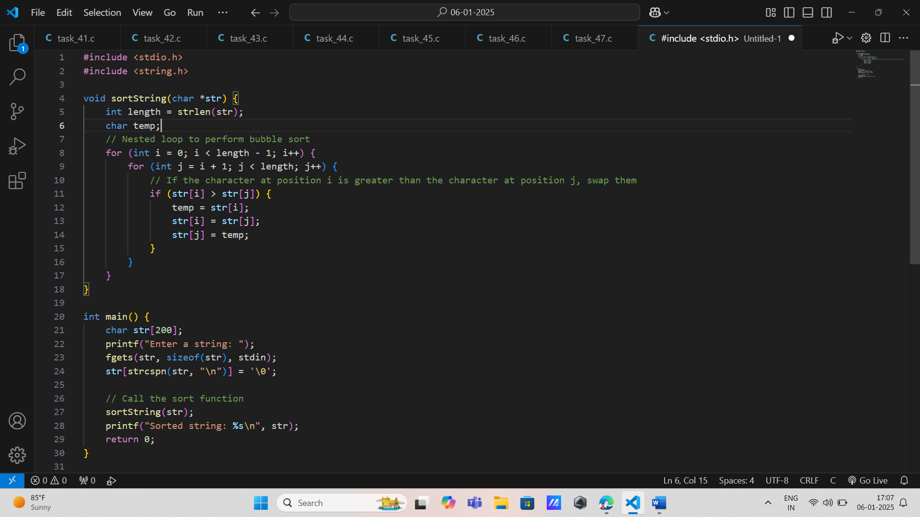

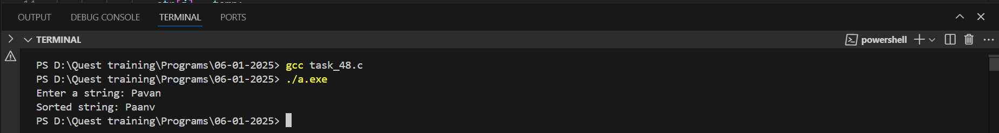

20. Count Words in String: Requirement: Write code to count how many words are present in an input sentence by identifying spaces as delimiters, utilizing strtok().

Input: A sentence from the user.

Output: Number of words counted.

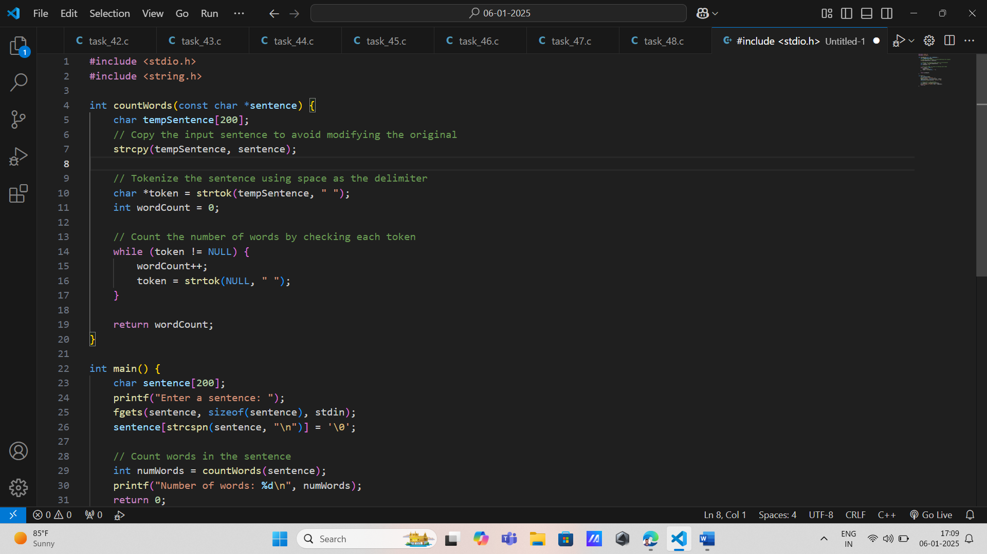

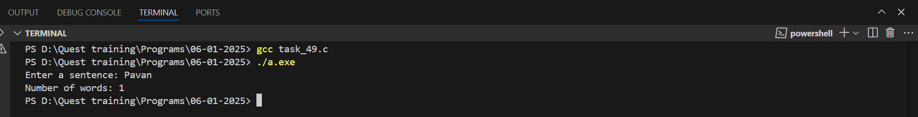

21. Remove Duplicates from String: Requirement: Develop an algorithm to remove duplicate characters while maintaining their first occurrence order in an input string.

- Input: A string with potential duplicate characters.

- Output: Modified version of the original without duplicates.

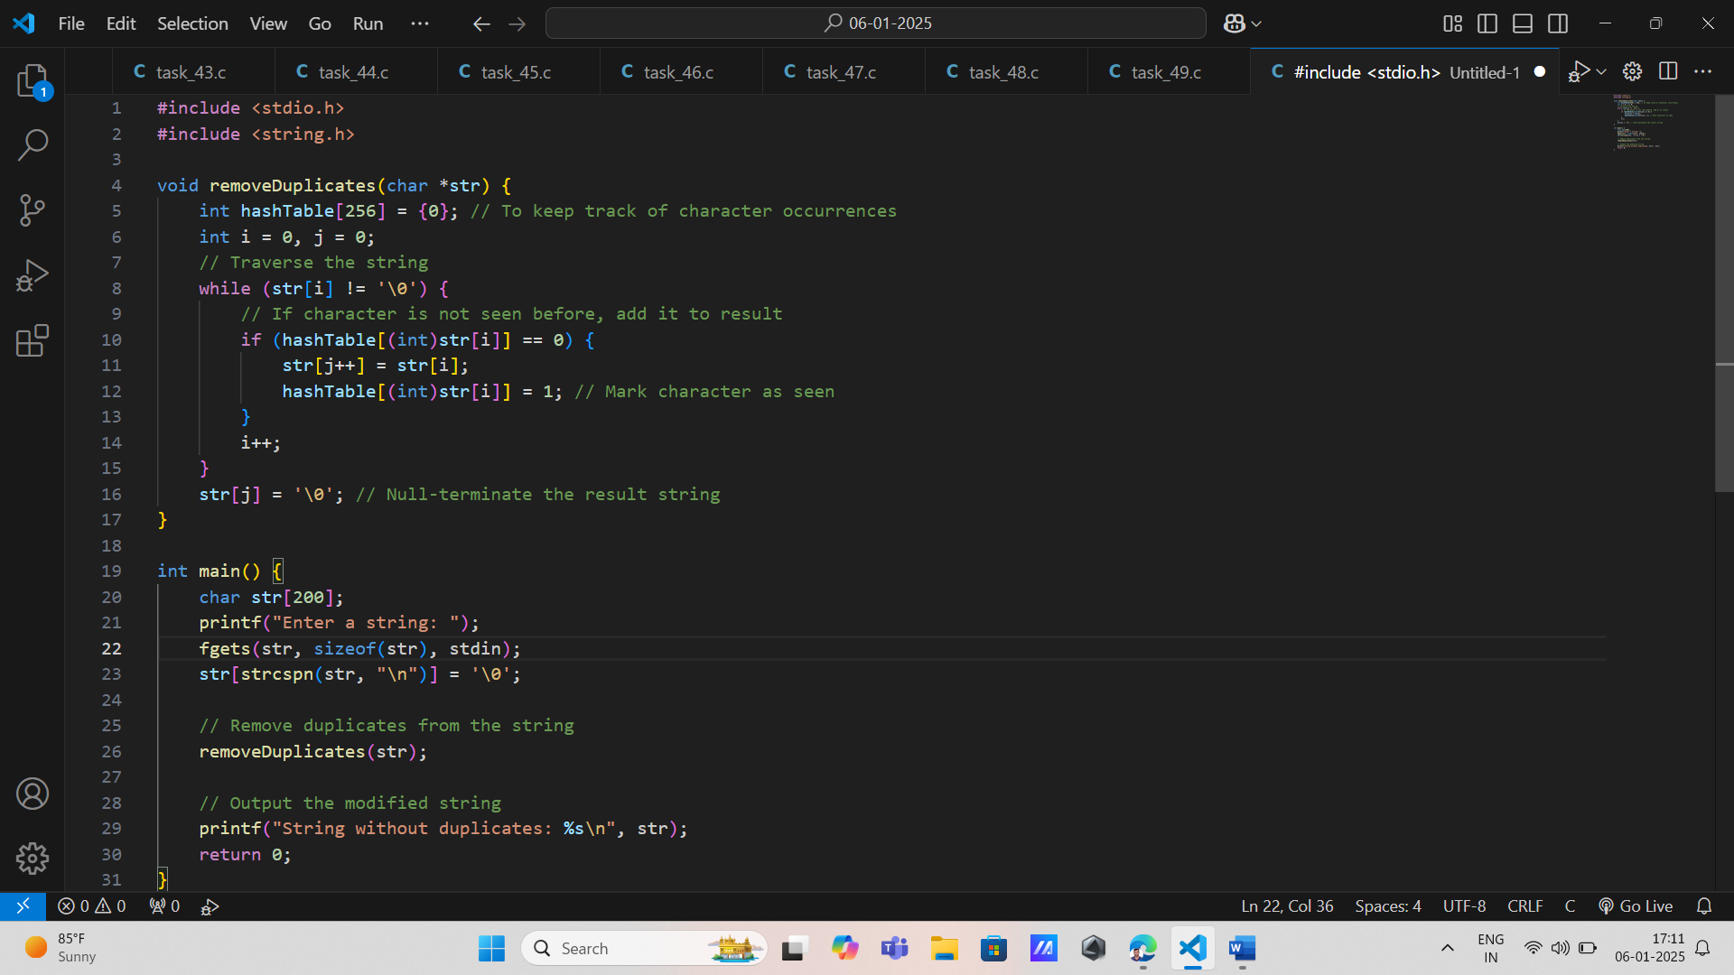

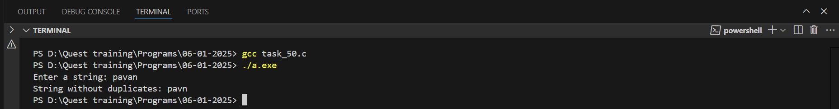

22. Find First Non-Repeating Character: Requirement: Create functionality to find the first non-repeating character in an input string, demonstrating effective use of arrays for counting occurrences.

- Input: A sample input from the user.

- Output: The first non-repeating character or indication if all are repeating.

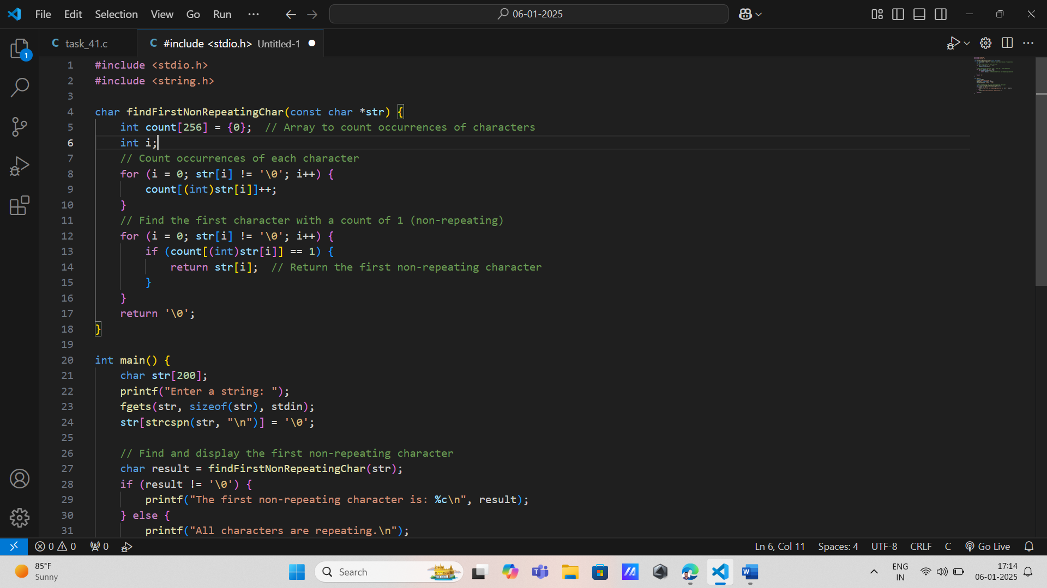

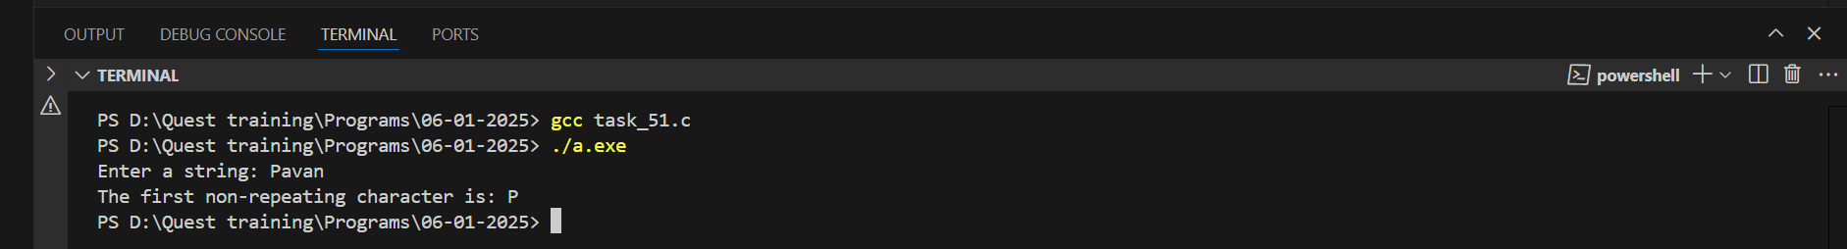

23. Convert String to Integer: Requirement: Implement functionality to convert numeric strings into integer values without using standard conversion functions like atoi(), handling invalid inputs gracefully.

- Input: A numeric string.

- Output: Converted integer value or error message.

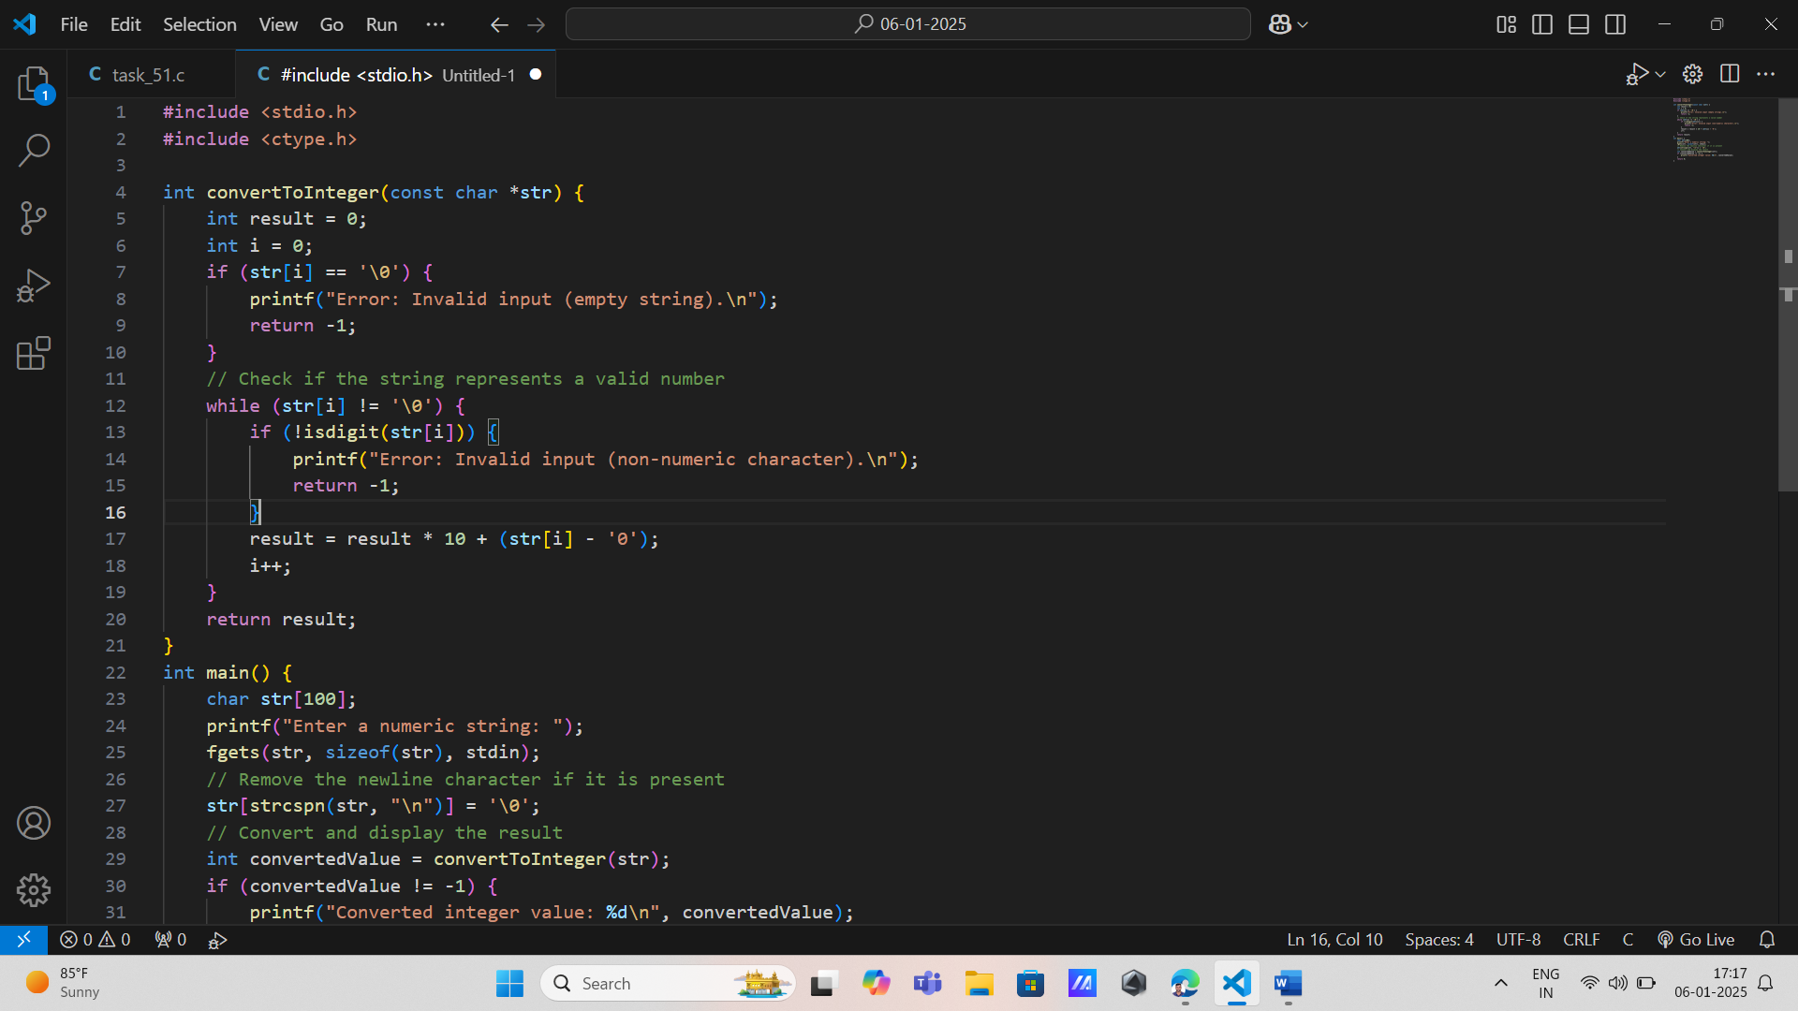

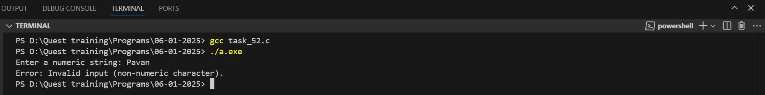

24. Check Anagram Status Between Two Strings: Requirement: Write code to check if two strings are anagrams by sorting their characters and comparing them.

- Input: Two strings.

- Output: Whether they are anagrams.

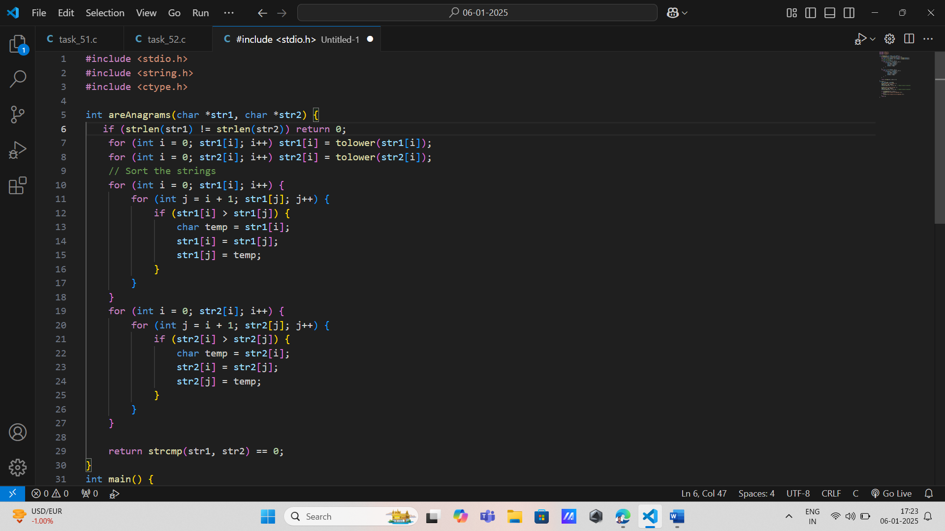

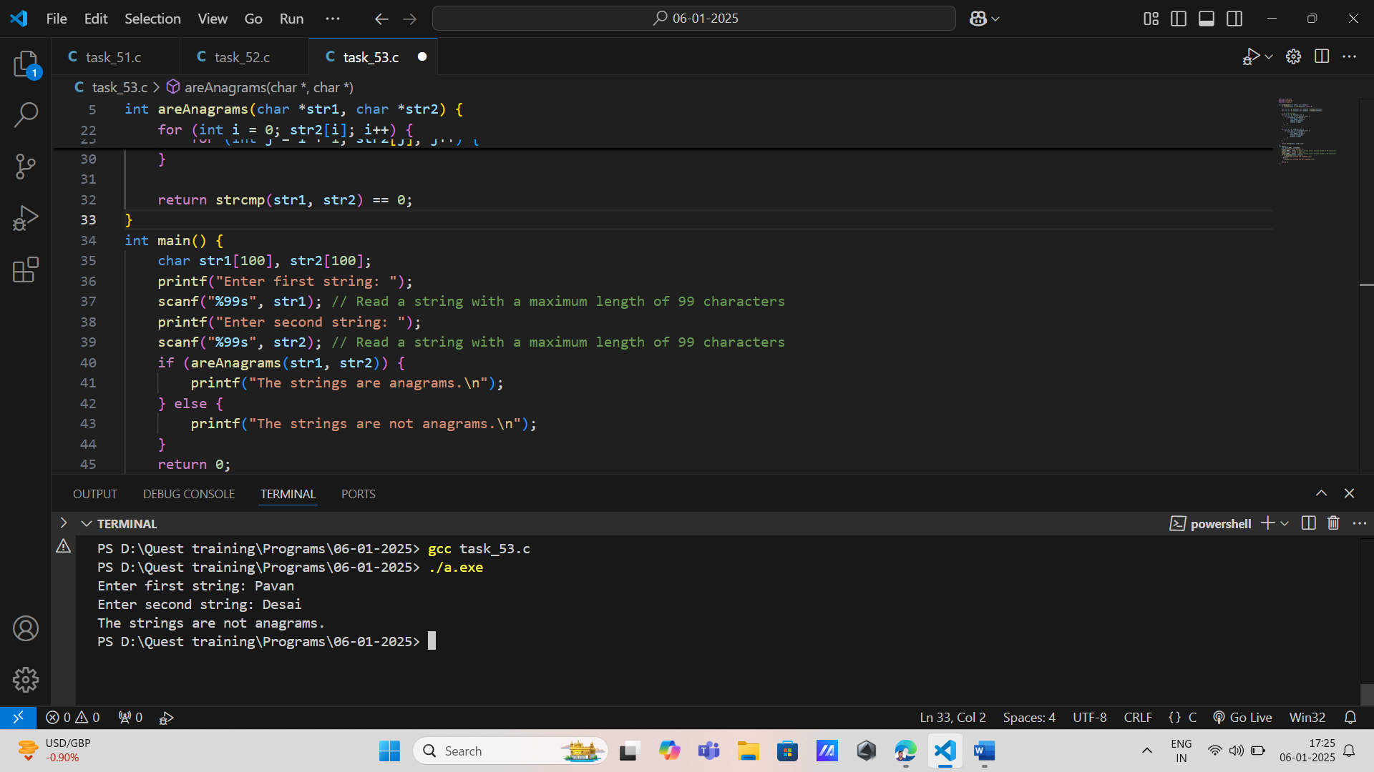

25. Merge Two Strings Alternately: Requirement: Create functionality to merge two strings alternately into one while handling cases where strings may be of different lengths.

- Input: Two strings.

- Output: Merged alternating characters.

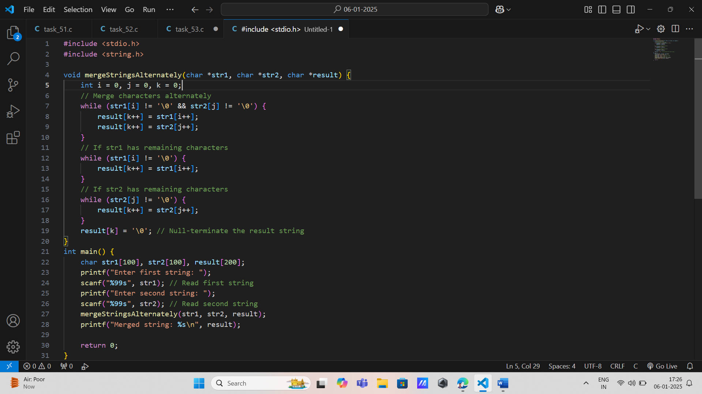

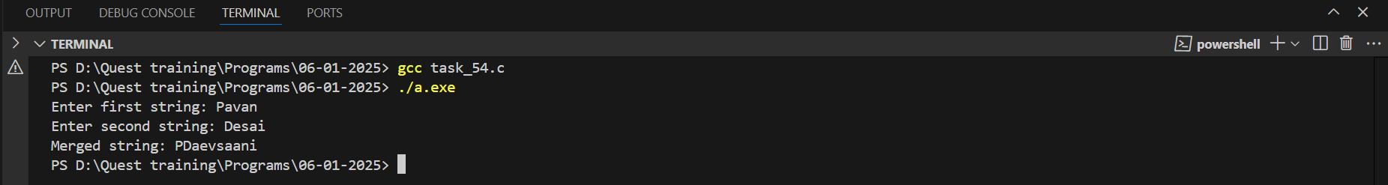

26. Count Consonants in String: Requirement: Develop code to count consonants while ignoring vowels and whitespace characters.

- Input: Any input text.

- Output: Count of consonants.

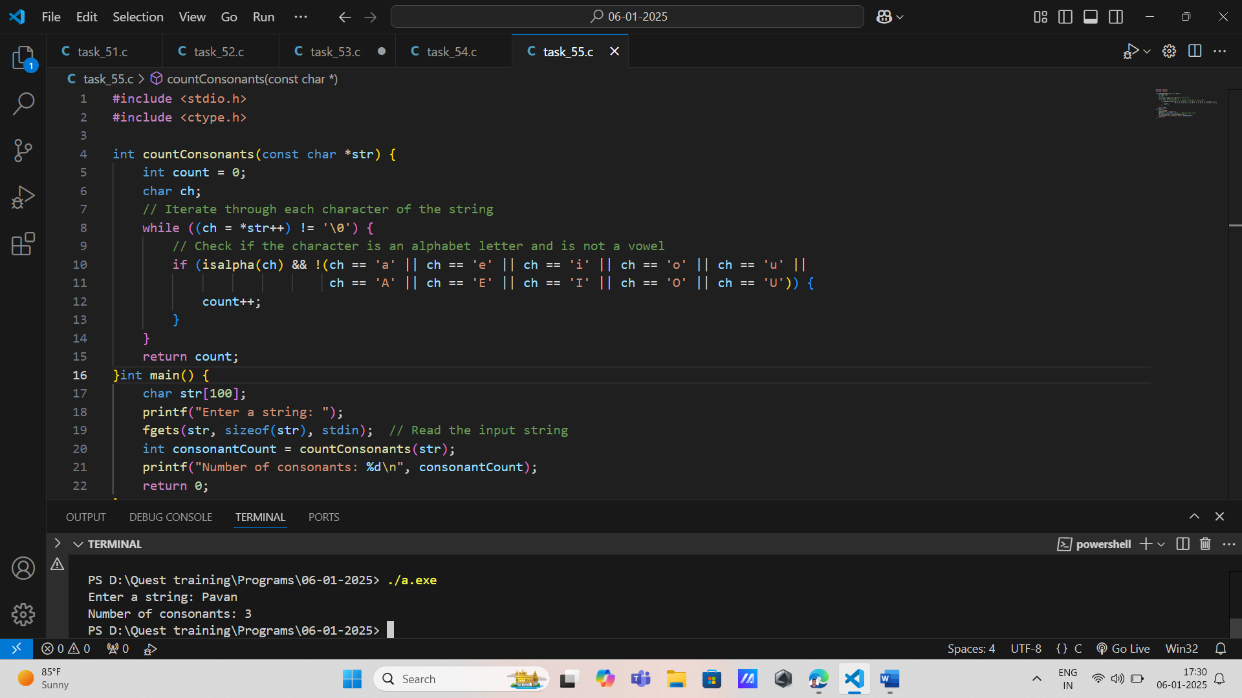

27. Replace Substring with Another String: Requirement: Write functionality to replace all occurrences of one substring with another within a given main string.

- Input: Main text, target substring, replacement substring.

- Output: Modified main text after replacements

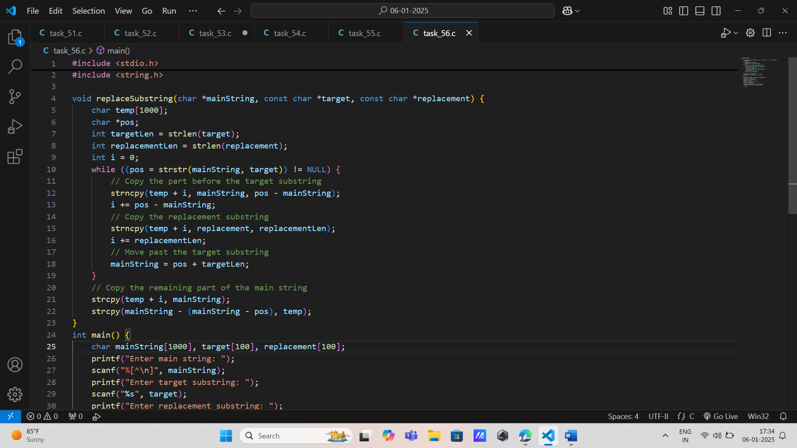

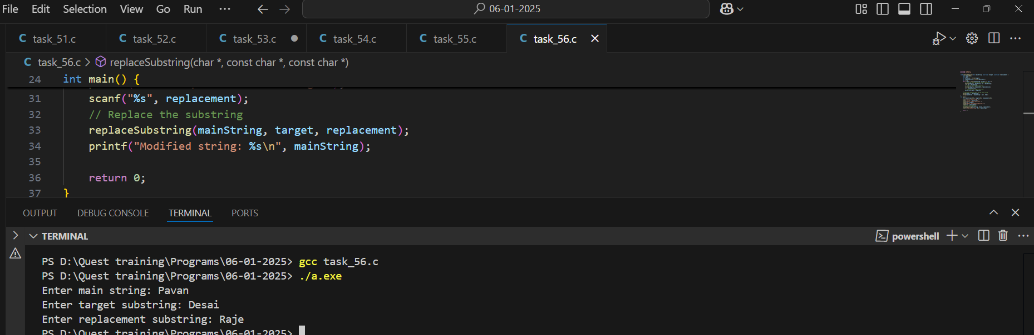

28. Count Occurrences of Substring

- Requirement: Create code that counts how many times one substring appears within another larger main text without overlapping occurrences.

- Input: Main text and target substring.

- Output: Count of occurrences.

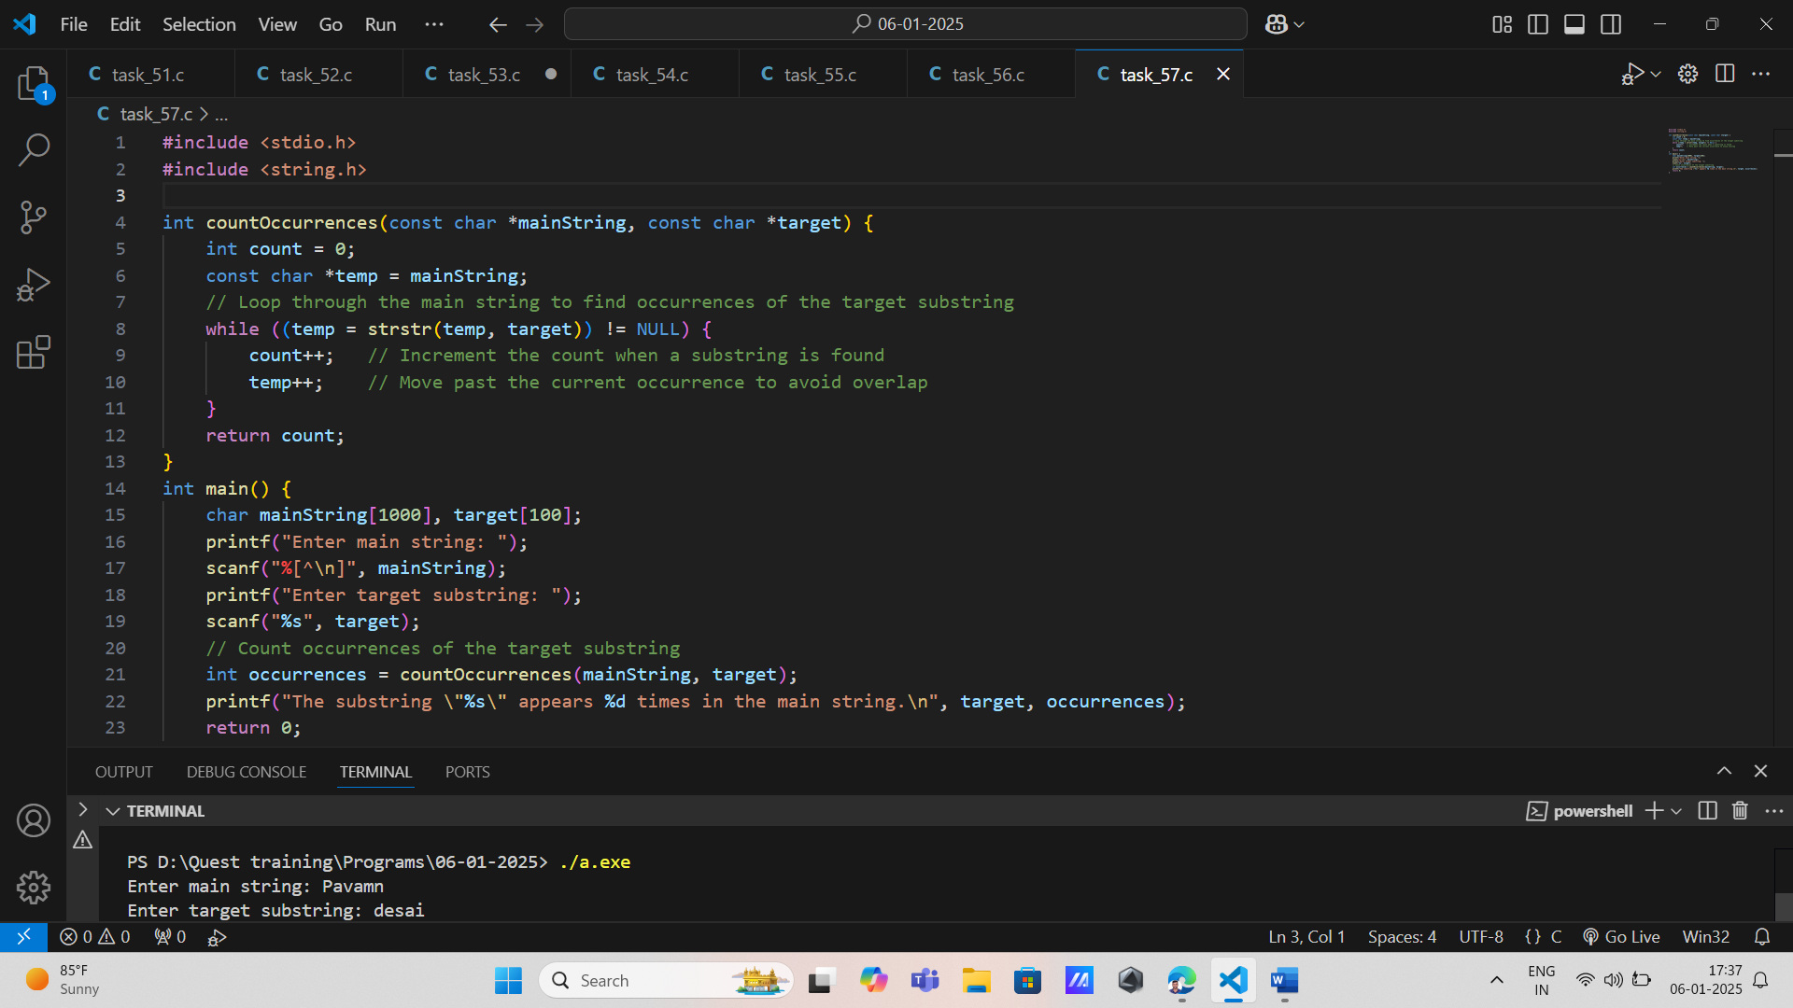

29. Implement Custom String Length Function - Requirement: Finally, write your own implementation of strlen() function from scratch, demonstrating pointer manipulation techniques. - Input:

Any input text. –

Output: Length calculated by custom function.

